Performance Testing
Date | 27/09/2026
Team ID | SWTID-2026-3776
Project Name | AI FAQ Assistant
Maximum Marks | 5 Marks
Performance Testing
Performance testing evaluates how the AI FAQ Assistant API behaves under expected load. The sections below document the testing approach, tools used, and results obtained.
Step 1: Testing Overview
Field | Details
Testing Tool Used | Thunder Client (VS Code) response-time readout, exported Postman collection (AI_FAQ_Assistant_API.postman_collection.json) and test_api.js script
Type of Testing | Baseline response-time performance testing with a single user and sequential requests, alongside functional checks of valid and invalid cases. A concurrent load / stress test (JMeter or k6) is planned.
Target Module / API | Auth: GET /api/auth/profile. FAQ: POST, GET, PUT and DELETE on /api/faqs. AI: POST /api/ai/generate (Google Gemini).
Test Environment | Local: Node.js / Express server on http://localhost:5000 with a local MongoDB instance (127.0.0.1) on a Windows laptop
Test Date | 25 - 26 September 2026
Step 2: Test Scenarios
S.No | Test Scenario / Description | No. of Virtual Users | Duration (sec) | Expected Outcome
1 | Authenticated profile retrieval: GET /api/auth/profile with a valid Bearer token | 1 | 1 | 200 OK with user details in under 2 seconds
2 | FAQ CRUD sequence: create, list, update and delete an FAQ through /api/faqs | 1 | 1 per request | 201 / 200 status codes; each response in under 2 seconds
3 | AI answer generation: POST /api/ai/generate with a valid question (external Gemini call) | 1 | 3 | 200 OK with a generated answer in under 5 seconds
4 | Invalid requests: missing / invalid token, missing required field, deleted FAQ id | 1 | 1 per request | Fast 401 / 400 / 404 JSON errors with no server crash
Step 3: Performance Test Results
S.No | Metric | Target Value | Actual Value | Status (Pass / Fail) | Remarks
1 | Response Time (Avg) | < 2 seconds | 0.49 s across all 6 measured requests (0.05 s for the 5 non-AI requests) | Pass | Measured: profile 31 ms, create 19 ms, list 59 ms, update 96 ms, delete 25 ms, AI 2.71 s.
2 | Response Time (Max) | < 5 seconds | 2.71 s (AI generation) | Pass | Slowest request is the external Gemini call; the slowest local request was update at 96 ms.
3 | Throughput (Req/sec) |  | About 21 req/sec (estimate for CRUD calls) | N/A | Derived as 1 / average CRUD time for a single sequential user. No load tool was used, so this is not a measured peak.
4 | Error Rate | < 1% | 0% unexpected errors | Pass | All requests returned the expected status codes; 401 / 400 / 404 responses were intended negative tests. 10 of 10 functional test cases passed.
5 | CPU Utilization | < 80% | [Record from Task Manager] | Pending | Not captured during testing; note the peak CPU while sending requests.
6 | Memory Utilization | < 80% | [Record from Task Manager] | Pending | Not captured during testing; note the memory used by the node process.
Step 4: Observations & Analysis
Key Findings:
- All local API calls responded in 19 - 96 ms (average 46 ms), far below the 2-second target.
- The AI endpoint was the slowest at 2.71 s because it waits on the external Google Gemini service, but it stayed under the 5-second target.
- No unexpected errors occurred; invalid inputs returned quick, structured JSON errors and the server stayed up.
Bottlenecks Identified:
- External Gemini API latency, and occasional overload / unavailability (covered by test case TC-09).
- GET /api/faqs returns the whole list in one response (1.06 KB for 3 records), so the payload will grow with the number of FAQs.
- bcrypt hashing makes registration and login slightly heavier than other calls, by design for security.
Optimization Steps Taken:
- Centralised error-handling middleware returns a graceful message when Gemini fails, instead of crashing the server.
- Validation middleware rejects bad requests early with a 400 response, before any database or AI work.
- Stateless JWT authentication avoids session look-ups on protected routes.
- Planned: pagination for the FAQ list, caching of repeated AI answers, database indexes on search fields, and a JMeter / k6 concurrent load test.
Step 5: Screenshots / Evidence
Thunder Client results from the local test run (response status and time are shown in each screenshot):
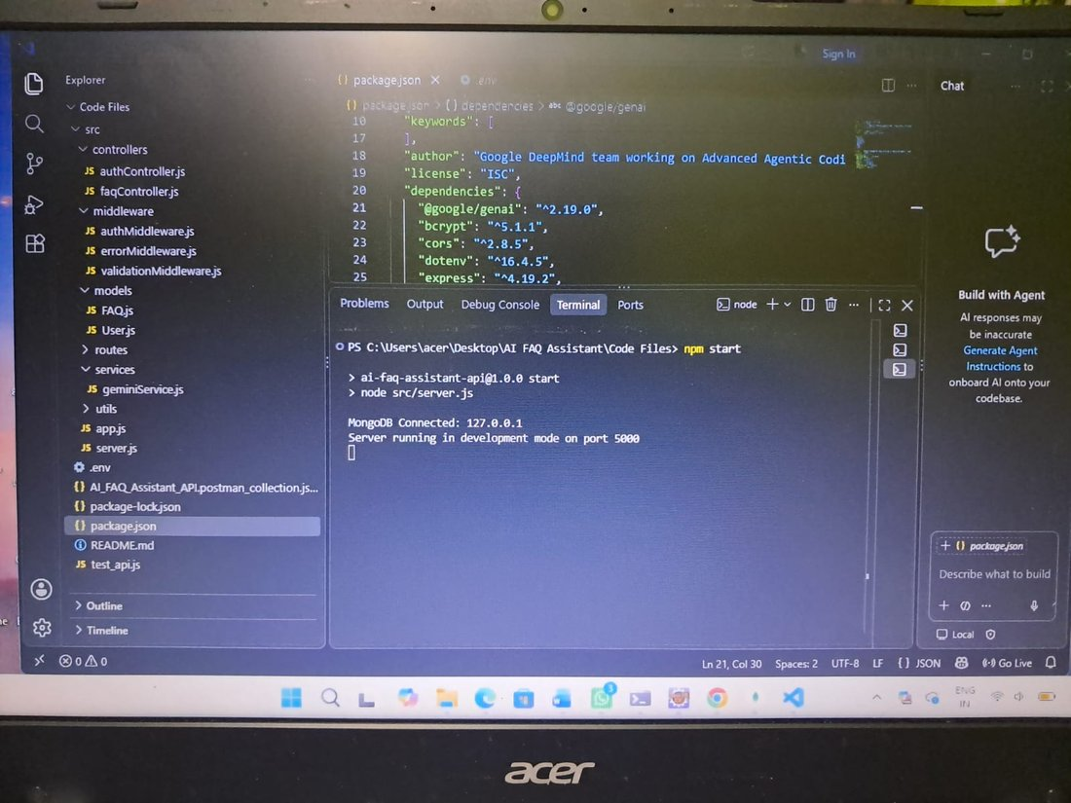  Fig 1. Server start: MongoDB connected, running on port 5000 | 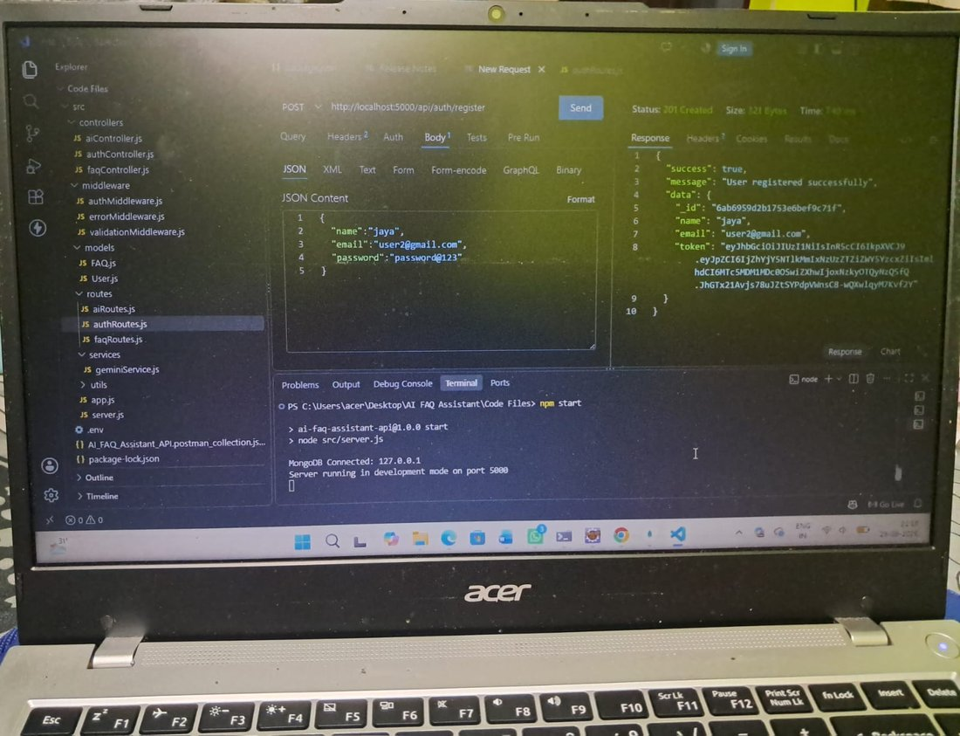  Fig 2. POST /api/auth/register: 201 Created
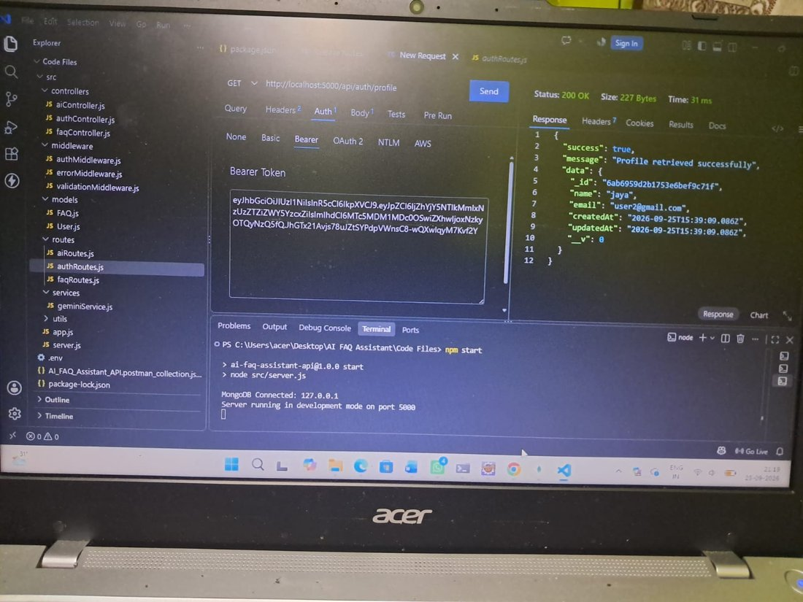  Fig 3. GET /api/auth/profile: 200 OK, 31 ms | 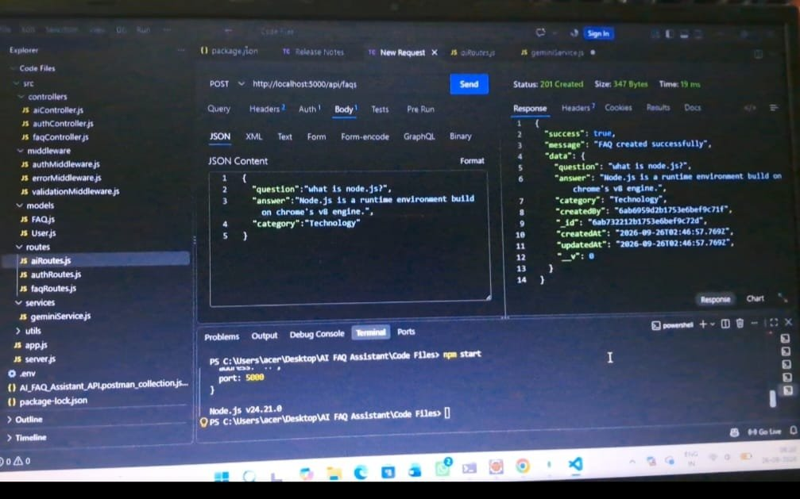  Fig 4. POST /api/faqs: 201 Created, 19 ms
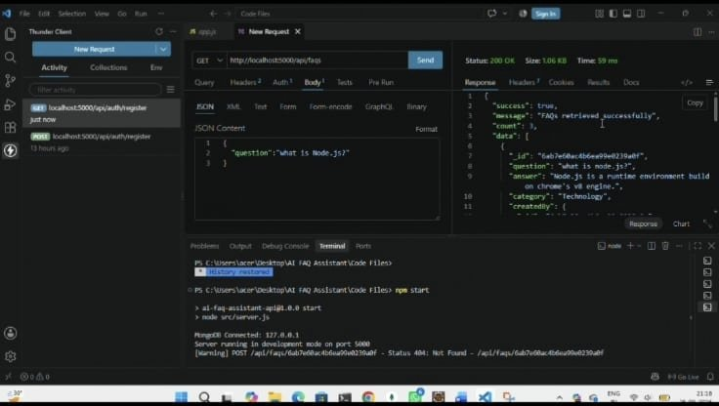  Fig 5. GET /api/faqs: 200 OK, 59 ms | 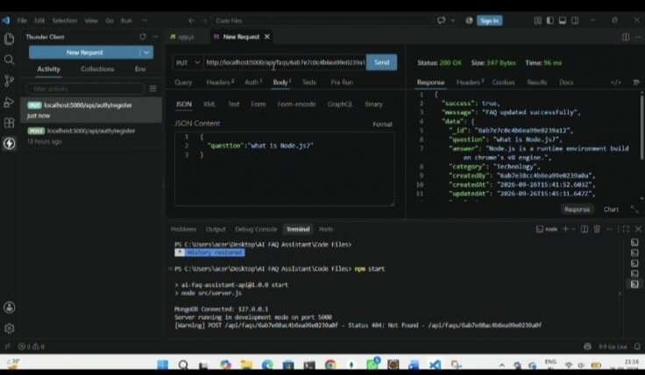  Fig 6. PUT /api/faqs/:id: 200 OK, 96 ms
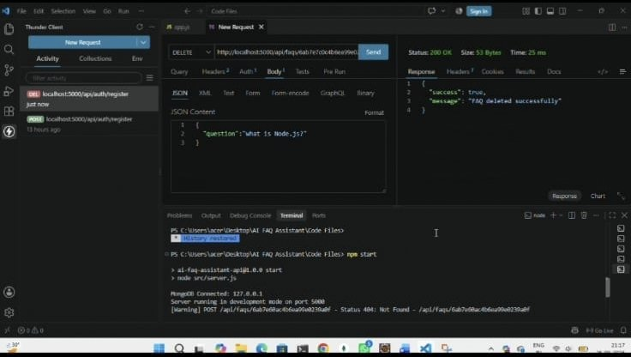  Fig 7. DELETE /api/faqs/:id: 200 OK, 25 ms | 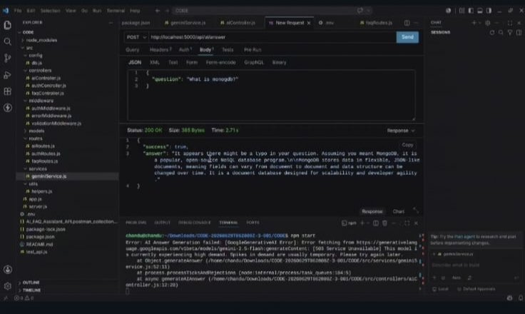  Fig 8. POST /api/ai/generate: 200 OK, 2.71 s

