Program:

I have read each line and used tokenizer to get the tokens of every line and obtained the unigrams and bigrams separately into two lists. Based on the parameter ‘chi-square’ or ‘PMI’, it calls the respective functions to calculate the measures and finally displays the output successfully for the top 20 bigrams along with their chi-square scores and PMI scores in the reverse order.

Chi-Square scores for top 20 bigrams

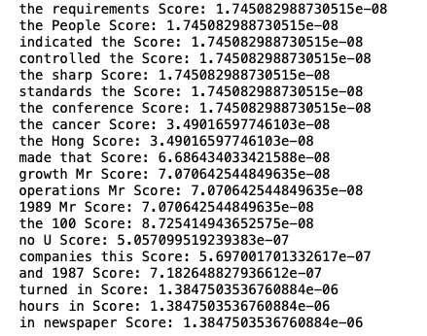

PMI scores for top 20 bigrams:

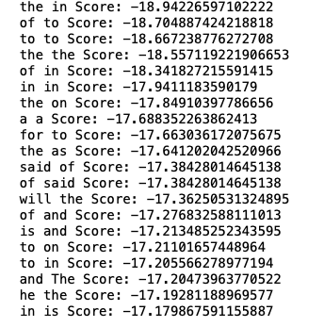

Both PMI and Chi-square have given quite accurate results and we can see that the results are not very similar. If you see the top 20bigrams given by PMI, we observe that they are most common stop words. Whereas it is not the same with chi-square. Therefore, I think PMI is more effective.

