Evaluation Metrics in Confident AI Documentation
Confident AI provides a set of evaluation metrics to assess LLM applications effectively, especially for RAG systems. Some key metrics include:
- Faithfulness → Checks whether the generated answer is grounded in the provided context (no hallucination beyond context)
- Answer Relevancy → Measures how well the response answers the given query
- Context Precision → Ensures retrieved documents are relevant
- Context Recall → Verifies if all necessary information was retrieved
- Bias → Detects unfair or prejudiced responses
- Toxicity → Identifies harmful or offensive outputs

Faithfulness
Scenario 1
input/query
What is the capital of France?
retrieval_context
France’s capital city is Paris.
actual_output
Paris is the capital of France and it is famous for the Eiffel Tower built in 1889.
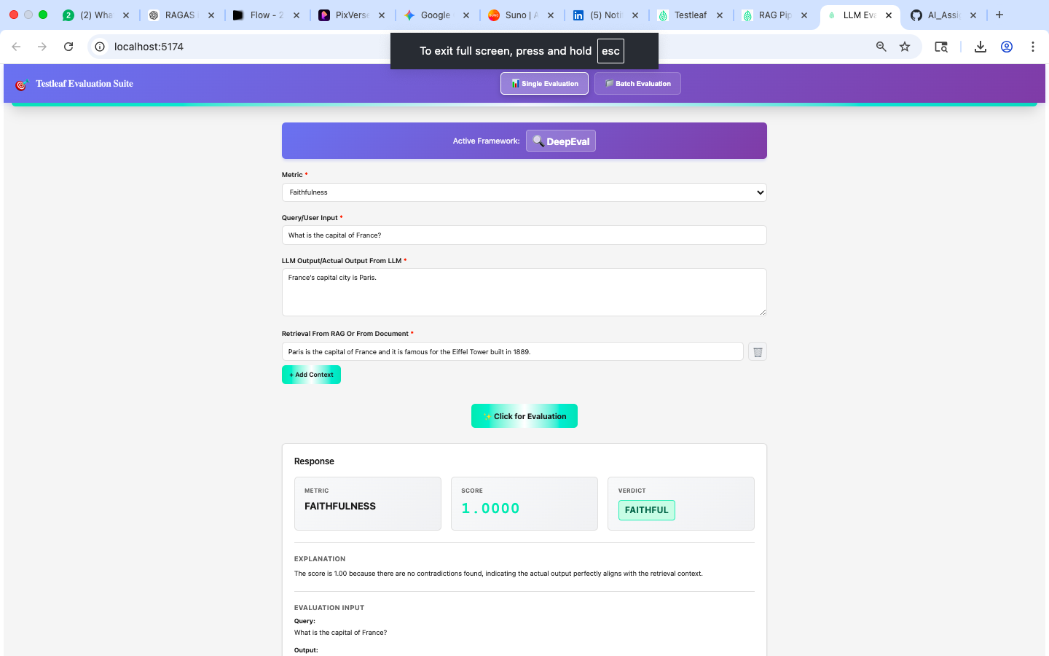

Scenario 2
input/query
Who discovered gravity?
retrieval_context
Isaac Newton discovered gravity when he observed a falling apple.
actual_output
Albert Einstein discovered gravity.
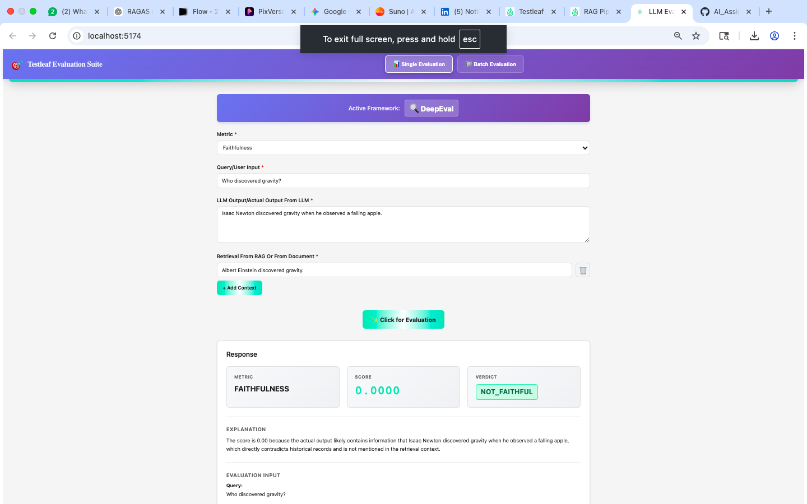

Scenario 3
input/query
What is the boiling point of water?
retrieval_context
Water boils at 100°C under standard atmospheric pressure.
actual_output
The boiling point of water is 100°C under standard atmospheric pressure.
