Injection – MongoDB

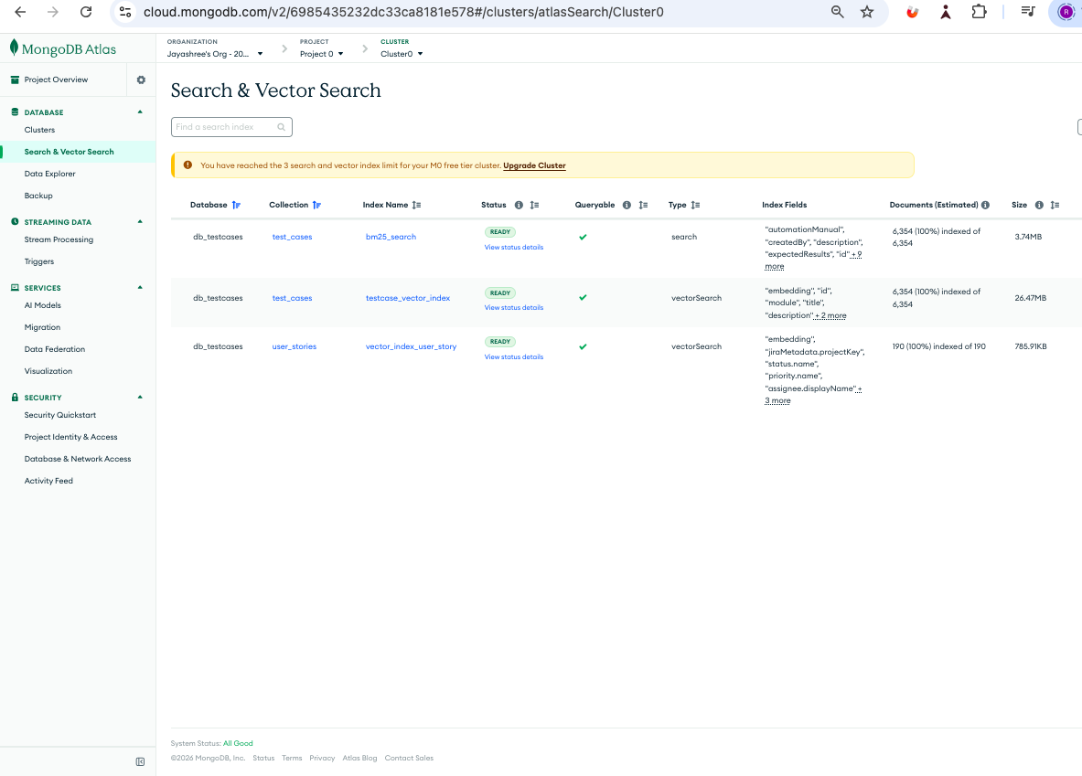

- Covert to Json – Uploaded testcases or user stories will be converted to Json.
- Embedding – choose the respective testcase or user story json and create the embedding.
- Once embedded data will be stored in Mongo Db . This is injection.
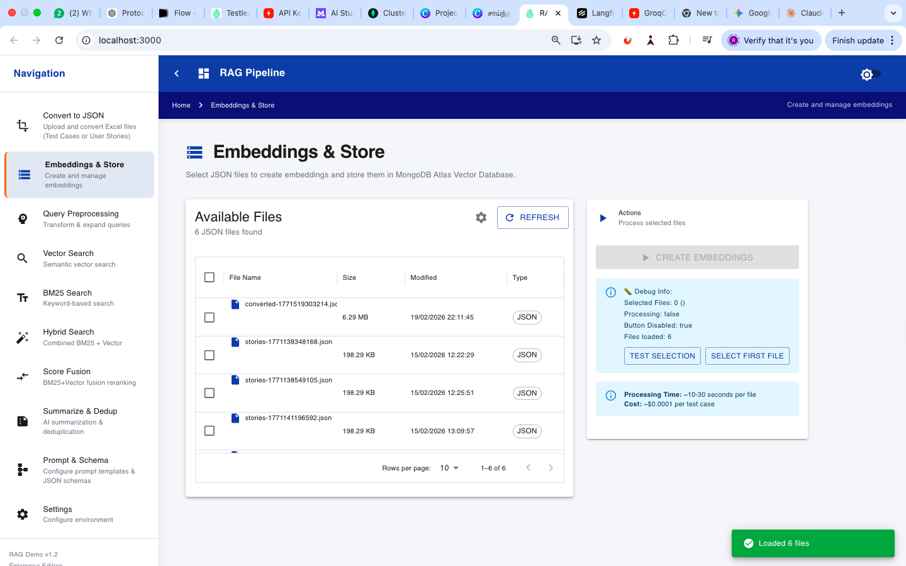

Query Preprocessing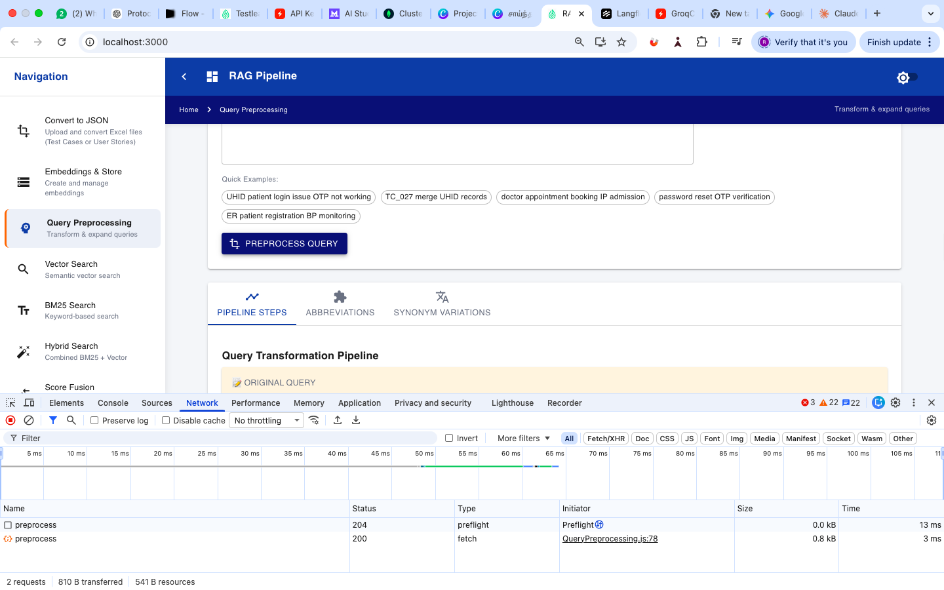

Retrieval:
Vector search – Getting the semantic search based response with score which will come from the existing DB.

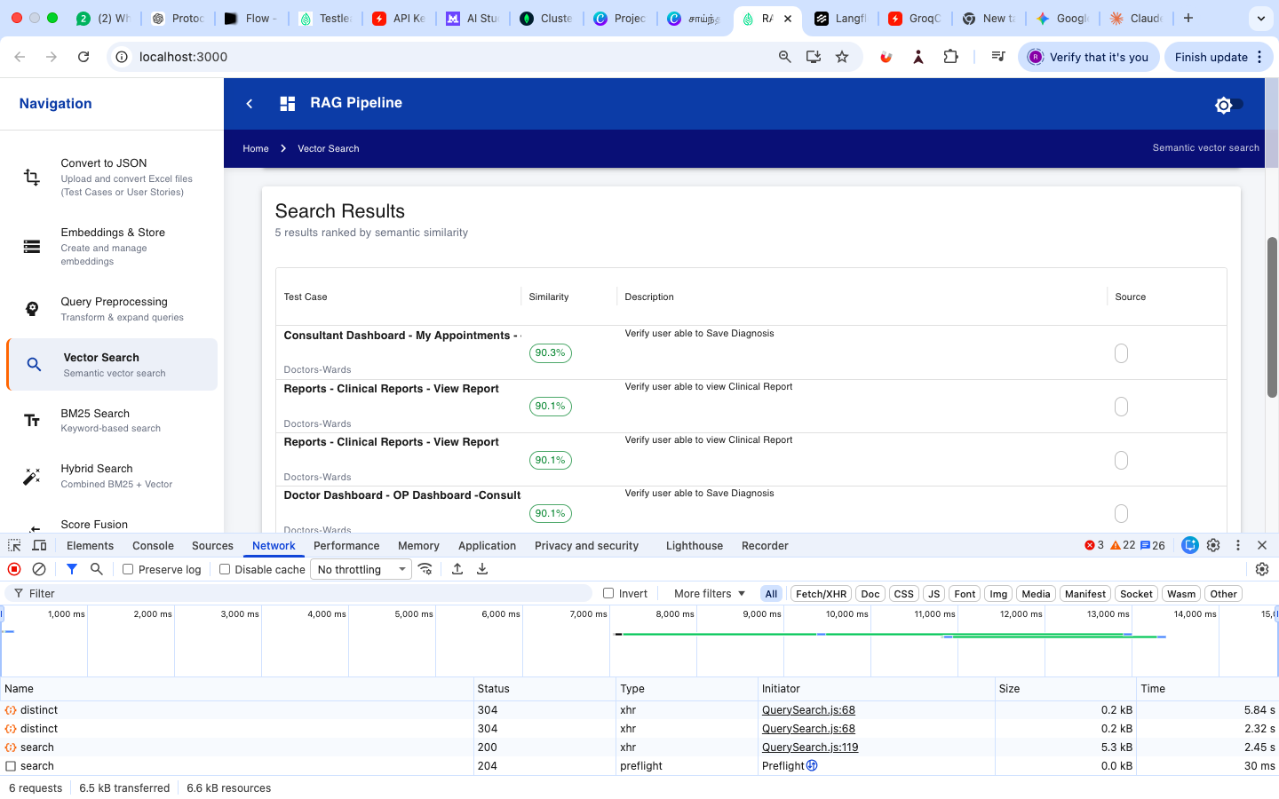

BM25 Search – Based on the keyword search
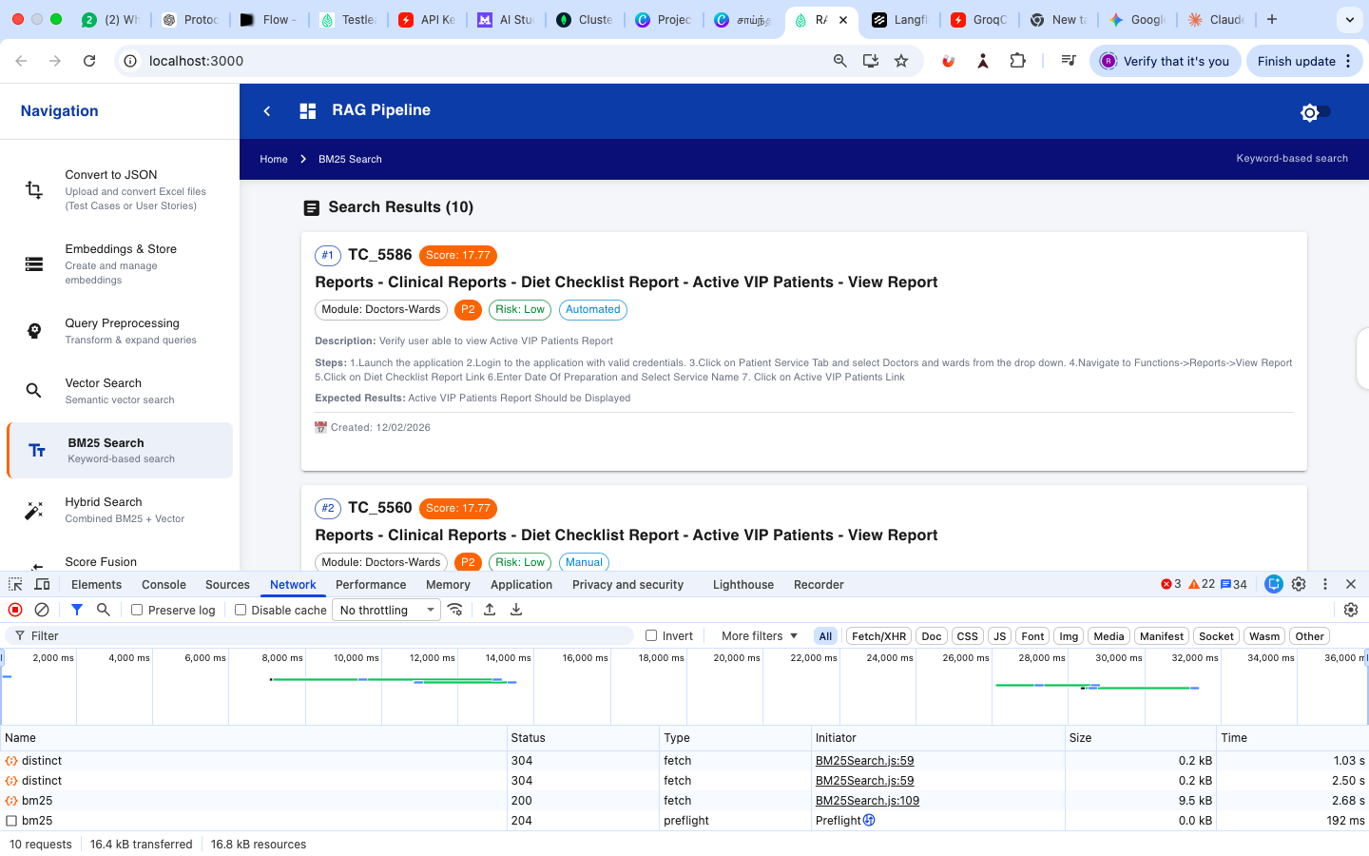
Hybrid search – We can increase or decrease the BM25 or vector search weight and get the response
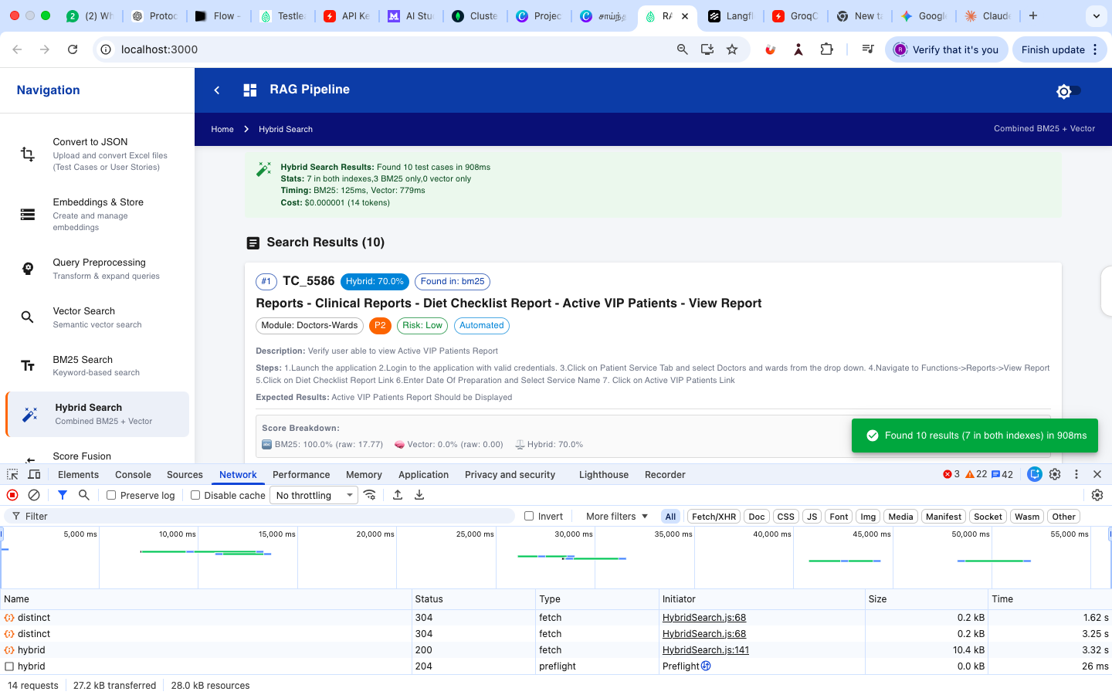

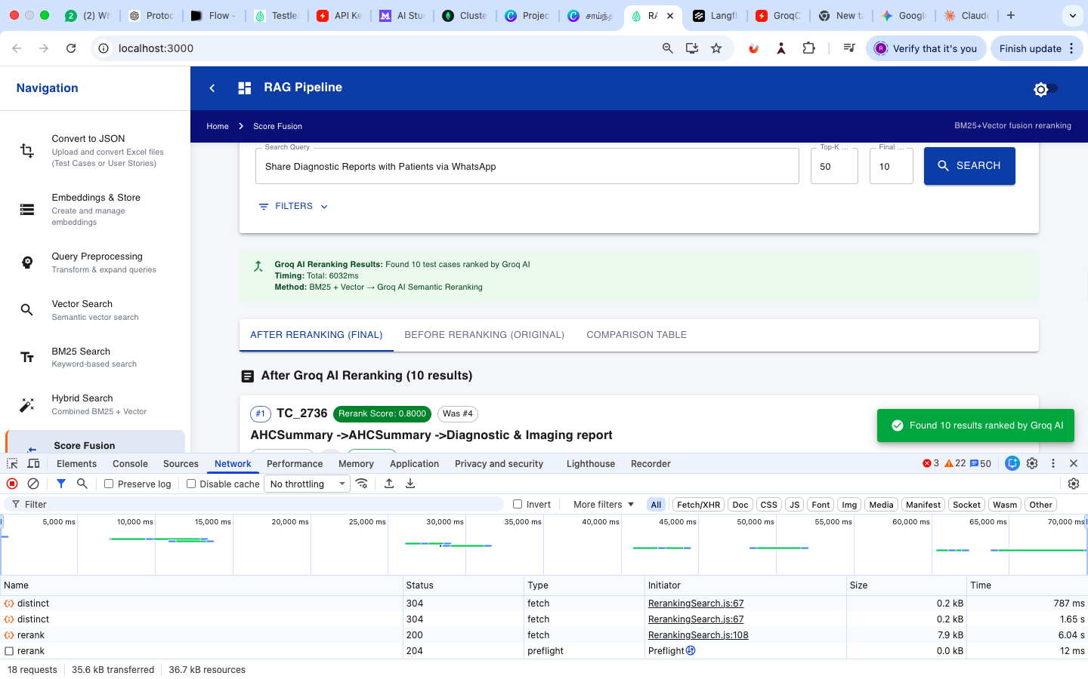
Test and Review complete RAG pipeline
LLM get called here we are using the Groq. Where the Misrel is used only for the embedding. The generated test cases are using the LLM model.

