**Ad_Hoc Requests**

**Ad_Hoc_Request 1 :**

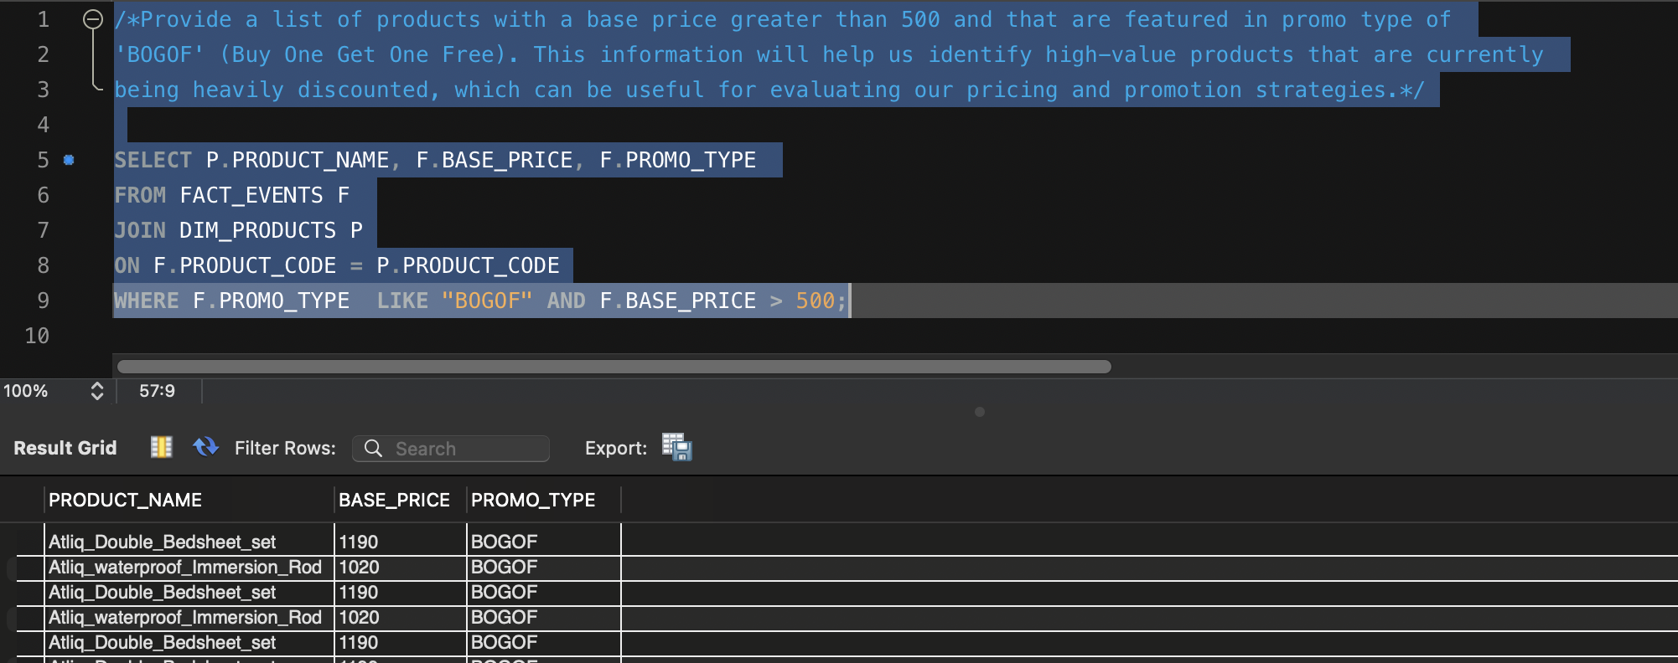

**Ad_Hoc_Request 2 :**

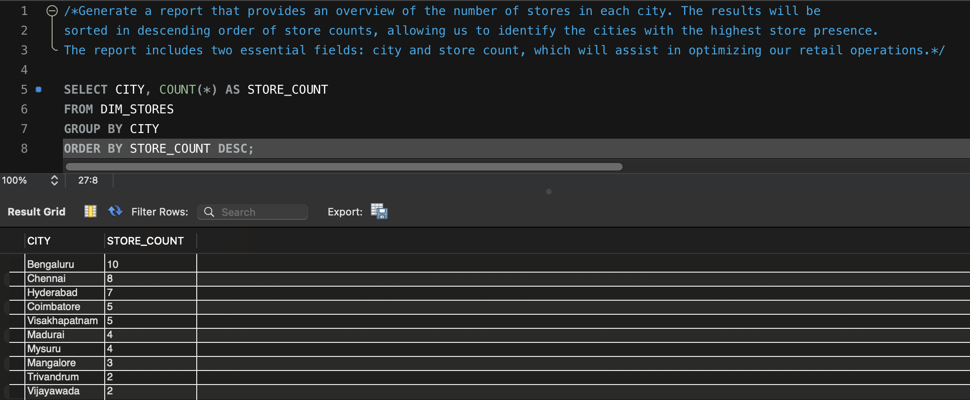

**Ad_Hoc_Request 3 :**

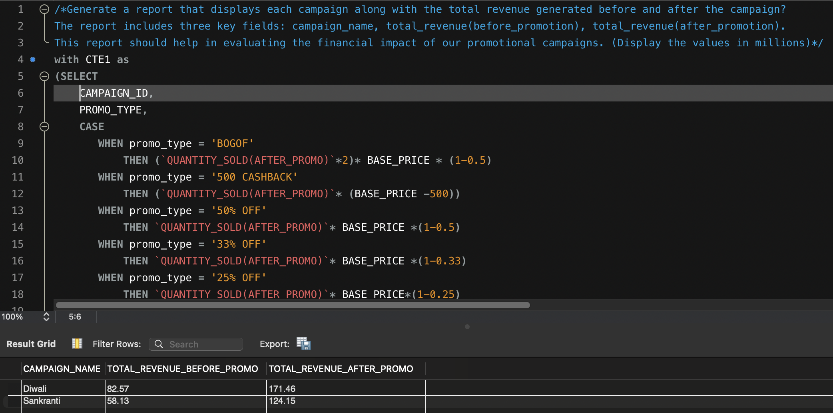

**Ad_Hoc_Request 4 :**

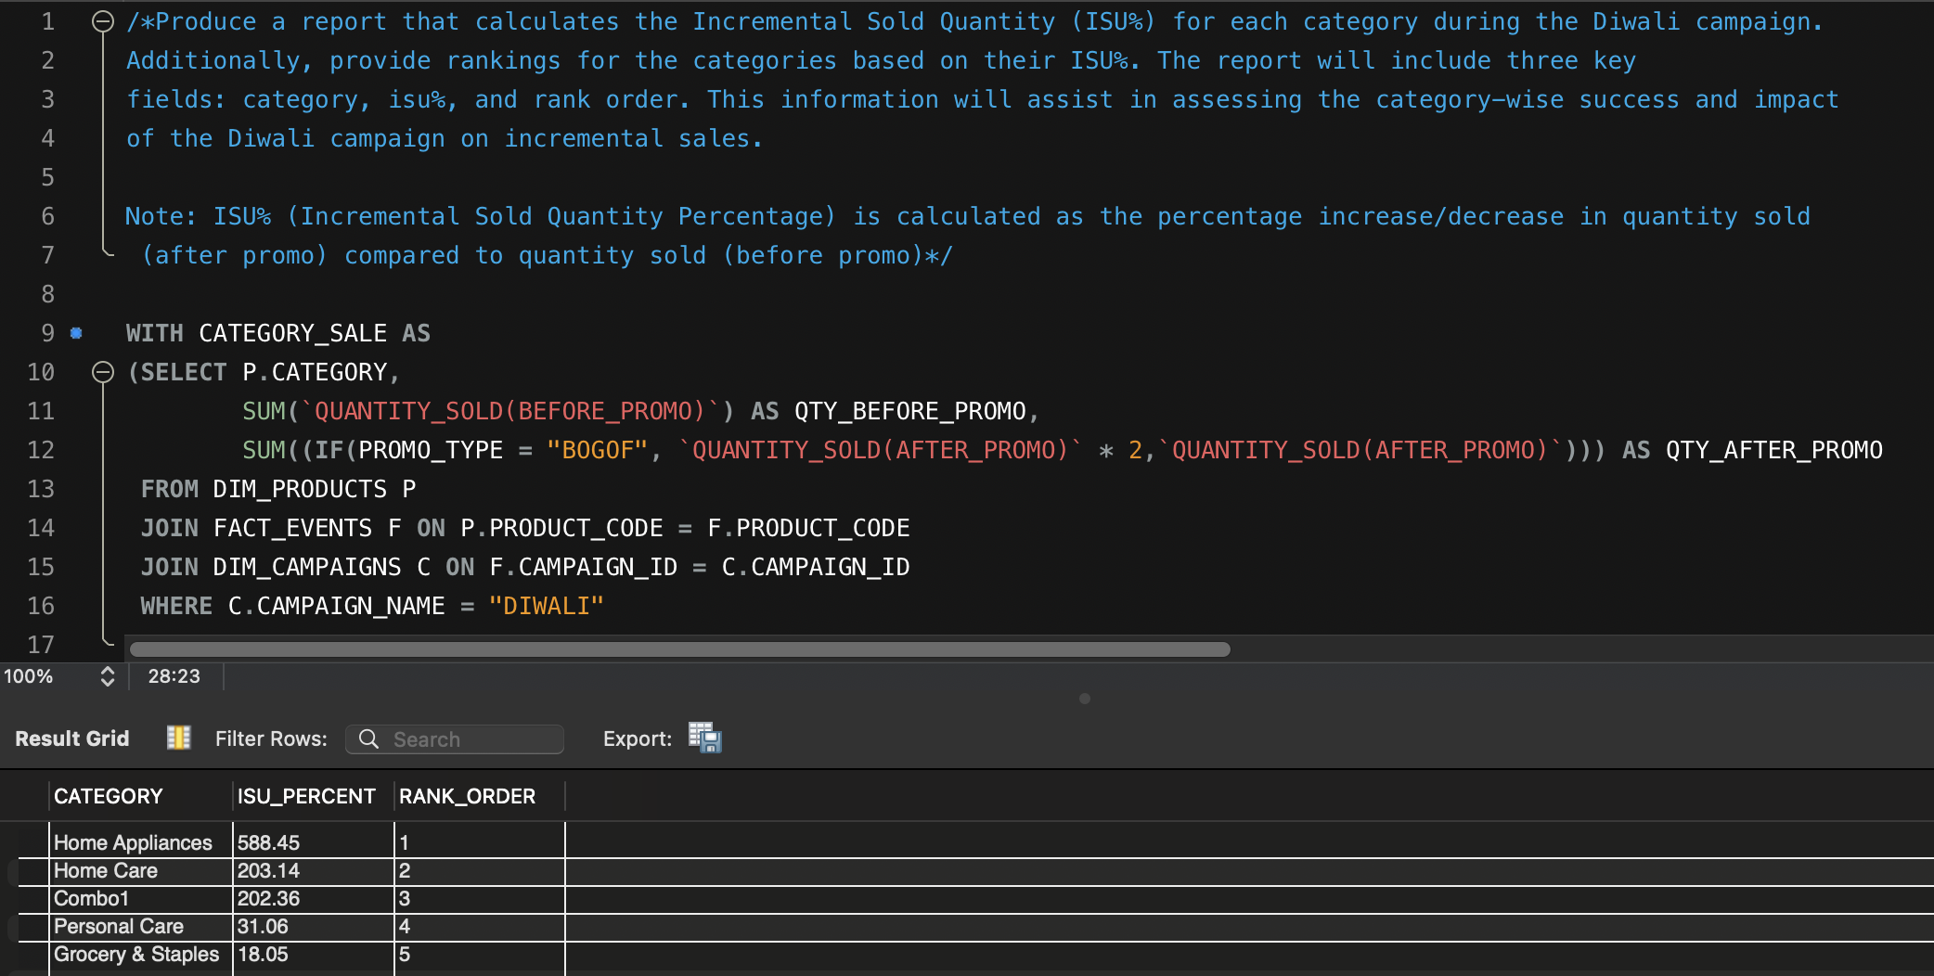

**Ad_Hoc_Request 5 :**

