I have used Spark - shell for all my the assignments , also attached the screen shots respectively

Checkpoint 1

Write a spark program to List top five IP address in terms of number of hits?

Answer( have attached snapshot of each check point respectively)

scala> val inputfile = spark.read.format("csv").
| option("Inferschema", "true").
| option("delimiter", " ").
| option("escape", "-").
| option("quote", "\"").
| load(“file:/Users/jayashree/ipaddress.txt")

scala> inputfile.createOrReplaceTempView(“hits")

scala> val hitsql = spark.sql("select _c0 as ipaddress, count(*) from hits group by _c0 order by count(_c0) desc")

scala> hitsql.show(5,false)
+--------------+--------+
|ipaddress |count(1)|
+--------------+--------+
|192.168.11.100|3 |
|192.168.11.102|2 |
|192.168.11.101|2 |
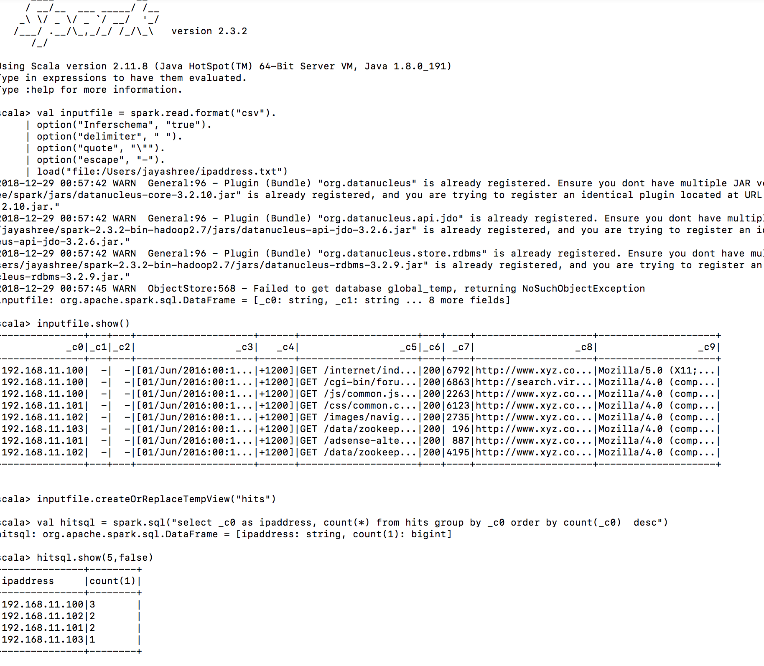
|192.168.11.103|1

Checkpoint 2
You have two data sets:
customer information(customer_id, email_id, language, location)
purchase information (transaction_id, product_id, customer_id, sell_price, item_description)
You need to write Spark/Spark SQL job to perform below analytics
a) Find locations in which sale of each product is max
b) Find customer who has purchased max number of items
c) Find customer who has spent max money
d) Find product which has min sale in terms of money
e) Find product which has min sale in terms of number of unit sold

a) Find locations in which sale of each product is max

scala> val dff = spark.sql("select distinct location, ItemDescrition, count(SellPrice) over(partition by location) max_product from customer, purchase where id = CustomerID”)

b) Find customer who has purchased max number of items

scala> val joinExpr = customer.col("id") === purchase.col(“CustomerId”)

scala> val df = customer.join(purchase, joinExpr)

scala> df.select(col("id"), col("ProductId"),col("first_name"), col("last_name")).groupBy("id","first_name","last_name").agg(
| count("ProductId").alias("max_purchased")).
| orderBy(desc(“max_purchased”)).show(1,false)

c) Find customer who has spent max money

scala> df.select(col("id"), col("SellPrice"), col("first_name"), col("last_name")).
| groupBy("id", "first_name", "last_name").agg(
| sum("SellPrice").alias("max_money")).
| orderBy(desc(“max_money”)).limit(1)

d) Find product which has min sale in terms of money

scala> spark.sql("select ProductId, round(sum(SellPrice),2) as min_sale from purchase group by ProductId order by sum(SellPrice)”).limit(1)

e) Find product which has min sale in terms of number of unit sold

scala> spark.sql("select ProductId, ItemDescrition, count(ItemDescrition) as min_item from purchase group by ProductId, ItemDescrition order by count(ItemDescrition)”).show(5,false)

Checkpoint 4
Below there is small DataFrame. You should use DataFrame API functions and UDFs to accomplish two tasks.
a) You need to parse the State and City into two different columns.
b) You need to get the number of days in between the start and end dates. Perform it in two ways.
i) Firstly, you should use SparkSQL functions to get this date difference.
ii)Secondly, you should write a UDF that gets the number of days between the end date and the start date.

a) You need to parse the State and City into two different columns.

scala> import org.apache.spark.sql.types.{StructField, StructType, StringType, LongType}

scala> val mySchema = StructType(Array(
| StructField("id", LongType, true),
| StructField("end_date", StringType, true),
| StructField("start_date", StringType, true),
| StructField("location", StringType, true)))
scala> val df = spark.read.format("csv").
| option("delimiter","|").
| option("header", "true").
| schema(mySchema).
| load(“file:/Users/jayashree/SparkSample/CP4.txt")

scala> val df = spark.read.format("csv").
| option("delimiter","|").
| option("header", "true").
| schema(mySchema).
| load(“file:/Users/jayashree/SparkSample/CP4.txt")

scala> val dff = df.withColumn("country", split(col("location"), "-").getItem(0)).
| withColumn("city", split(col("location"), “-“).getItem(1))

scala> dff.show()
+---+-------------------+-------------------+--------+-------+----+
| id| end_date| start_date|location|country|city|
+---+-------------------+-------------------+--------+-------+----+
| 1|2015-10-14 00:00:00|2015-09-14 00:00:00| CA-SF| CA| SF|
| 2|2015-10-15 01:00:20|2015-08-14 00:00:00| CA-SD| CA| SD|
| 3|2015-10-16 02:30:00|2015-01-14 00:00:00| NY-NY| NY| NY|
| 4|2015-10-17 03:00:20|2015-02-14 00:00:00| NY-NY| NY| NY|
| 5|2015-10-18 04:30:00|2014-04-14 00:00:00| CA-SD| CA| SD|
+---+-------------------+-------------------+--------+-------+----+

scala> dff.drop(col("location")).show()
+---+-------------------+-------------------+-------+----+
| id| end_date| start_date|country|city|
+---+-------------------+-------------------+-------+----+
| 1|2015-10-14 00:00:00|2015-09-14 00:00:00| CA| SF|
| 2|2015-10-15 01:00:20|2015-08-14 00:00:00| CA| SD|
| 3|2015-10-16 02:30:00|2015-01-14 00:00:00| NY| NY|
| 4|2015-10-17 03:00:20|2015-02-14 00:00:00| NY| NY|
| 5|2015-10-18 04:30:00|2014-04-14 00:00:00| CA| SD|
+---+-------------------+-------------------+-------+----+

b) You need to get the number of days in between the start and end dates. Perform it in two ways.
- Firstly, you should use SparkSQL functions to get this date difference.

scala> dff.withColumn("date_diff", (unix_timestamp($"end_date") - unix_timestamp($”start_date"))).show()

Or

scala> dff.select(datediff(col("end_date"), col("start_date"))).show()

ii)Secondly, you should write a UDF that gets the number of days between the end date and the start

import java.time.format._
import org.apache.spark.sql.functions.udf
import java.time.temporal._
import java.time._

scala> def date_diff(end_date: String, start_date:String): Long = {
| val formatter = DateTimeFormatter.ofPattern("yyyy-MM-dd HH:mm:ss")
| val dt1 = LocalDateTime.parse(end_date, formatter)
| val dt2 = LocalDateTime.parse(start_date, formatter)
| val days = ChronoUnit.DAYS.between(dt2,dt1)
| return days
| }

scala> val datediffudf = udf(date_diff(_:String, _:String):Long)

scala> df.select(datediffudf(col("end_date"), col("start_date"))).show()

Checkpoint 3
Design below feature which should be scalable, re-usable, extensible and reliable-
** Data in TB size is stored in HDFS from some source (Assume it is of log data)
** Read above data from HDFS and perform transformation
** Save above transformed data into Kafka Topic
-- Main problem to work is as below:
When you are reading data from HDFS using your job, then their may be failure due to any reason, then how will your job ensure that when it will be up again, it will start reading from the same last point where failure happens
** Whether your solution will be batch processing or stream processing based.Give justification

Answer

We can ensure Job to read data from HDFS after recovery by offset management , offsets in the application is used to control the position of data read by the jobs.
It can be achieved by enabling Spark Streaming checkpoint or storing offsets in ZooKeeper.

Spark APIs allows us to have control over storing offsets before and after periodic reads or processing.
Streaming checkpoint are designed to save the state of application, so that we can recover the data read upon failure.
Zookeeper allows offsets to be stored by user providing reliable method for starting stream processing after failure recovery

