Name : Jayashri Ishwar Dadmal centre:KH

Module :Concepts of Operating System

**Assignment 2**

**Part A**

What will the following commands do?

* echo "Hello, World!"
* It will print Hello, World!

• name="Productive"

* This command name="Productive" will create a string variable with name name and productive word is goint to store in it.
* When we do Echo $name

Output:-Productive

• touch file.txt

* This command will create the file with name file.txt

• ls -a

* List all files and directories in Alphabetical order.

Because of ‘-a ‘ option entries starting with ‘. .. ‘ are also printing at output i.e.all hidden files are also printed

• rm file.txt

* Remove file.txt from given directory

• cp file1.txt file2.txt

* Copy the content of file1.txt into file2.txt

• mv file.txt /path/to/directory/

* move files and directories from one directory to another or to rename a file or directory.In this file.txt will move in specified directory.

• chmod 755 script.sh

* This command will change the permission of user as all, for group it would be read and execute and for others also read and execute for file script.sh

• grep "pattern" file.txt

* This command will search for lines matching a word “ pattern “and print the matching lines to standard output.

Ex.file.txt

Code:

Pattern on the screen is nice.

This is nice pattern.

I like this.

Output:- Pattern on the screen is nice.

This is nice pattern.

• kill PID

* This command will terminate a running process on a computer by specifying its Process ID (PID)

• mkdir mydir && cd mydir && touch file.txt && echo "Hello, World!" > file.txt && cat file.txt

* && (logical AND) operator is used here which enables the user to run multiple commands in single command. mkdir will make directory with name mydir .&& operator will execute command 2 i.e. cd mydir if command 1 i.e. mkdir mydir executed successfully and then after cd mydir command touch file.txt will execute which will create file with name file.txt. after this "Hello, World!" will append in file.txt and then cat file.txt will print the contain of file.txt
* output :- Hello, World!

• ls -l | grep ".txt"

* ls -l command print the list of all files in directory but because of pipelining with grep “.txt” it will list files with .txt

• cat file1.txt file2.txt | sort | uniq

* Because of pipelining with sort and uniq command.

content of file2.txt and content of file1.txt are produces with sorted and unique manner .

• ls -l | grep "^d"

* ls command list the files and directories. grep "^d" command filters the output to show only lines that start with "d" which in the ls -l output indicates directories.

• grep -r "pattern" /path/to/directory/

* Here grep-r command recursively search “pattern” in given directory. The lines which contain “pattern” will be printed.

• cat file1.txt file2.txt | sort | uniq –d

* cat file1.txt file2.txt command will print content of file1 followed by content of file2.txt and sort command will sort the as it is pipe lined there.
* Uniq -d will only print duplicate lines, one for each group

• chmod 644 file.txt

* This command will change the mode of permission of user ,group and others.
* Here chmod 644 file.txt will allow user to read and write and for group and other it will be read permission for file.txt

• cp -r source_directory destination_directory

* This command will recursively copy the source_directory into destination_directory

• find /path/to/search -name "*.txt"

* This command is use to search the directories and file ending with *.txt

• chmod u+x file.txt

* this command will give execution permission of file file.txt to user.

• echo $PATH

* This command displays the value of system environment variable that stores directories where executable programs are located.

**Part B**

**Identify True or False:**

1. **ls** is used to list files and directories in a directory.

**:- True**

1. **mv** is used to move files and directories.

**:- True**

1. **cd** is used to copy files and directories**.**

**:- False ,** cd is use to change the directory.

1. **pwd** stands for "print working directory" and displays the current directory**.**

: **-True**

1. **grep** is used to search for patterns in files.

:-**True**

1. **chmod 755 file.txt** gives read, write, and execute permissions to the owner, and read and execute permissions to group and others.

**:- True**

1. **mkdir -p directory1/directory2** creates nested directories, creating directory2 inside directory1 if directory1 does not exist.

**:- True**

1. **rm -rf file.txt** deletes a file forcefully without confirmation.

**:- False**

**Identify the Incorrect Commands:**

1. **chmodx** is used to change file permissions**.**

* **chmod** is used to change file permissions**.**

1. **cpy** is used to copy files and directories.

* **cp** is used to copy files and directories.

1. **mkfile** is used to create a new file.

* **touch** command is use to create a new file and **mkdir** is use to create new directory.

1. **catx** is used to concatenate files.

* **cat** is used to concatenate files.

1. **rn** is used to rename files.

* **mv** command is use to rename the file when file names are pass as arguments.

**Part c**

**Question 1:** Write a shell script that prints "Hello, World!" to the terminal.

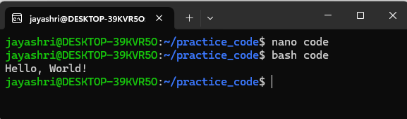

Code:-echo Hello,world!

**Question 2:** Declare a variable named "name" and assign the value "CDAC Mumbai" to it. Print the value of the variable.

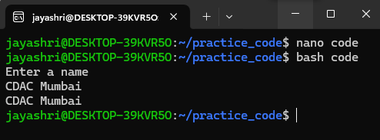

Code :

echo “Enter a name”

read name

echo $name

**Question 3:** Write a shell script that takes a number as input from the user and prints it.

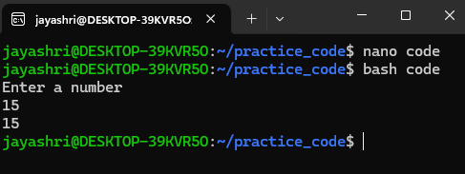

Code:

echo “Enter a number”

read num

echo $num

**Question 4:** Write a shell script that performs addition of two numbers (e.g., 5 and 3) and prints the result.

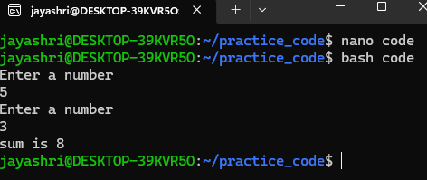

Code:

echo "Enter a number"

read num1

echo "Enter a number"

read num2

result=` expr $num1 + $num2 `

**Question 5:** Write a shell script that takes a number as input and prints "Even" if it is even, otherwise prints "Odd".

Code:

echo “Enter a number”

read $num

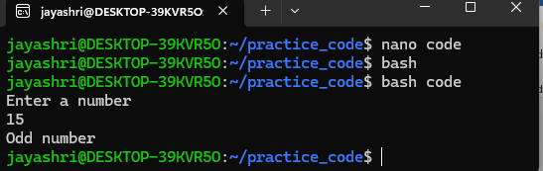

If (( $num % 2 == 0 ))

then

echo Even Number

else

echo Odd Number

fi

**Question 6:** Write a shell script that uses a for loop to print numbers from 1 to 5.

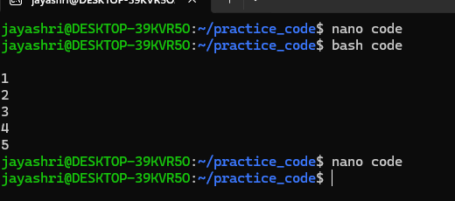

Code:

for(( i=1 ; i<=5 ; i++))

do

echo $i

done

**Question 7:** Write a shell script that uses a while loop to print numbers from 1 to 5.

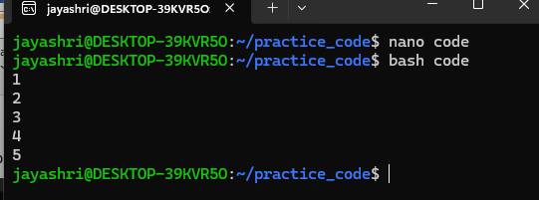

Code:

i=1

while [ $i -le 5 ]

do

echo $i

i=` expr $i +1 `

done

**Question 8:** Write a shell script that checks if a file named "file.txt" exists in the current directory. If it does, print "File exists", otherwise, print "File does not exist".

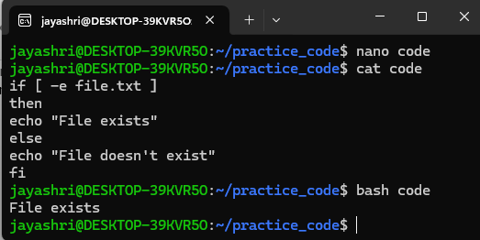

**Question 9:** Write a shell script that uses the if statement to check if a number is greater than 10 and prints a message accordingly.

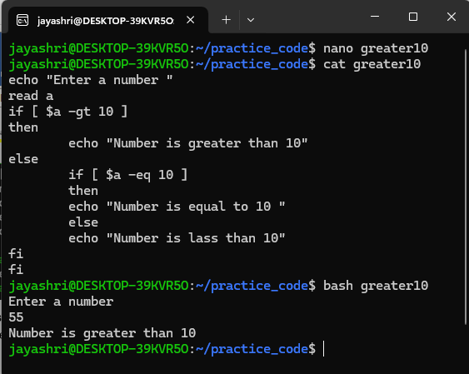

**Question 10:** Write a shell script that uses nested for loops to print a multiplication table for numbers from 1 to 5. The output should be formatted nicely, with each row representing a number and each column representing the multiplication result for that number.

