# Exercise: Distributing content with cloudFront

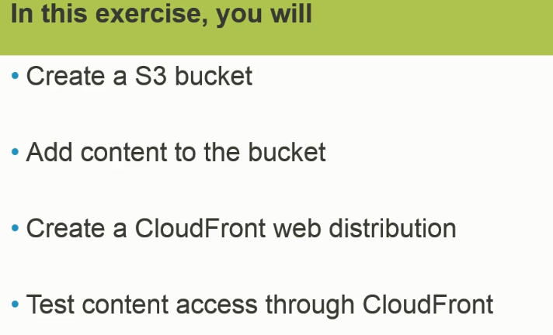

Create S3-> create Folder -> Upload a content (Files) -> Go To CloudFront ->Click on Create Distribution -> Under **WEB** select “Get Start”

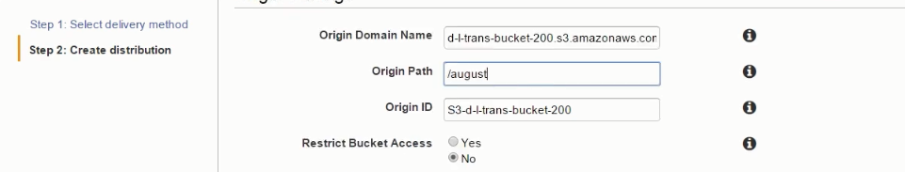



Price content : Select US and Europe

Finally click on **create Distribution**.

Click on the ID



Choose Domain Name for testing the access.

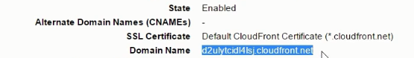

Make sure files uploaded in S3 accessible.

Finally copy Domain name from CloudFront and then paste in new browser and test it.