Project Report

INT 375
EDA Project

LOVELY PROFESSIONAL UNIVERSITY PHAGWARA, PUNJAB


Vehicle Registration Analysis

SUBMITTED BY- JAYA SINHA
Registration Number: 12309441
Section– K23EC
Roll no- 37

DECLARATION
I, Jaya hereby declare that the work done by me on “Vehicle Registration Analysis” is record of original work for the partial fulfillment of the requirements for the award of the degree of Bachelor of Technology in Computer Science- Data Science, Lovely Professional University, Phagwara.

Signature Signature:
Name: JAYA SINHA VIKAS MANGOTRA
Reg No: 12309441 UID: 31488

ACKNOWLEDGMENT

First and foremost, I would like to express my deepest gratitude to my college for providing me with the opportunity and resources to undertake this project.
I extend my sincere thanks to my teacher, SIR VIKAS MANGOTRA, for his invaluable guidance, constructive feedback, and constant encouragement throughout the project. Her expertise and support were instrumental in achieving the objectives of this work.
Thank you all

TABLE OF CONTENT
- Abstract
- Introduction
- Methodology
- Results and analysis
  - Key Findings
  - Visualizations and Tables
  - Interpretation of Results

Conclusion
- References
  - Cited Papers,
  - Articles, and Resources

- Dataset link :
https://catalog.data.gov/dataset/motor-vehicle-registrations-dashboard-data

Vehicle Registration Analysis EDA Report

1. Abstract:
In this project, I performed an Exploratory Data Analysis (EDA) on a dataset containing motor vehicle registrations in the United States from 1900 to 2020. The data includes the number of registered Automobiles, Buses, Trucks, and Motorcycles for each state and year. The main goal was to understand how vehicle registrations have changed over time and across different states. I used various charts and summary statistics to identify trends, patterns, and any unusual data points

2. Introduction:
This project focuses on analyzing a dataset that contains motor vehicle registration data from different U.S. states, spanning from the year 1900 to 2020. The dataset includes yearly records for four main types of vehicles: Automobiles, Buses, Trucks, and Motorcycles. By exploring this data, we can better understand how vehicle ownership has evolved over time, how different states compare in terms of vehicle registration, and what trends or changes occurred during specific periods, such as economic booms or recessions. This kind of analysis can give useful insights into the history of transportation and regional development across the United States.

3. Methodology:
The dataset was loaded using Pandas.
- Missing values were handled by dropping rows where all three salary-related columns were null.
- Numeric conversion was applied to total vehicle.
- Exploratory Data Analysis (EDA) was performed to understand patterns, distributions, and outliers.
- Visualizations were created using Sea born and Matplotlib to support analysis.

4. Results and Analysis
Data Coverage:
The cleaned dataset includes records from U.S. states, giving a broad view of vehicle registration trends across the country from 1900 to 2020.

- Total Vehicle Registrations:
A total of approximately vehicle registrations were recorded across all years and states. This includes Automobiles, Buses, Trucks, and Motorcycles.
- Top Years for Registrations:
The bar chart showing the top 20 years by total vehicle registrations reveals that the most recent years (especially in the 2000s and 2010s) saw the highest number of vehicles registered, showing a clear upward trend in motorization over time.
- Top States for Registrations:
States like California, Texas, and Florida (most likely in the top 10) had the highest overall vehicle registrations. This aligns with their large populations and urban development.
- Trends by Vehicle Type:
The line graph of vehicle types over the years showed that:
- Automobiles consistently dominate registrations.
- Truck registrations have shown a steady increase.
- Motorcycle and Bus registrations are relatively low compared to Autos and Trucks, but Motorcycles show more variation across states.
- Vehicle Type Share (Overall):
The pie chart highlighted that Automobiles account for the largest share of registrations, followed by Trucks, Motorcycles, and lastly Buses.
- Motorcycle Hotspots:
The top 10 states for motorcycle registrations were also plotted. These states are likely known for either rural geography, recreational riding culture, or high population.
- Most Registered Vehicle Type:
Based on total counts, most common type was identified as the most registered vehicle type in the dataset.
5. Visualizations and Interpretation
- Visualization 1: Bar Plot – Top 10 Years by Total Vehicle Registrations
Visualization: Bar chart showing the 10 years with the highest total vehicle registrations.
Interpretation:
This helps you identify which years had the most vehicle activity.
A peak in recent years could indicate rising population, urbanization, or economic growth.
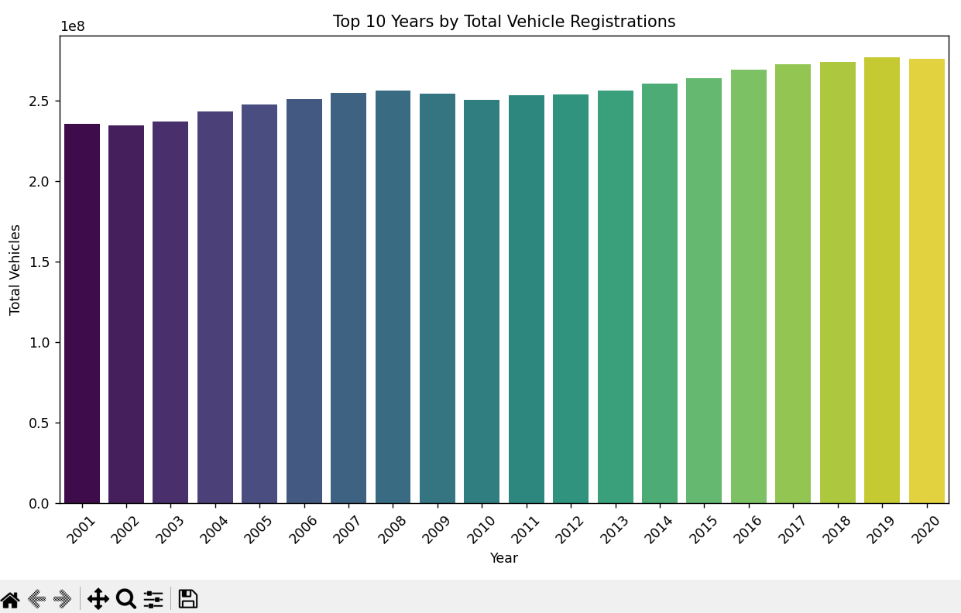

- Visualization 2: Bar Plot – Top 10 States by Total Vehicle Registrations
Visualization: Horizontal bar chart of top 10 states with the most total vehicle registrations.
Interpretation:
These states are likely to have higher populations or major cities.
They may also have better road infrastructure and vehicle ownership rates.
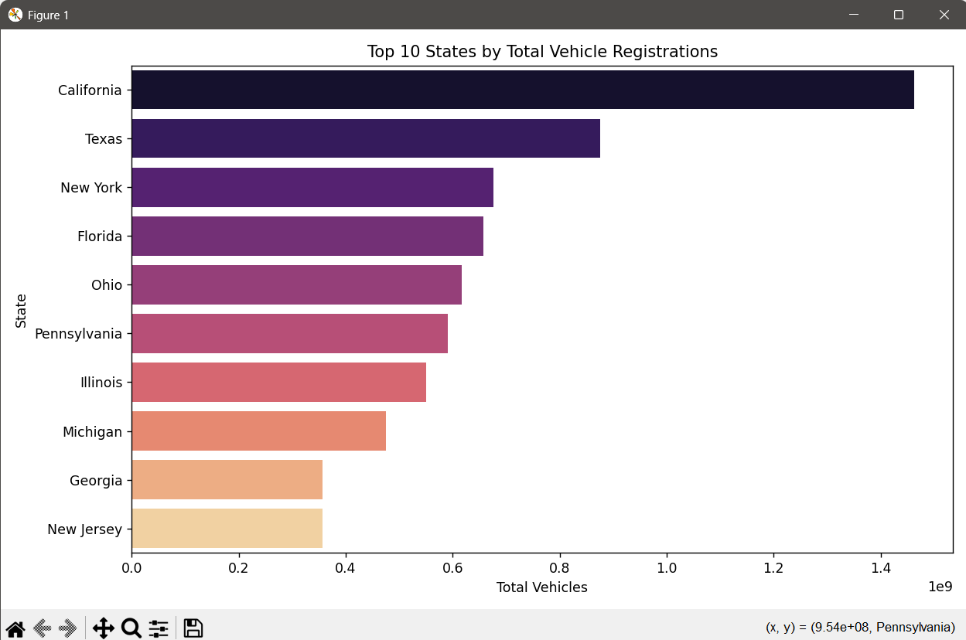

3. Visualization 3: Line Plot – Trend of Vehicle Types Over the Years
Visualization: Line plot showing the trend for each vehicle type (Auto, Bus, Truck, and Motorcycle) across years.
Interpretation:
It shows how each vehicle category is increasing or decreasing over time.
For example, motorcycles may show consistent growth, indicating they are affordable and popular.
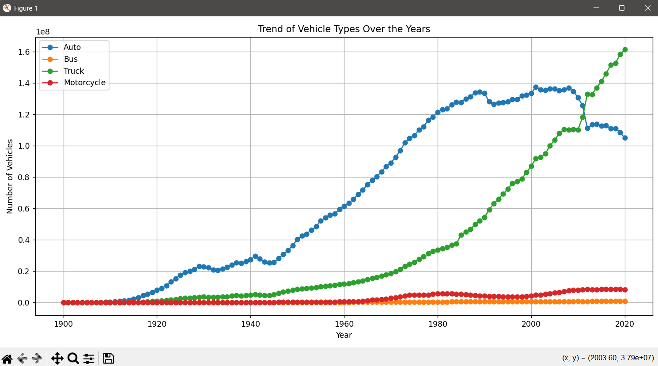

Visualization 4: Pie Chart – Vehicle Type Share (Overall)
Visualization: Pie chart showing the share (%) of each vehicle type across the entire dataset.
Interpretation:
Gives a quick idea of the most common vehicle type.
If motorcycles take the largest share, it shows they dominate Indian roads.
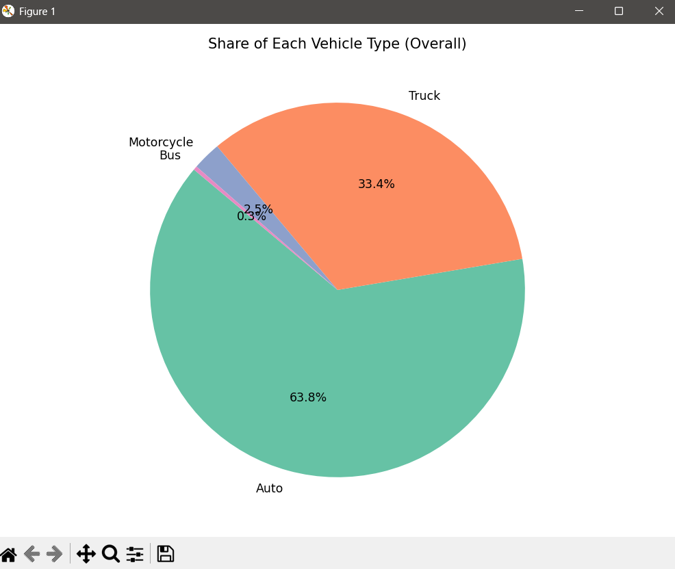

Visualization 5: Bar Plot – Top 10 States by Motorcycle Registrations
Visualization: Horizontal bar chart focusing on motorcycle registrations by state.
Interpretation:
Highlights which states rely heavily on motorcycles, perhaps due to lower income levels or congested urban areas.
These insights can help policymakers target two-wheeler infrastructure development.
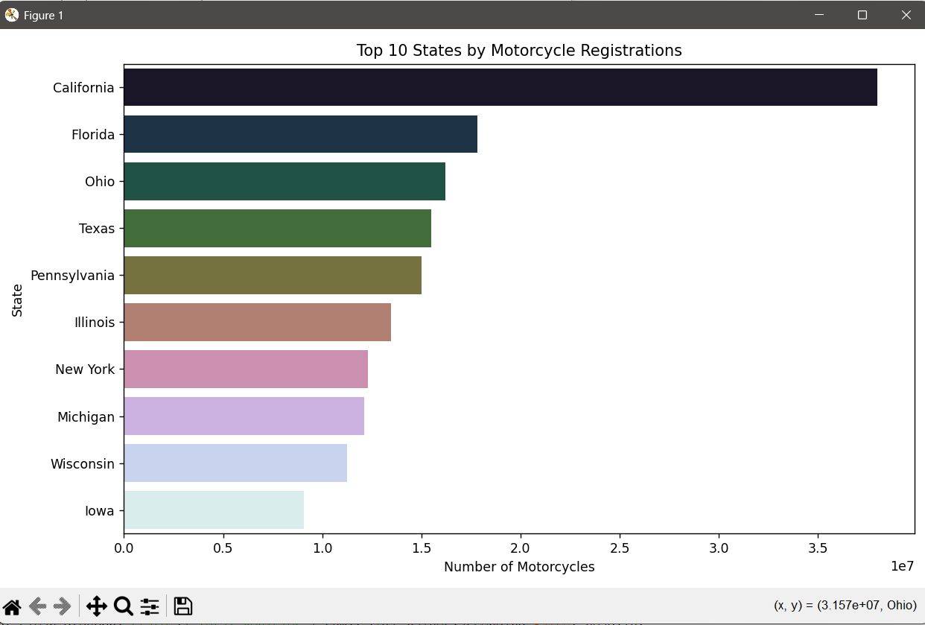

6. Conclusion
The primary goal of this EDA project was to uncover meaningful patterns, trends, and anomalies in motor vehicle registration data. Through systematic data cleaning, summary statistics, and visualizations, we explored how vehicle registrations vary over time and across states. Key insights included identifying the most and least registered vehicle types, top-performing states, and registration trends over the years. This analysis lays the groundwork for deeper investigations, such as forecasting trends or analyzing the impact of policy changes on vehicle usage.

7. References
- Pandas Documentation:
(https://pandas.pydata.org/docs/)
- Matplotlib Documentation:
(https://matplotlib.org/stable/contents.html)
- Seaborn Documentation :
(https://seaborn.pydata.org/)

8. GitHub & LinkedIn
- GitHub Repository:
https://github.com/jayasinha05/vehicle-registration-Analysis-EDA-Report
- LinkedIn:
https://www.linkedin.com/posts/jaya-sinha-a833ba299_dataanalytics-python-eda-activity-7316875544824856576-7jgo?utm_source=share&utm_medium=member_android&rcm=ACoAAEgj-IMBvc-wJBaOk0wjmxHt_qsXukvovHg

