# TEAM: ESCAPING VELOCITY

**NEAR-SPACE NEAR YOU!**

**HIGH ALTITUDE BALOONS:**

These fond of balloons can fly in Higher altitude than all other common balloon. Rather than the common helium balloons these are used in **telecommunications and space tourism**. Private companies such as ***zero2infinity*** and ***World View Enterprises*** are developing both crewed and uncrewed high-altitude balloons for scientific research, commercial purposes, and space tourism.

**BENEFITS OF HAB:**

* can be launched from locations worldwide to support scientific needs.
* can be readied for flight in as little as six months.
* offer a low-cost method of conducting science investigations.
* provide a stable platform for longer flight durations.

**PAYLOADS:**

The payloads include scientific experiments on organisms, equipment to study radiation, temperature, ultra- violet radiation, and pressure. The balloon flights and experiments are logged by means of video devices and are tracked from the ground through multiple tracking devices.

* GPS(Global positioning system)
* Camera
* Working or research materials
* Parachute

**CHALLENGES TO BE FACED:**

Though it as easy and cheapest way, it has some challenges as follows:

* surviving the mechanical rigors of the flight such as potential jet stream turbulence on ascent, fall-induced turbulence during the descent, and a parachute landing.
* operating successfully in the harsh conditions of nearspace including low pressure, low temperature, and high cosmic radiation levels.
* Tracking the flight using GPS-enabled system.
* recovering the payloads safely from all sorts of *terrain*, including *trees*, *tall crops*, and open *water* includes *power lines*.
* ­analysing the experimental data, most of which is logged on-board rather than being transmitted to the ground during the flight.

**TRAVELLING LOCATIONS AND TEMEPRATURES:**

The balloons ascend through the Tropopause then into the Stratosphere. The Tropopause is the area between the Troposphere and the Stratosphere. The Troposphere starts about 6km and continues until about **12km**, with temperatures ranging from **62°F to -60°F**. The Tropopause is the boundary separating the lower layer of the atmosphere (**troposphere**). The altitude of the tropopause varies according to sea-surface temperature and season, but also over shorter periods, from an average of **10–12 km** over the North and South poles to **17 km over the equator**.

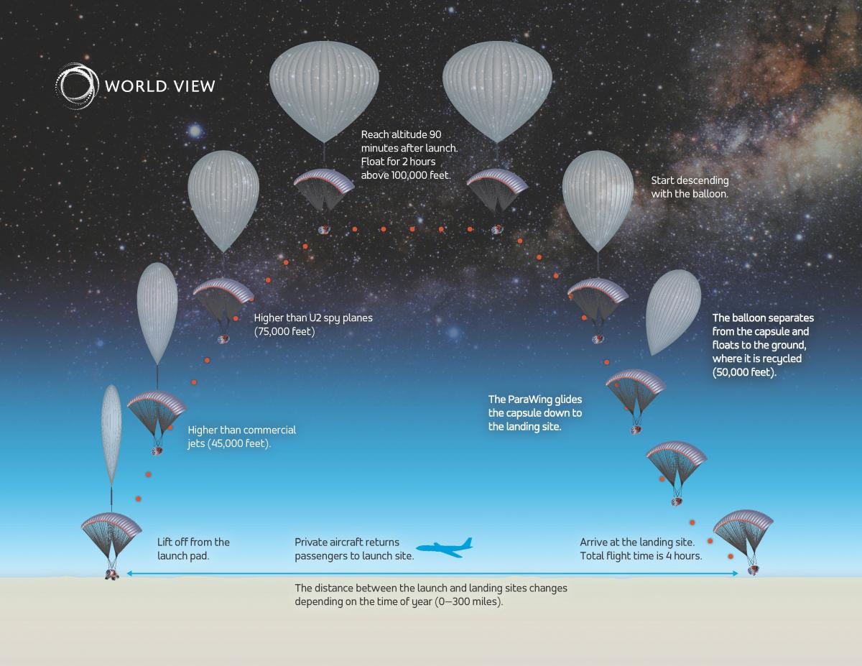

**MATERIALS:**

scientific balloons are constructed of polyethylene film; the same type material used for plastic bags. This material is only 0.002 centimetres (0.0008 inches) thick, about the same as an ordinary sandwich wrap. The film is cut into banana-peel shaped sections called gores and heat sealed together to form the balloon. These standard, zero-pressure, balloons are open to the atmosphere at the bottom to equalize the internal pressure with the surroundings. The balloon system includes the balloon, the parachute and a payload that holds instruments to conduct scientific measurements.GAS FILLING PROCESS:

Helium, the same gas used to fill party balloons, is used in these fond of balloons. These very large balloons can carry a payload weighing as much as 3,600 kilograms (8,000 pounds), about the weight of three small cars. They can fly up to 42 kilometres (26 miles) high and stay there for up to two weeks.

**FACTORS THAT CAUSE TEAR IN BALOON:**

capabilities are being expanded with the development of an Ultra Long Duration Balloon (ULDB). The ULDB is made of advanced materials and uses a new pumpkin-shaped balloon design to achieve flights of up to 100 days.

ULDB:

**Ultra- Long Duration Balloon** is completely sealed and pressurized in order to maintain constant altitude night and day. The ULDB payload consists of a solar power system, radio receivers and transmitters, computers, batteries and other systems required for science experiments. The balloon is launched by partially filling it with helium and launched with the payload section suspended beneath it. As the balloon rises, the helium expands, filling the balloon until it reaches float altitude in two to three hours.

**SEPERATION OF PAYLOADS:**

After the science measurements are complete, flight controllers send a radio command that separates the payload from the balloon. The payload floats back to the ground on a parachute where it can be retrieved and flown again. Payload separation creates a large tear in the balloon material, which releases any remaining helium. The balloon also falls to the ground, where it’s retrieved and discarded. The balloon and payload land approximately 45 minutes after separation.

