**Creating a Database using MongoDB and Mongosh**

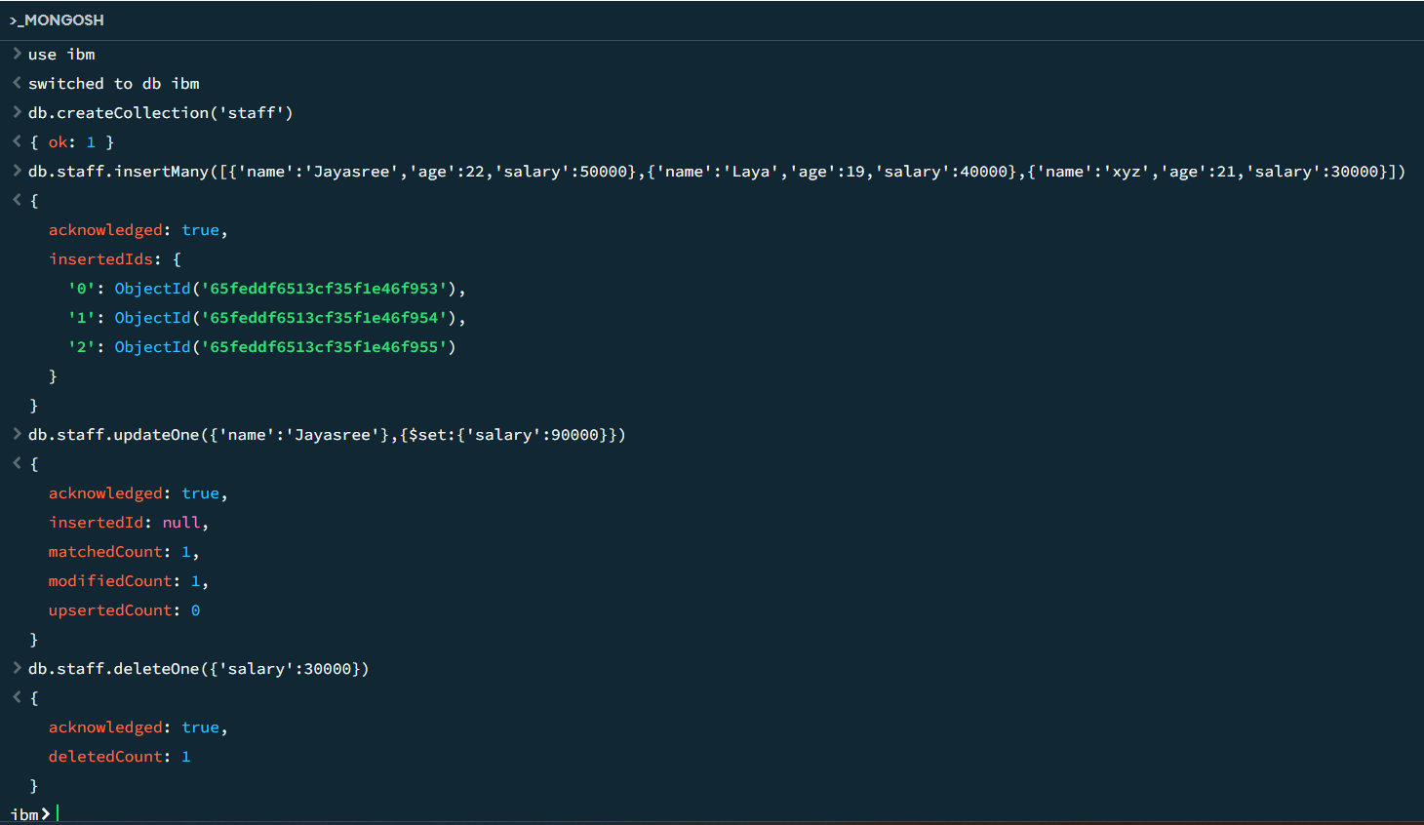

**Document insertion**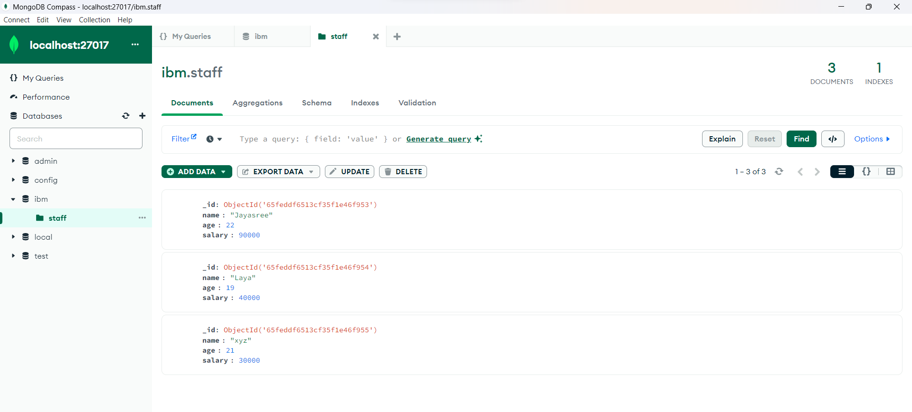

**Update Operation**

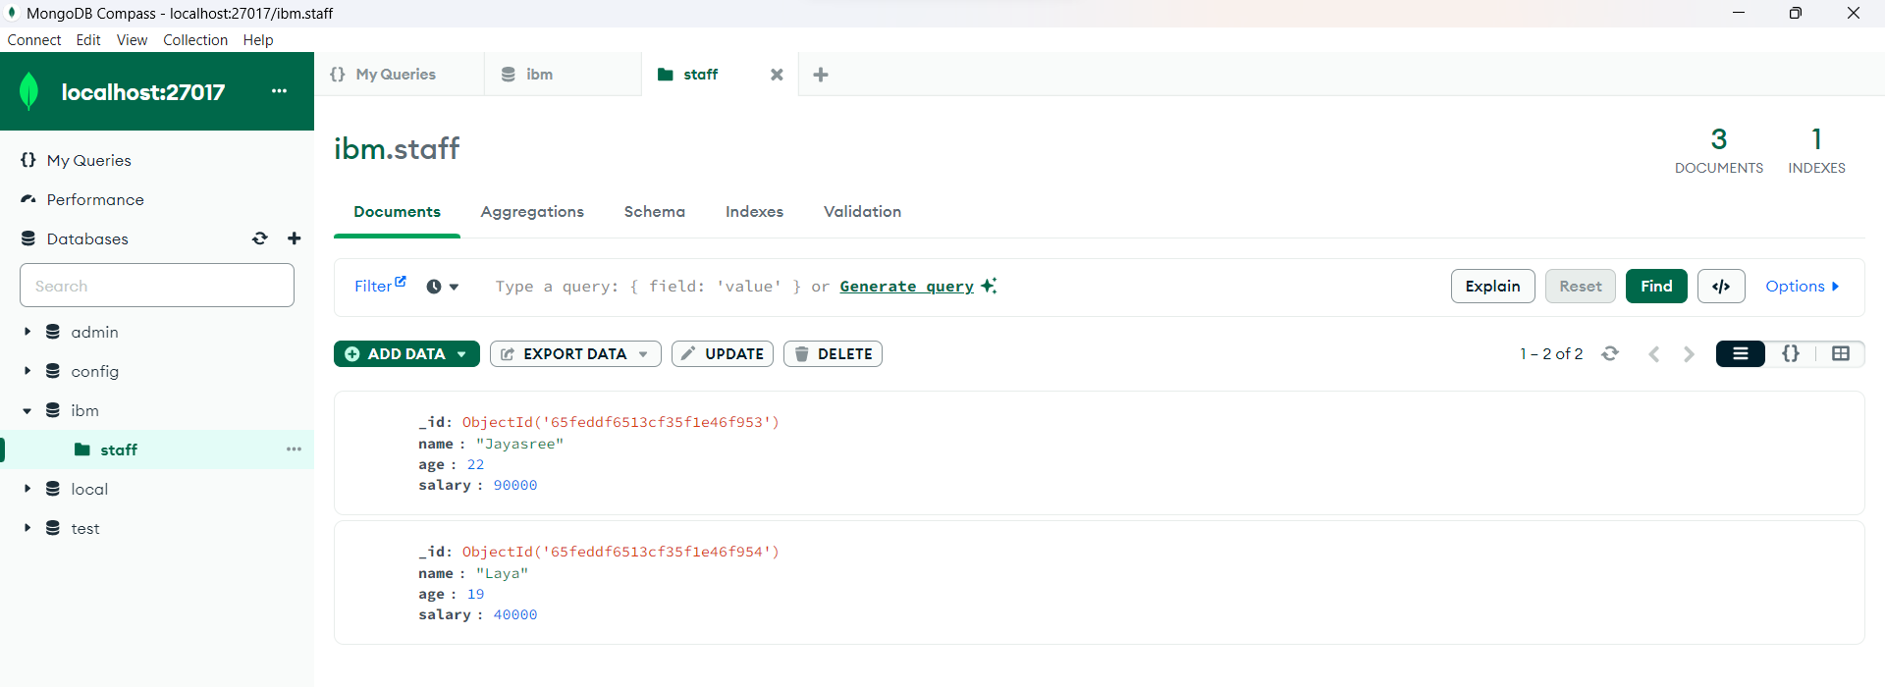

**Delete Operation**



**Index Creation**

