**Assignment-9.2**

1. Explain the working of below pig script commands with an example :

1. LOAD-Load command is used to load the corresponding file into the destined file.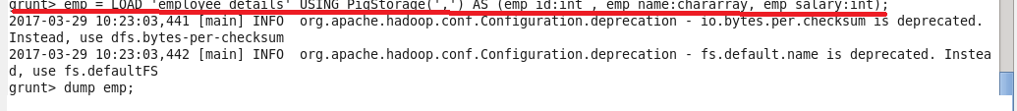

2. STORE-Store command is used to store the given file in the destined name

Just we are copying ,employee_details text file into pig, with this we are performing all functions using this text file.

Employee details file:

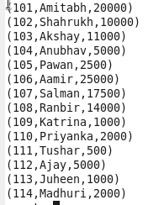

Store command to store the content of emp_salary into the file empsalary



Output showing that the file is saved into empsalary

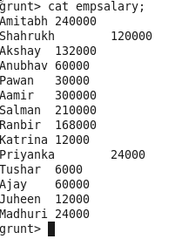

3. DUMP-dump is used to display the content of the file

COMMAND:C:\Users\612912\Documents\dumpcmd.png

OUTPUT:

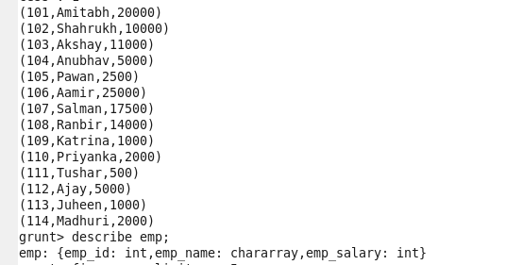

4. FOREACH -The **FOREACH** operator is used to generate specified data transformations based on the column data.

COMMAND:

C:\Users\612912\Pictures\foreach.PNG

5. Filter-Filter command is used to select specified data based on the given criteria

COMMAND:Here it filers the data based on name starts with ‘a’

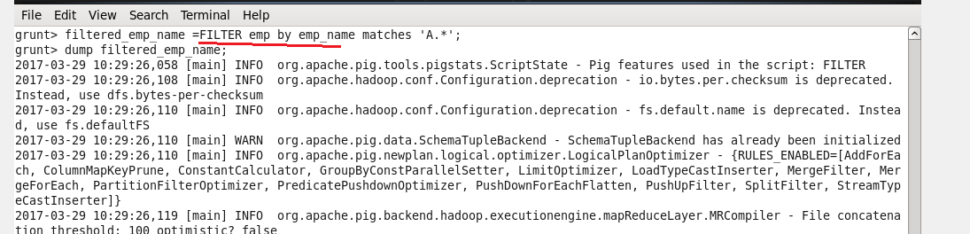

Output:

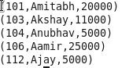

6. GROUP BY –this command is used to group the given data file based on the column data

Command:

C:\Users\612912\Pictures\group by.PNG

Here the data is grouped by employee rating

Output:

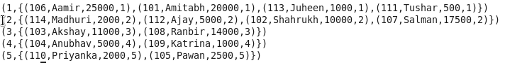

7. ORDER BY-this command is used to display the content in certain order which is specified by the user

Command:

C:\Users\612912\Pictures\order by cmd.PNG

Here the data is displayed in the descending order of the salary.

Ouput:

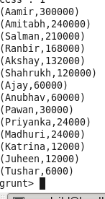

8. DESCRIBE-this command describe the column data and its data type

C:\Users\612912\Pictures\dump.PNG