**Ass-10.1**

1. Write a program to implement wordcount using Pig.

Program to implement word count

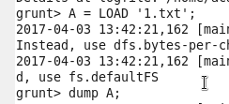

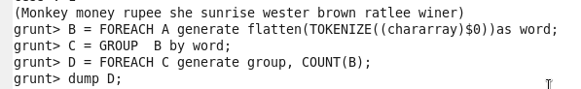

1. At first we are loading the text file to be counted into pig,here 1.txt file is loaded into A.
2. Then if there is any bag it reduces into tupple which contains chararray
3. These words are then grouped together
4. Then the number of words in the group is counted using count and it is stored in D
5. Then the content of D is dumped

OUTPUT:

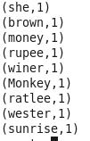

Here this gives the count of words in this text file.