**ASS-10.3**

(a)Top 5 employees (employee id and employee name) with highest rating. (In case two employees have same rating, employee with name coming first in dictionary should get preference)

PIG SCRIPT: here we are ordering the employees by rating and then by the name in case of multiple employees on same rating,the top 5 is limited from the order

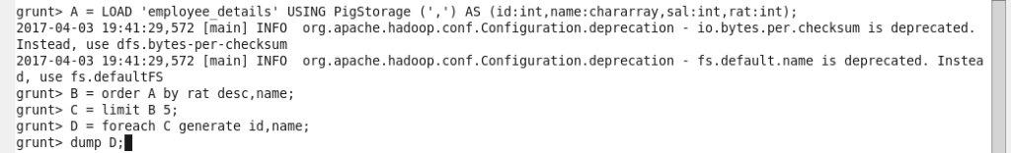

Output terminal:

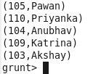

(b)Top 3 employees (employee id and employee name) with highest salary, whose employee id is an odd number

PIG SCRIPT: here at first id with odd no is filtered and then grouped in descending order based on their salary ,from them the top 3 emloyees are selected by using limit fn

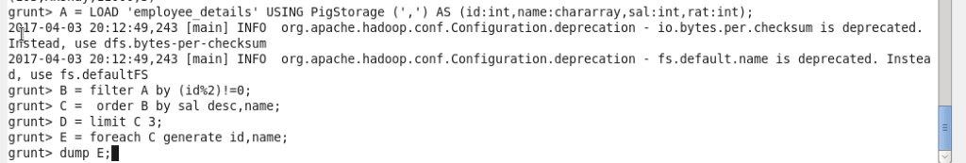

Output terminal:

C:\Users\Jayachandran\Desktop\asg pics\10.3.2 cmd.jpg

(C)Employee (employee id and employee name) with maximum expense

PIG SCRIPT: here the expenses are and the employee details are in two files,so at first both the files are joined together and then ordered by expenses then the highest expensing employee name is filteredhere here 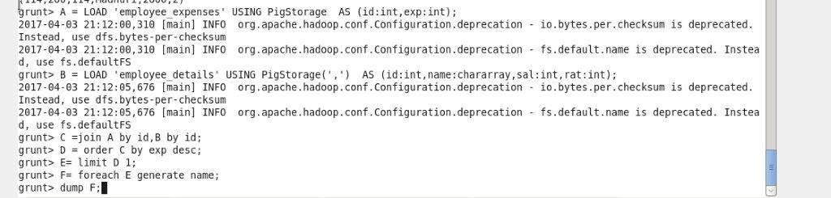

OUTPUT TERMINAL: C:\Users\Jayachandran\Desktop\asg pics\10.3.3 op.jpg

(d)List of employees (employee id and employee name) having entries in employee_expenses file.

PIG SCRIPT:by using inner join we can find out the employees who have entries in expenses.

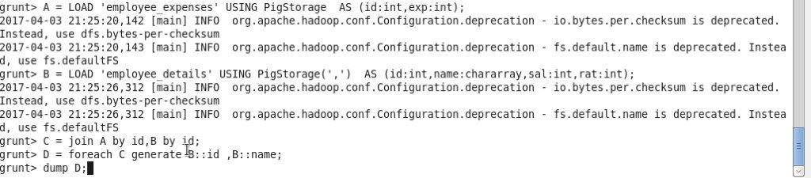

OUTPUT TERMINAL:

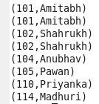

(e)List of employees (employee id and employee name) having no entry in employee_expenses

PIG SCRIPT: by using cogroupat first both the files are joined and the empty files are checked by using isempty and those employee id and names are filtered by 