**ASS-10.5**

QN1.Write a pig script to find the top 20 destination people travel the most

PIG SCRIPT:

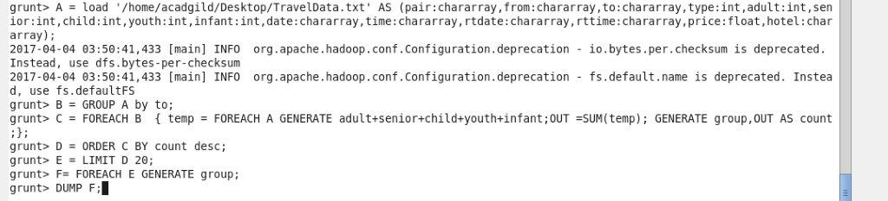loading the data set ,then group the data by destination place. Then for each destination the count of people is calculated and then the destination is ordered from highest to the lowest ,Then the top 20 destination is limited and their destinations are given as result

OUTPUT TERMINAL:

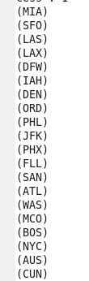

QN2. Write a pig script to find the top 20 locations from where people travel the most

PIG SCRIPT:this is similar to previous question only that it shows only the from location

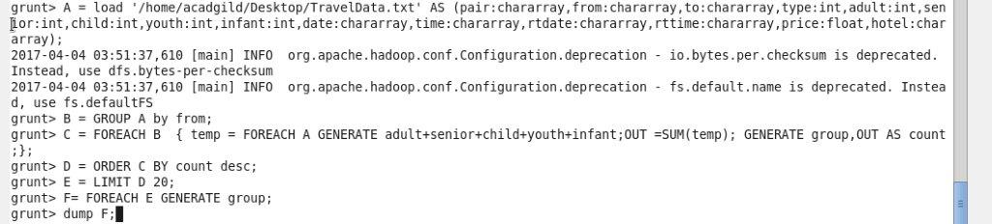

OUTPUT TERMINAL:

