**ASS-10.6**

1.Write a pig script to find the minimum temperature observed in a given weather station in a particular year.

PIG SCRIPT:

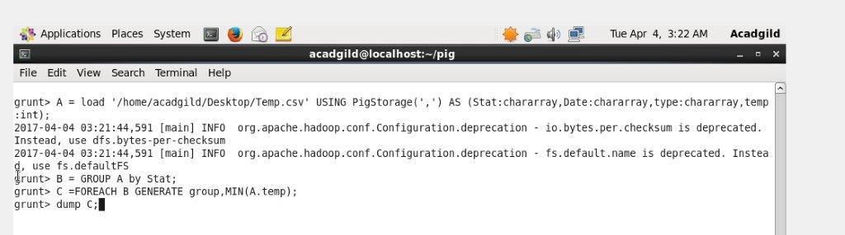

At first, we load the data set into pig and described their data types.

Then group the data based on the station name

Then from this we are selecting the minimum temperature in each station

OUTPUT TERMINAL: This gives the minimum temperature in each station

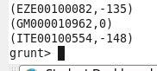

2. Write a pig script to find the maximum temperature observed in a given weather station in a particular year.

PIG SCRIPT: It is similar to the previous question but here we find the maximum temp in each station

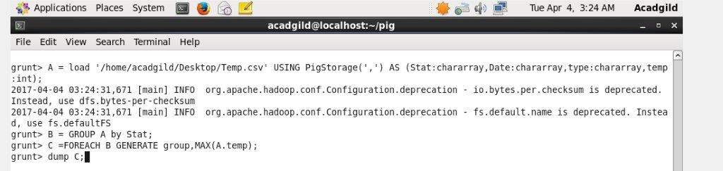

OUTPUT TERMINAL:

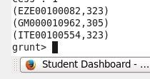

3. Write a pig script to find the number of readings given by each weather station according to the dataset

PIG SCRIPT:In this using count fn ,we calculate the no of recordings in each station

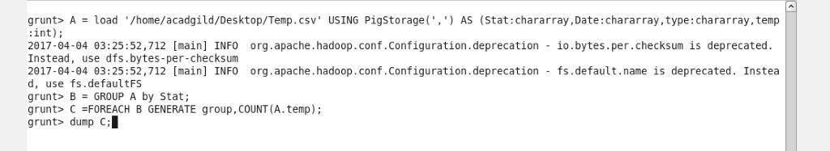

OUTPUT TERMINAL:

C:\Users\Jayachandran\Desktop\asg pics\10.6.3 op.jpg