**Ass-11.1**

1. What is the total amount of petrol in volume sold by every distributor?

PIGSCRIPT: Since we need for each distributor we are grouping by distributor and then we are adding the volume of petrol sold.

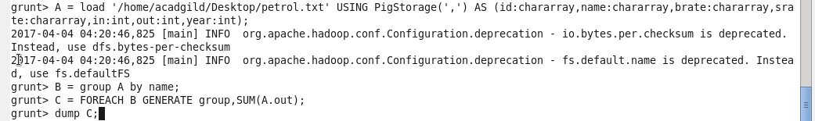

Output terminal:

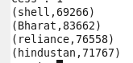

2. Which are the top 10 distributors ID's for selling petrol? Also display the amount of petrol sold in volume.

PIGSCRIPT:In this we are ordering the distributor sold volume in descending order and then to get top 5 we are limiting the list by 5.

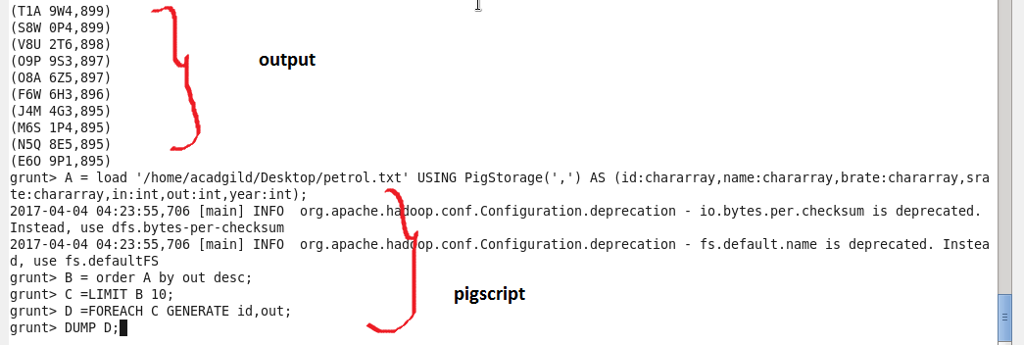

3. List 10 years where consumption of petrol is more with the distributer id who sold it.

PIGSCRIPT:

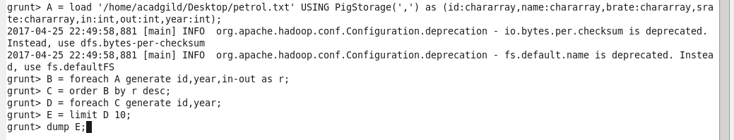

Output terminal:

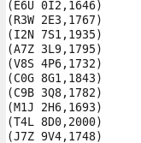

4. Find the distributer name who sold petrol in least amount.

PIGSCRIPT: To get least amount sold id we are ordering the distributor id by sold rate in ascending order and then limiting by 1 to get the least one

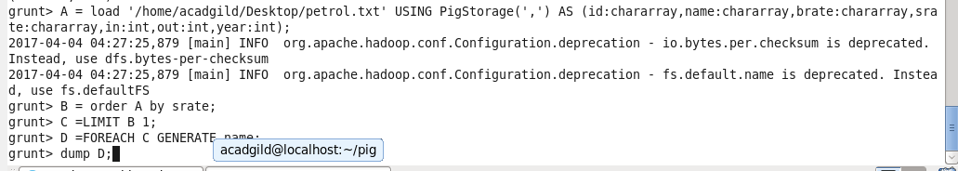

Output terminal: C:\Users\612912\Pictures\screenshot\11.1.4 opop.PNG

Least volume of petrol sold: Pigscript:

