**Ass-11.2**

1. Find the number of students who scored less than 5(50%).

PIGSCRIPT: To get scores less than 50% we are filtering grade which is less than 5.0

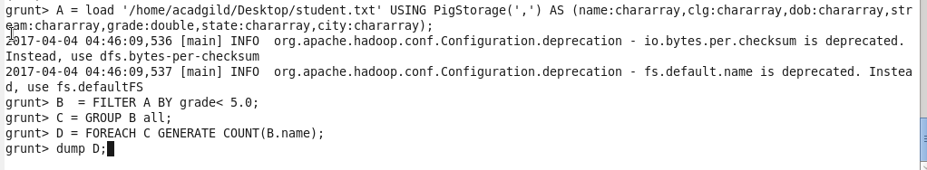

Output terminal: C:\Users\612912\Pictures\screenshot\11.2.1 op.PNG

2. List the name of students who are from Alaska.

PIGSCRIPT:To get the students from Alaska we are filtering the dataset whose state matches ‘Alaska’

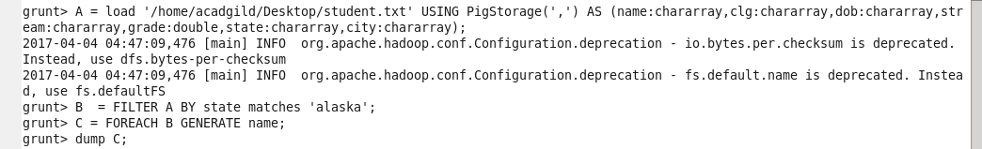

Output terminal:

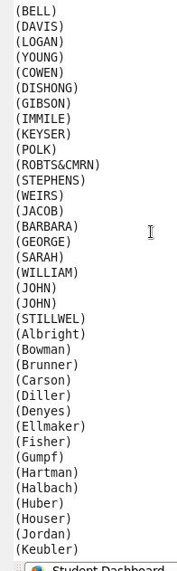

3. How many government colleges are there in Alabama?

PIGSCRIPT: here to get government college ,we are filtering colleges by government and state by Alabama

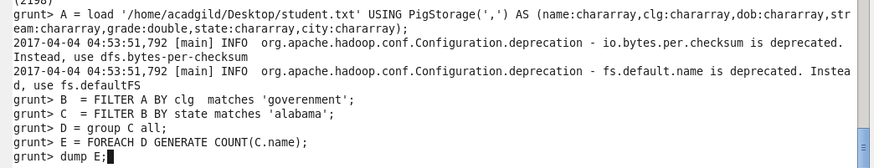

Output terminal: C:\Users\612912\Pictures\screenshot\11.2.3 op.PNG

4. List the name of students who are from Oregon and pursuing BE.

PIGSCRIPT: here to get no of students pursuing B.E is filtered by stream and state by’Oregon’

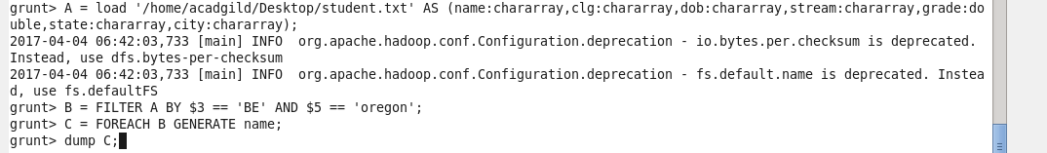

Output terminal:

