**Ass-11.3**

1. Write a Pig UDF to find the tweets posted by @realDonaldTrump from the given dataset.

Pigscript: So to find the number of tweets posted by realDonaldTrumps ,we are using an udf program .Pigscript doesnot contain all the required functions ,so user required functions can be obtained by udf programs .

In pigscript we are uploading the data set ,so first we are registering the udf program in pig and then we are creating an object for that class

At first we are obtaining the handle ,to compare it with Donald trump

Then we are filtering to be not null

Then we are sending the data to udf program

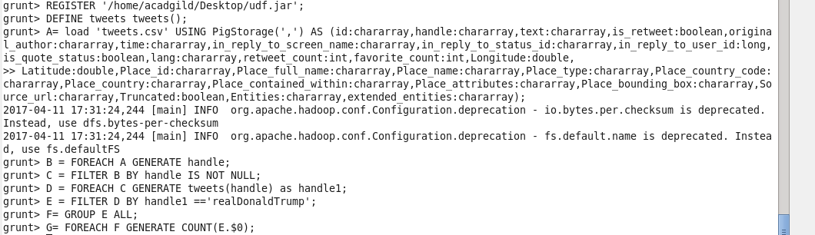

UDF program:

The udf program checks whether the input has realdonaldTrump, if so it returns it else it returns null value. Then the result is filtered by checking whether it matches realDonaldTrump ,then it is counted.

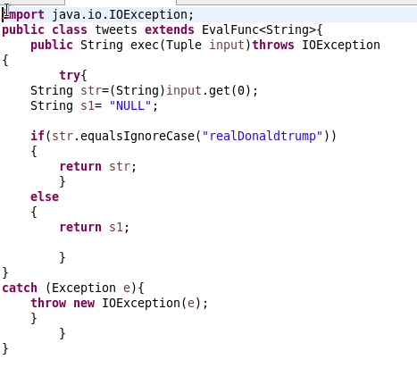

Output : C:\Users\612912\Pictures\11.3 op.PNG