**Ass-11.4**

Write a pig script to find the count of each Hashtag in the dataset.

So there are 6 files inside the given rar file we are extracting those 6 files and we need to count the number of hashtags in each file .

PigScript:

Pigscript is similar for all the six files except that each has a distinct file name

In this at first we will load the file into pig ,then we will divide the given data and store it in word.then we are filtering these word with hashtag .Then we are counting the number of hashtags.

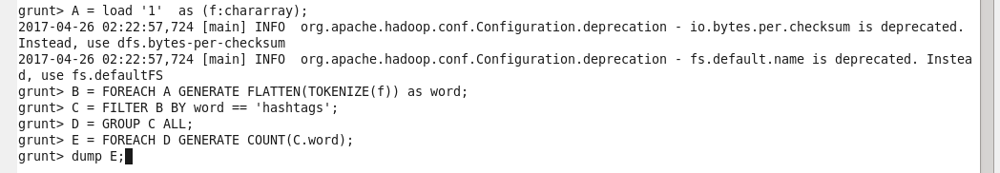

Output: C:\Users\612912\Pictures\11.4.1 op.PNG

File 2: PigScript:

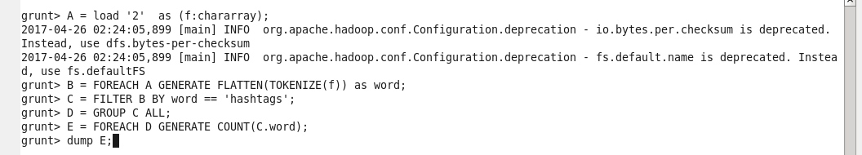

Output: C:\Users\612912\Pictures\11.4.2 op.PNG

File 3: PigScript:

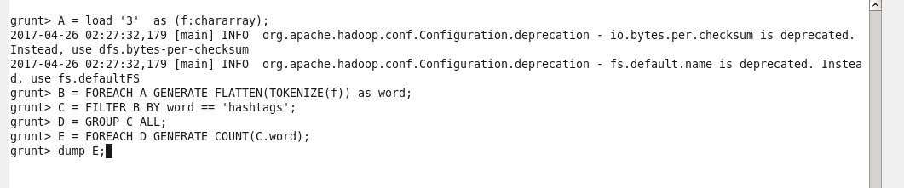

Output: C:\Users\612912\Pictures\11.4.3 op.PNG

File 4: PigScript: 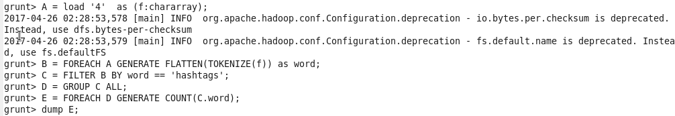

Output: C:\Users\612912\Pictures\11.4.4 op.PNG

File 5: PigScript: 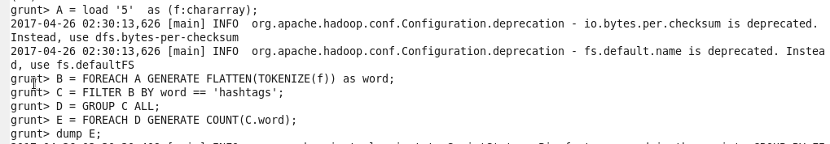

Output: C:\Users\612912\Pictures\11.4.5 op.PNG

File 6: PigScript: 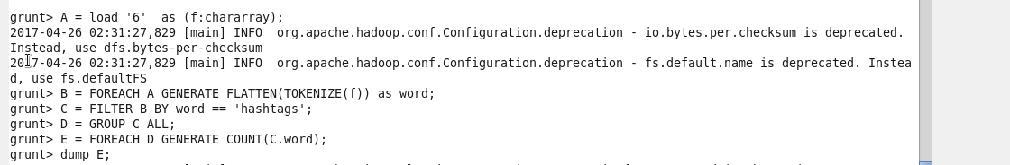

Output: C:\Users\612912\Pictures\11.4.6 op.PNG

So the number of hashtags in each file has been identified using the pigscript command