**Ass-11.6**

1.Find the top five kinds of GoogleKnowlege_Occupation people who were guests in the show, in a particular time period i.e., between '1/11/99' and 6/11/99. You need to write an UDF to compare the dates.

UDF PROGRAM:

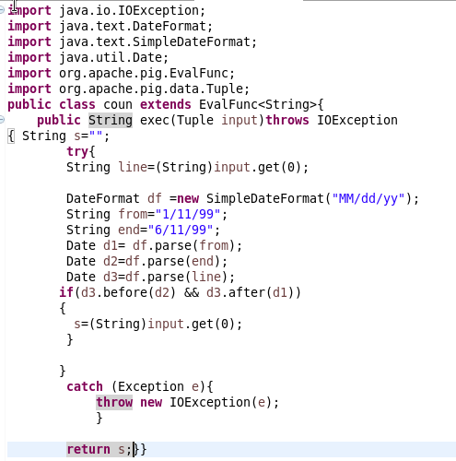

To check whether the given date is within the limit, we are creating an udf program that checks the input date comes after 1/11/99 and before 6/11/99.If so it returns the date or else null value is returned.

This udf program is registered in pig which is then defined to create an object .

Pigscript:

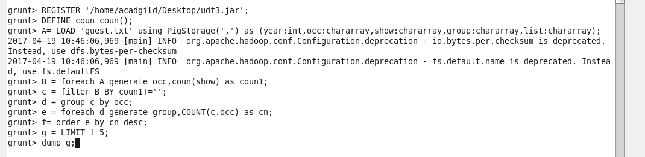

After loading the input data set,then it is grouped based on the occupation and the date is checked by udf program. Then the obtained output is filtered from null values and then to find the top 5 occupation, it is grouped by occupation and the no of people is counted which is ordered in descending order and the top 5 is obtained by limiting the dataset by 5.

Output terminal:

