**ASS-16.3**

**PROBLEM STATEMENT:**

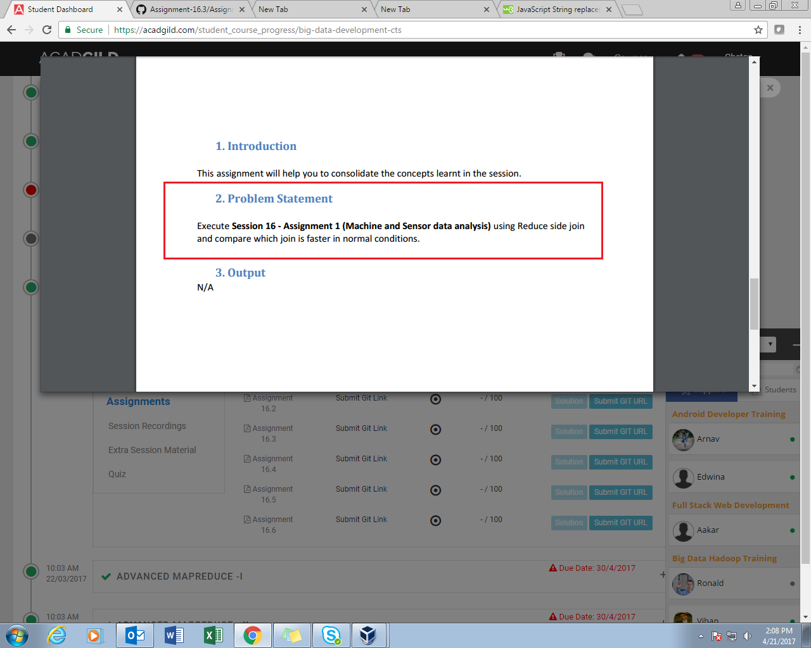

**FOR REFERENCE PROBLEM STATEMENT 16-1:**

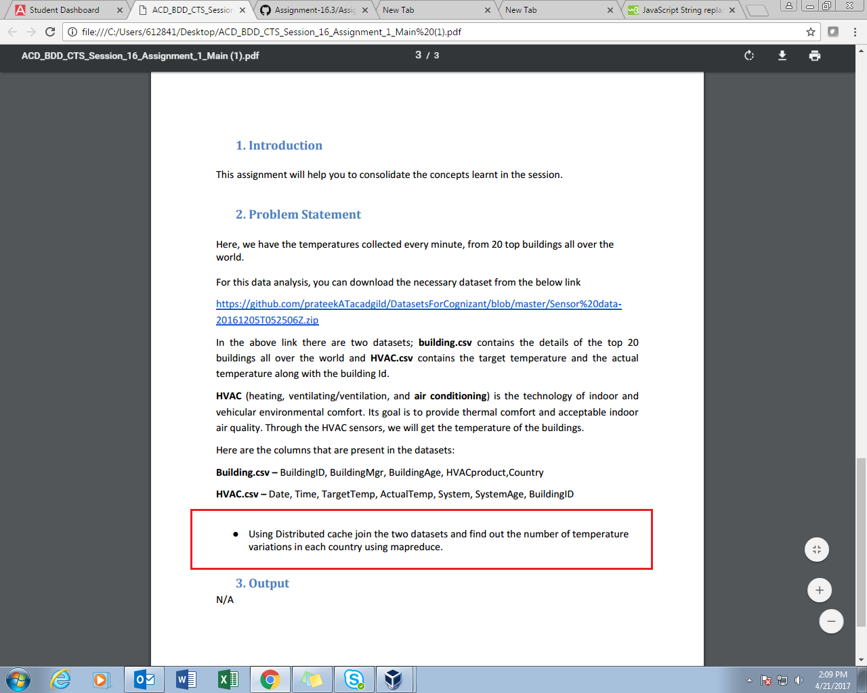

**PROGRAM:**

/DRIVER CLASS

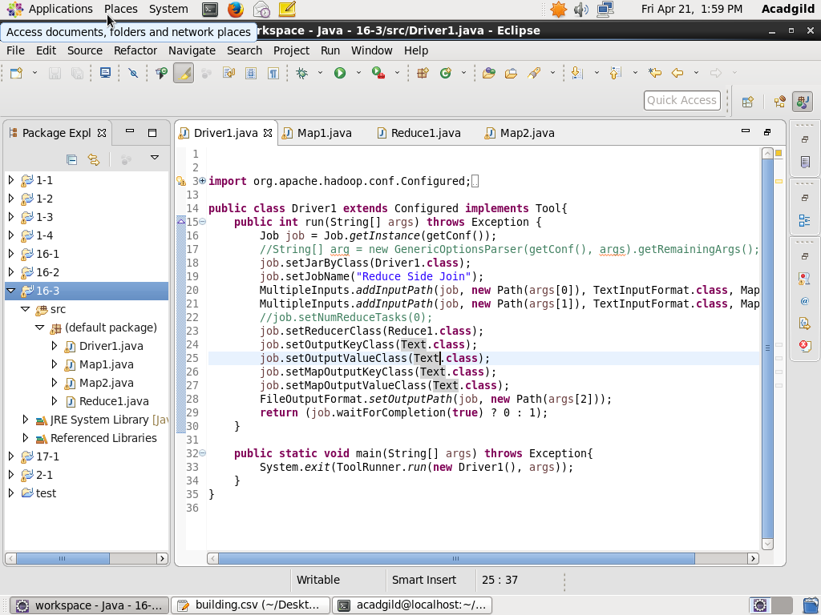

//MAPPER-1

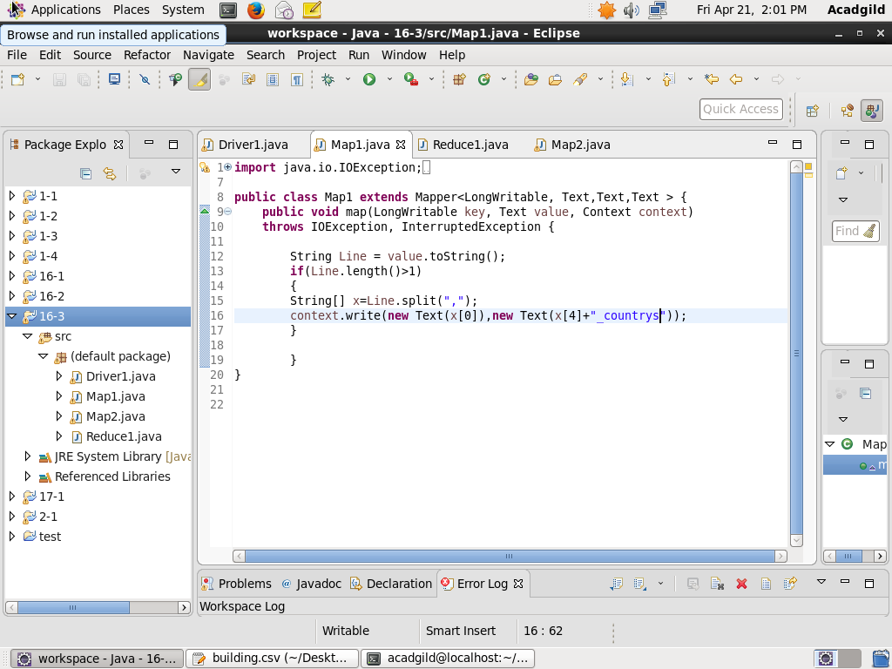

//MAPPER-2

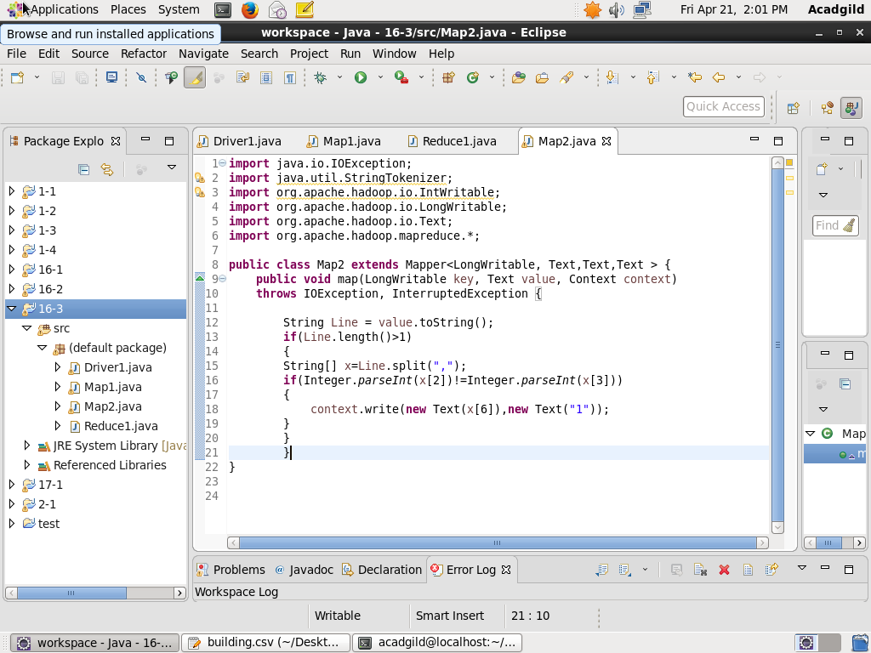

//REDUCER

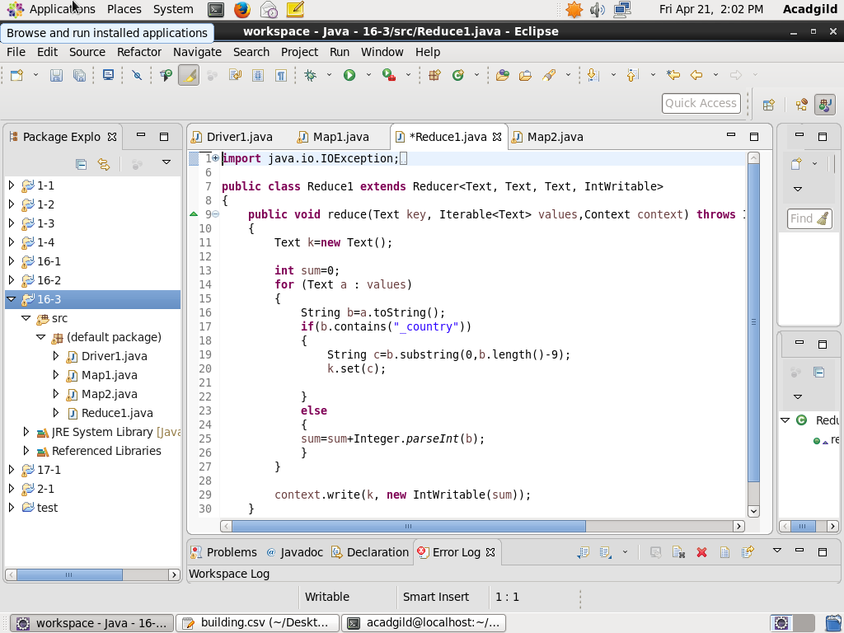

**EXECUTION COMMAND:**

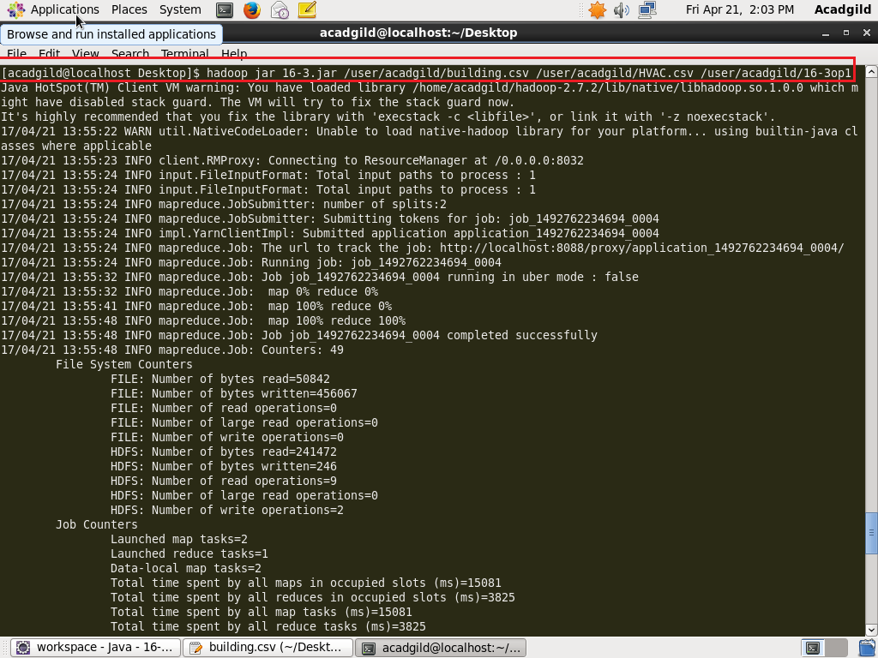

**OUTPUT:**

