**ASS-16.6**

**PROBLEM STATEMENT:**

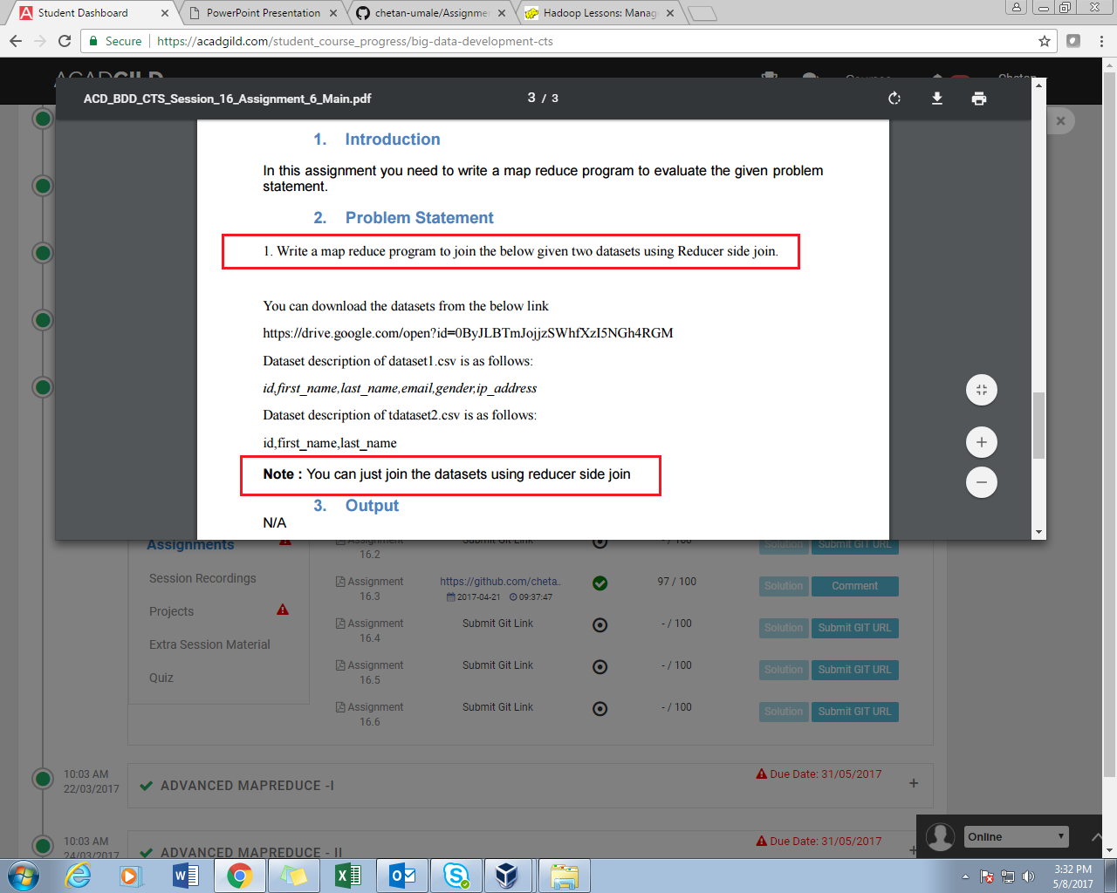

**PROGRAM:**

//DRIVER CLASS

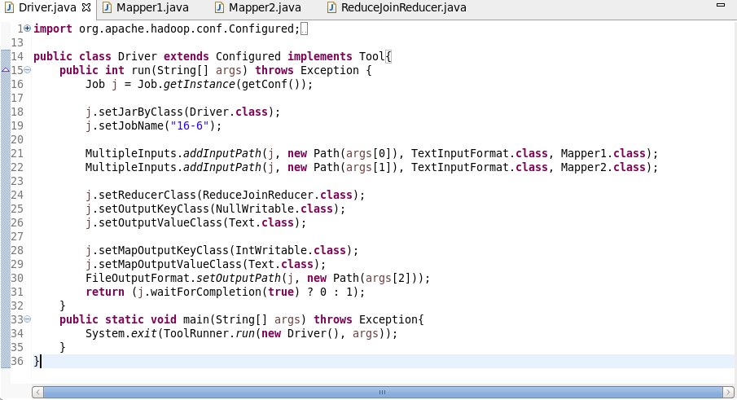

//MAPPER1 CLASS

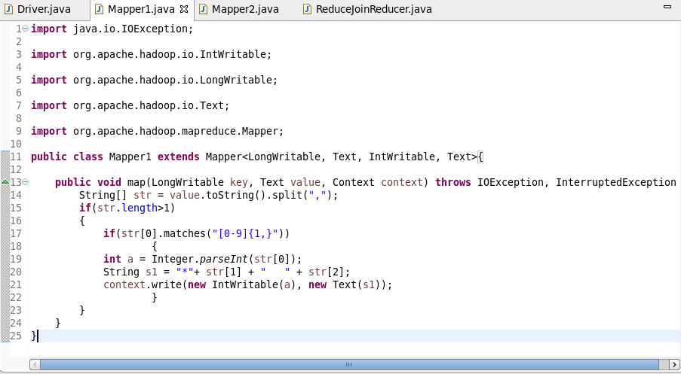

//MAPPER2 CLASS

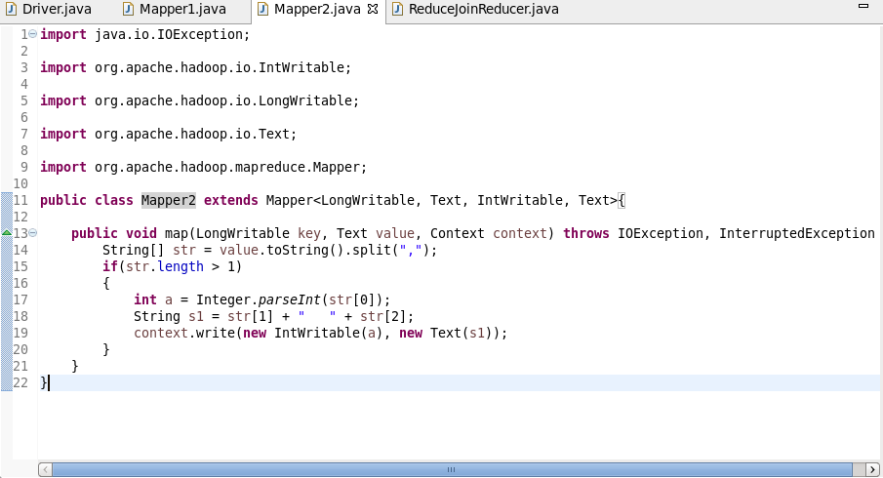

//REDUCER CLASS

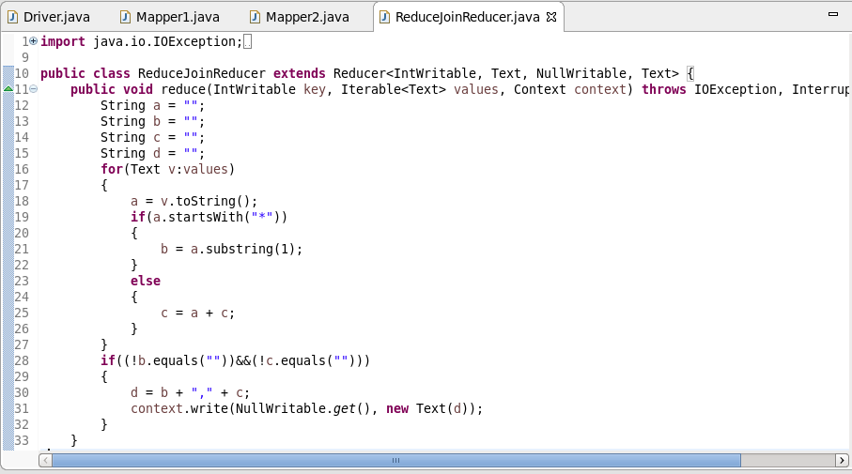

**EXECUTION COMMAND:**

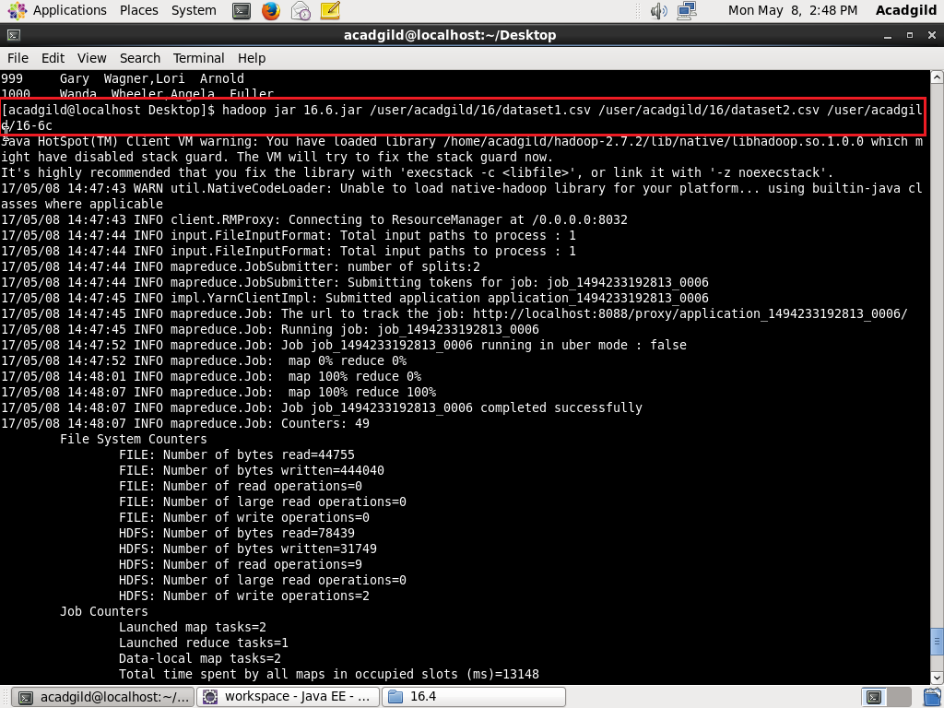

**OUTPUT:**

