**ASS-17.3**

**QN Write a mapreduce job that takes configuration from command line (min.word.count). Based on the configuration, it should perform count of words from a document and produce only those words in the output whose count is greater than or equal to the configuration.**

**DRIVER**

In driver we should make the class extends configured class and implement tool interface and toolrunner static method run cwhich creates a configuration object before the run method

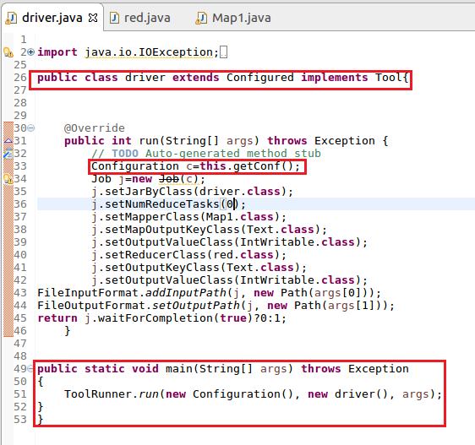

**MAPPER:**

**In Mapper,I am using hash map and If hashmap contains the word the count will be incremented or else a count of 1 will be made and USED context.getconfiguration to get the value for key ”Name” .**

**Step2:words will be counted only if the occurrence of word is greater than or equal tothe given value**

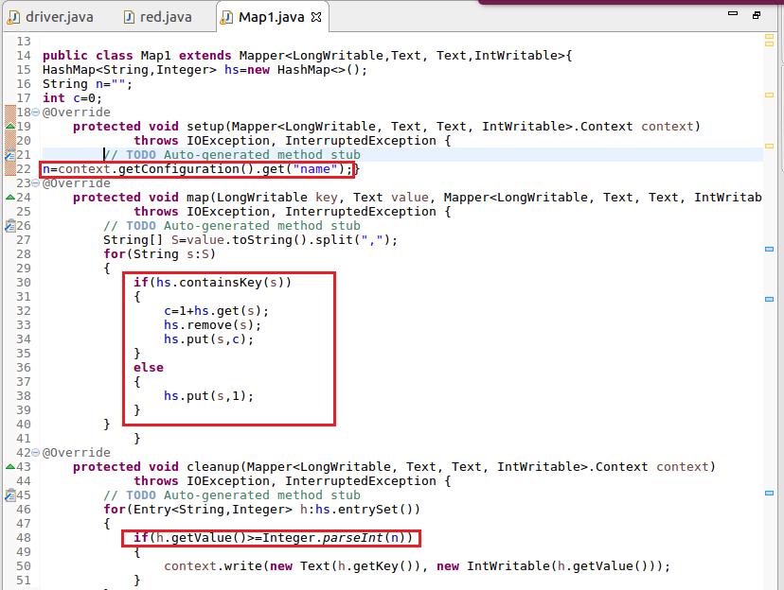

**RUNNING JAR**

**Here I have specified the mincount=3 by giving –D name=3 as highlighted below**

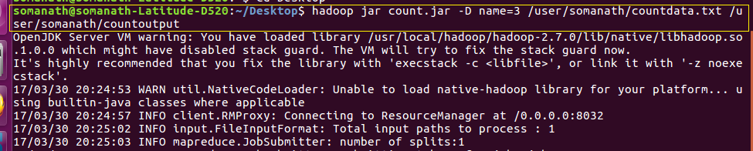

**INPUT file:**

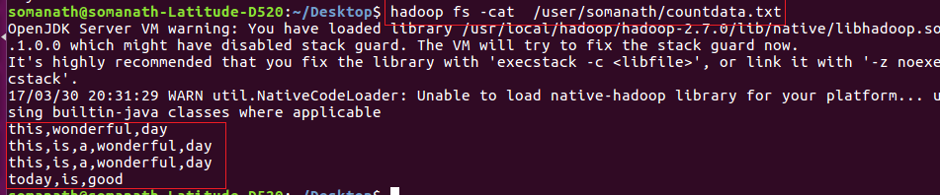

**OUTPUT**

**INFERENCE: ONLY WORDS WITH OCCURRENCE GREATER THAN OR EQUAL TO 3 IS COUNTED**

