**ASS-17.5**

**PROBLEM STATEMENT:**

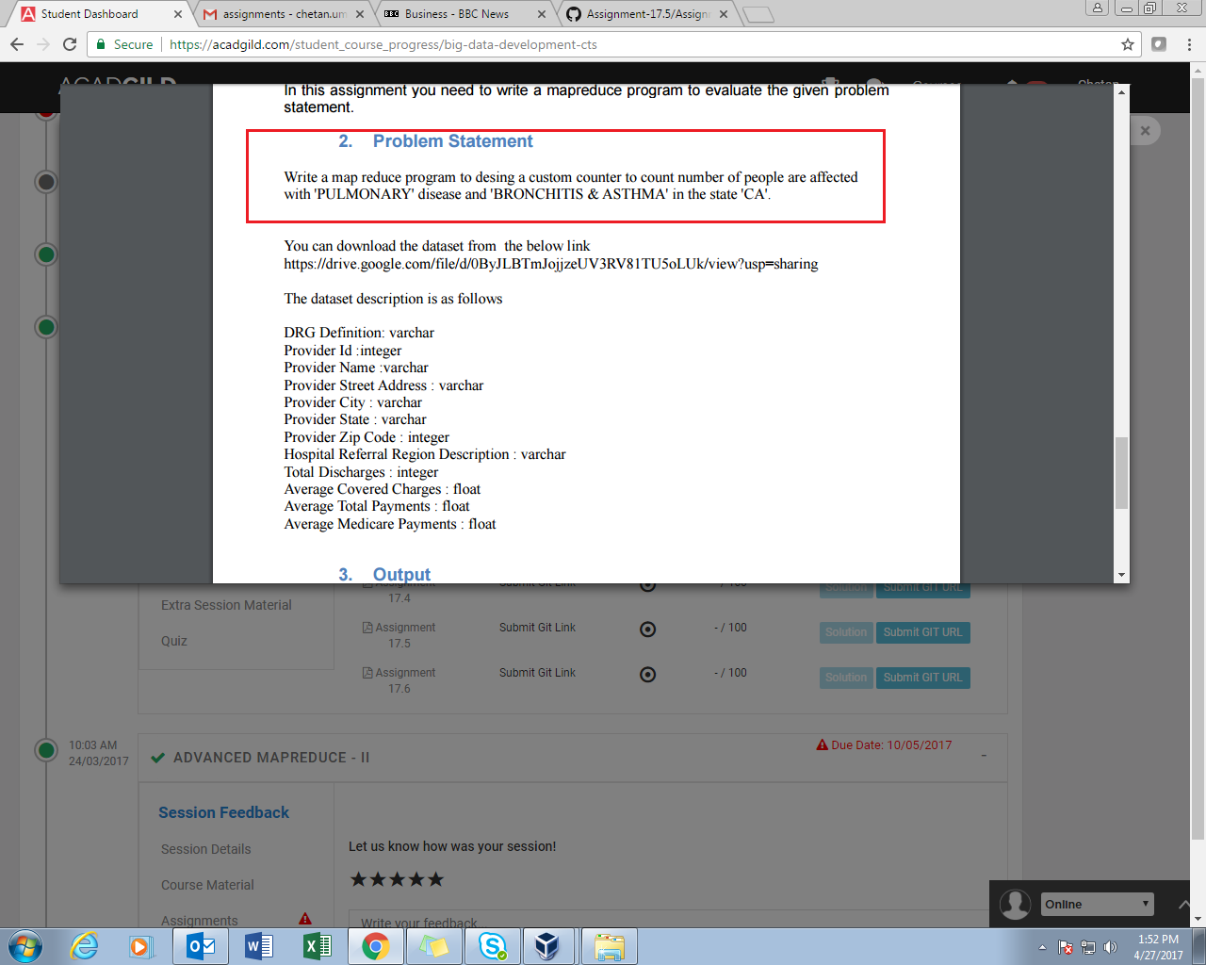

**PROGRAM:**

//DRIVER CLASS

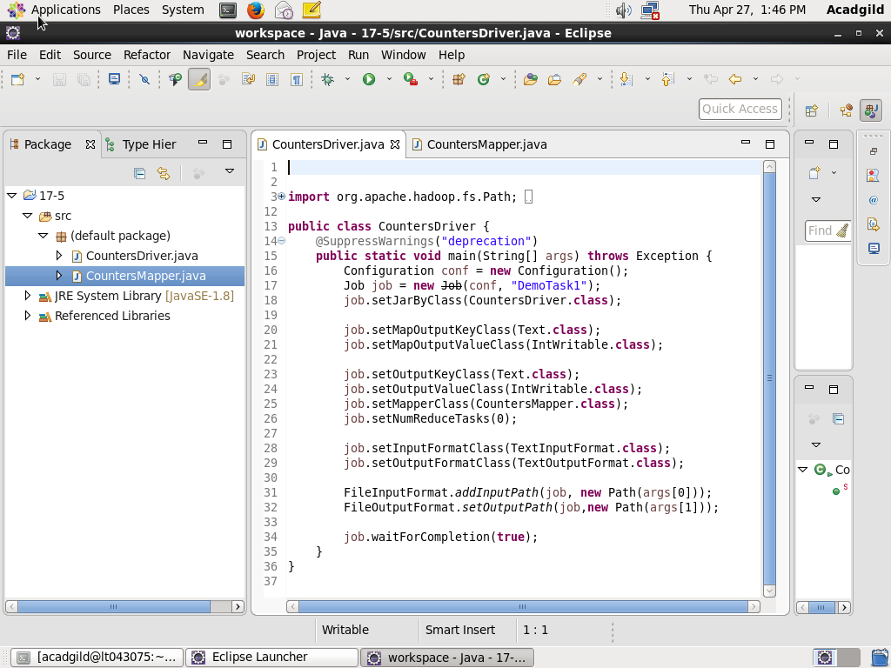

//MAPPER CLASS

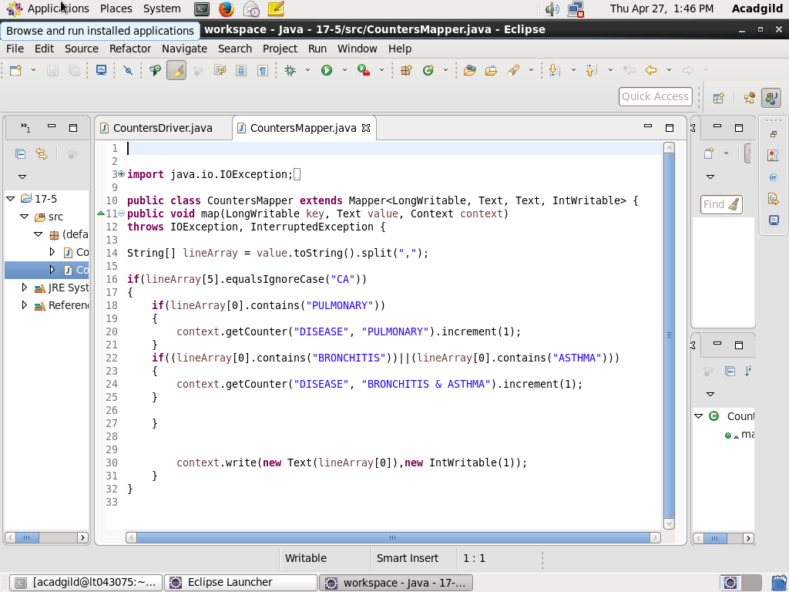

**EXECUTION COMMAND:**

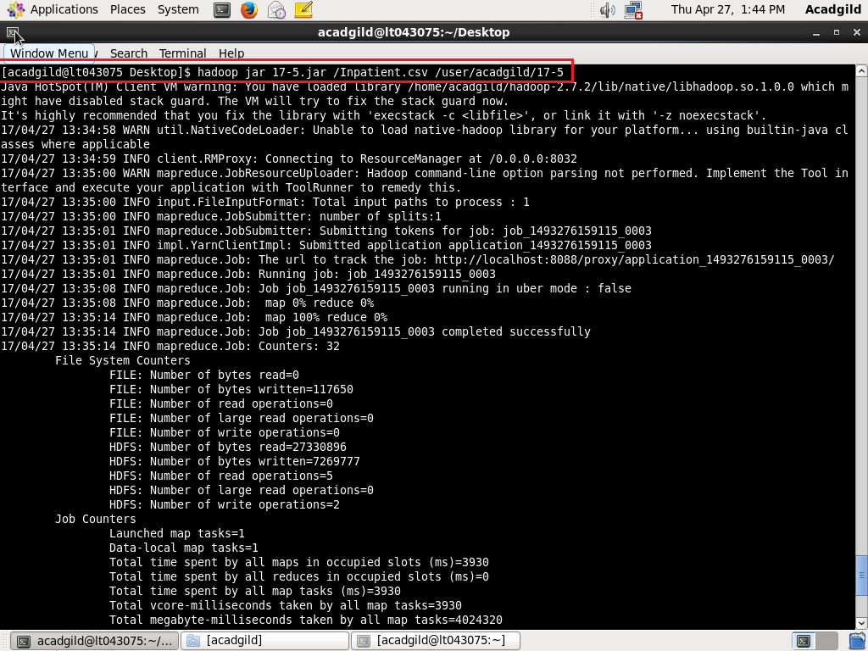

**OUTPUT:**

