**ASS-18.3**

**1.Merge the small files in hadoop by following the below blog.**

**We can merge the small files in Hadoop by**

**Hadoop fs -getmerge -nl <source file path> <local system destination path>**

**Executing Merge Command**

**Source path- /user/merge/**

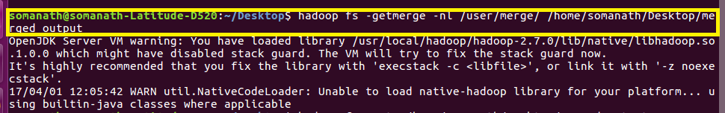

**Local system Destination path - /home/Somanath/Desktop/merged_output**

**-nl is Optional and is used for adding new line in result**

**INPUT**

**file to be merged and its Content are listed by ls command and displayed by cat**

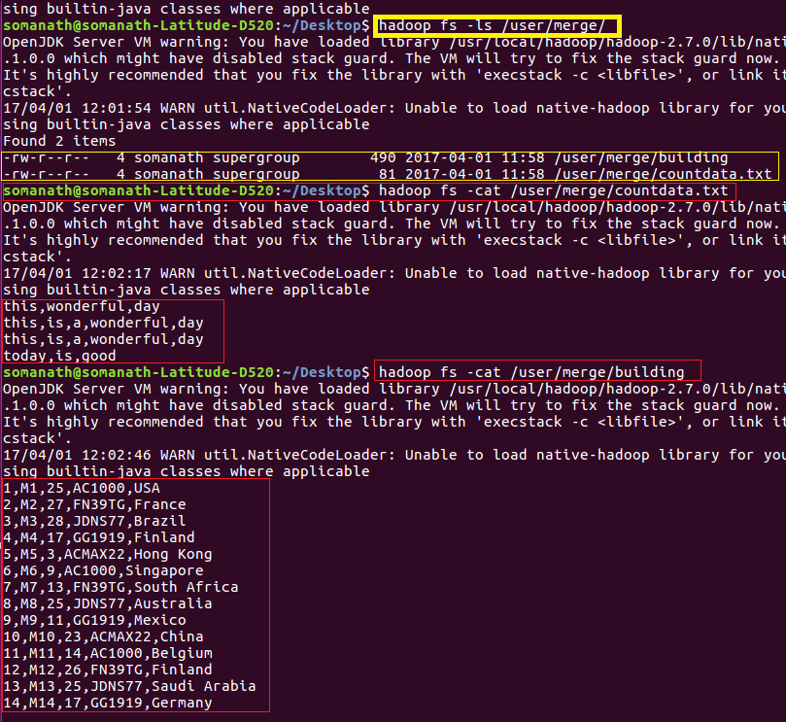

**Output**

The small files in Input are merged in the output folder

