**ASS-21.3**

**This dataset consists of two columns i,e., first_name & last_name &city use custom input format to read the key as the combination of first_name and last_name and arrange the output of the program should be the key sorted by last_name.**

**Logic:**

**Step 1:Since we want record reader to read firstname and last name as key,Define a composite key that contains first name and last name and then order last name by descending**

**Step2:For reading the file by composite key I will write a custom Input format class that extends the Input format which accepts the parameters key and value as our custom _key and the value as Text as value is the city**.

**Step3:Now, these values are passed to the Record reader, which does the actual formatting of the inputs. The custom RecordReader class is as follows.**

**Step1:composite key**

**We are just setting a composite key of first name and last name**

**Step2:Override compare to method to sort in ascending order by last name**

**Step3:Override Tostring Method to display the output in the way we want**

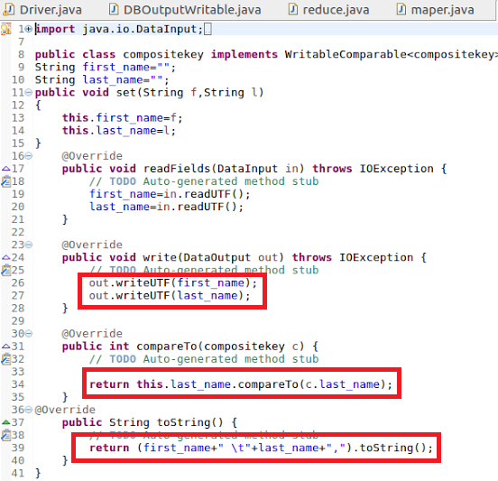

**Step2:created a custom input format class that extends fileInputformat**

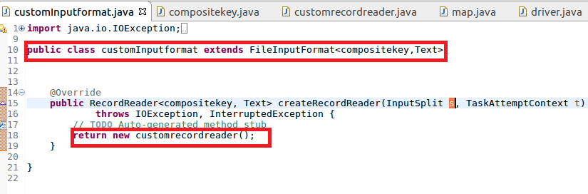

**Step3:customrecord reaeder class with compositekey and text**

Step1:we will define a linereader

Step2:we will override nextkeyvalue method which will read each line and using linereader object split the line by comma and set the compositekey (firstname and lastname) and value as city

Set a Boolean which will check if there is nerxt kay value is there to read if it is true it checks for null or else the splitting will be done and key and value will be set

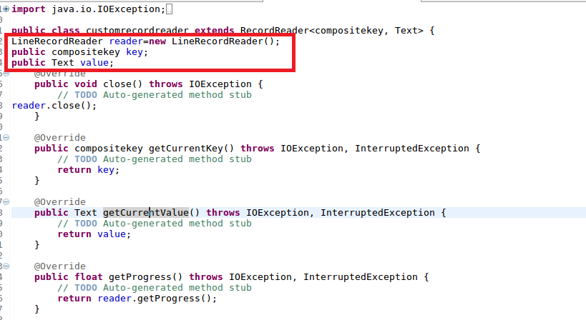

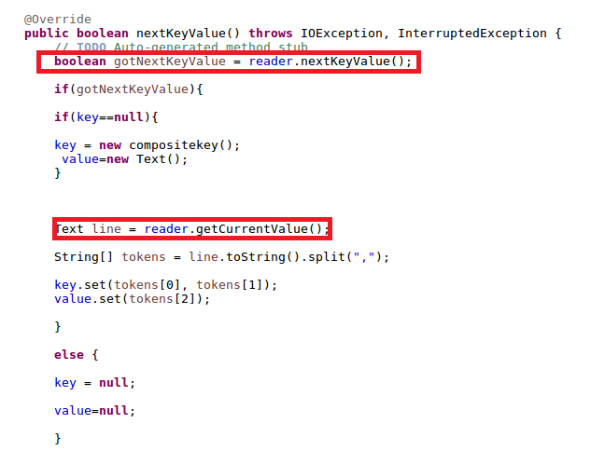

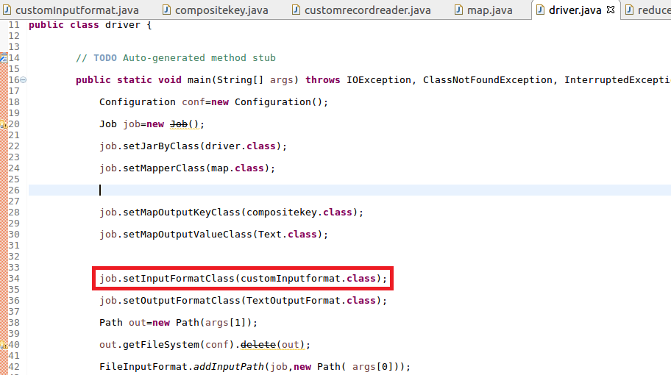

**Mapper And Reducer**

**Mapper and Reducer just prints the key and value**

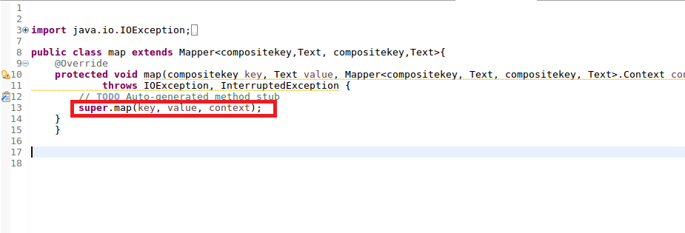

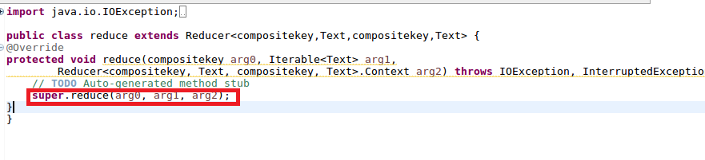

**OUTPUT:we could see the Output contains key as firstname and last name and sorted by ascending order of first name and**