**ASS-23.1**

**Create a database named 'custom'.**

C:\Users\Jayachandran\Desktop\bigdata\23.1.1.PNG

Syntax for creating new database : ***create database databasename***

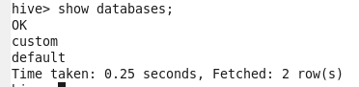

So the new custom database is created

**Create a table named temperature_data inside custom having below fields:**

**date (mm-ddyyyy) format 2. zip code 3. temperature**

create a table if it does not exist already by describing each column name by date,zipcode and temperature which is delimited by ‘,’.

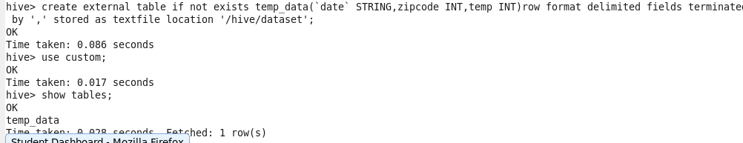

**The table will be loaded from comma-delimited file.**

**Load the dataset.txt (which is ',' delimited) in the table**

Then load the file from the hdfs system



**To dispay the content of file ,select * from table**

