**ASS-24.2**

**Fetch date and temperature from temperature_data where zip code is greater than 300000 and less than 399999.**

At first we create a table with the dataset columns and then we load the table with dataset from the local file system. Then to find the date and temperature we are giving select statement with a where condition of zipcode to be greate than 300000 and less than 399999

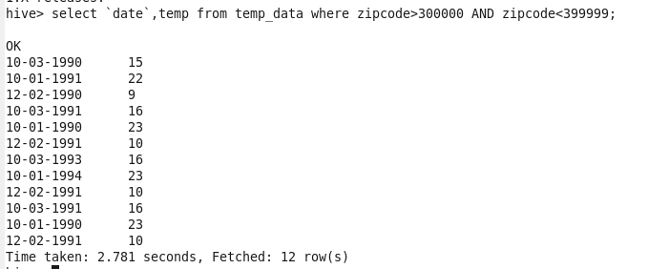

**Calculate maximum temperature corresponding to every year from temperature_data table.**

So to get the maximum temperature,we can use max function since we need it for every year we are grouping the dataset by year .To get the year we are using substring Or timestamp fn to calculate the difference between the reference date and the data ,to filter out the data based on the condition

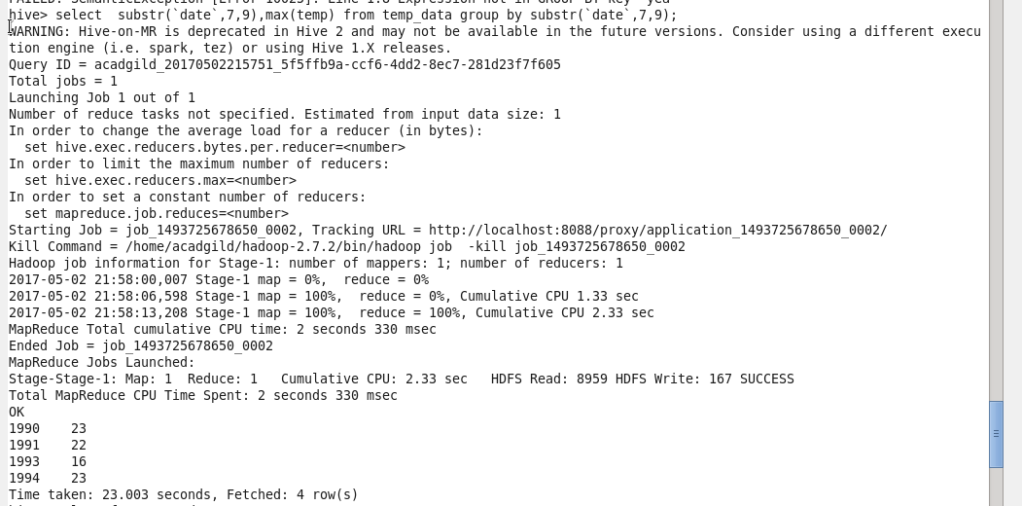

**Calculate maximum temperature from temperature_data table corresponding to those years which have at least 2 entries in the table.**

It is similar to the previous question additional to that we have to have atleast 2 entries in the table,this can be verified by count function.

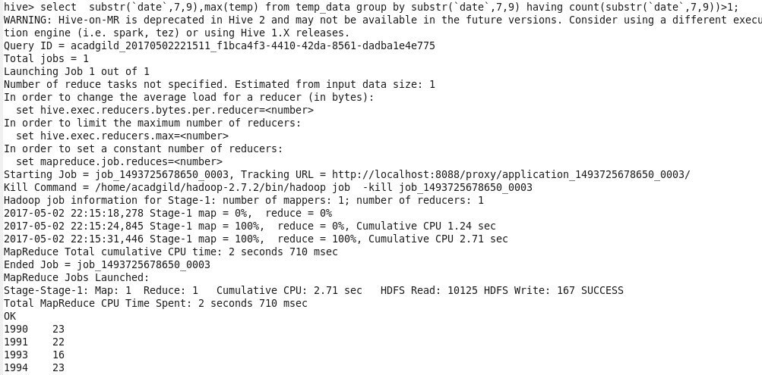

**Create a view on the top of last query, name it temperature_data_vw.**

So the command to create view is **create view *viewname*** *,*now followed by the previous select command that should fill in the view



**To view those files ,we are giving select * from viewname**

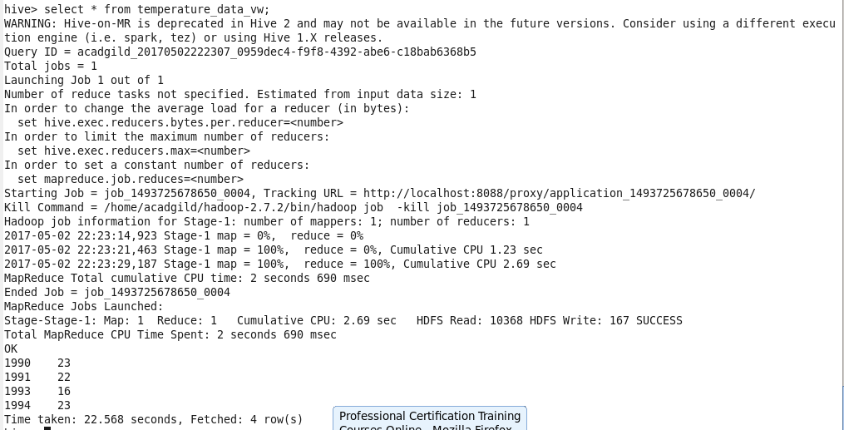

**Export contents from temperature_data_vw to a file in local file system, such that each file is '|' delimited.**

Now we are exporting this to a file in local system by the following commands

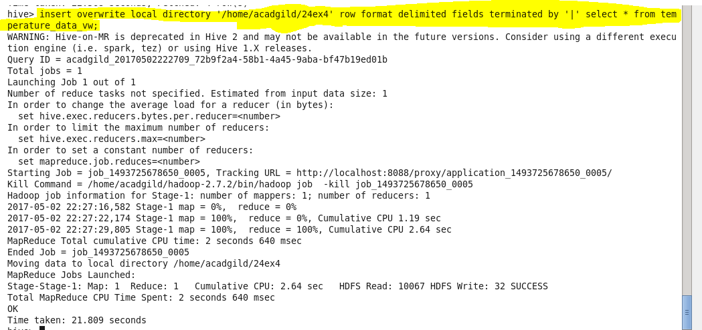

**Output terminal:**

