**ASS-24.3**

**Calculate the number of employees corresponding to each skill from the table 'employee' which is loaded in the Demo.**

* Create a table of empsal,upload the details into the table from local file system
* Now to get the count of employee in each skill,group the details by skill and count the number of employee using names

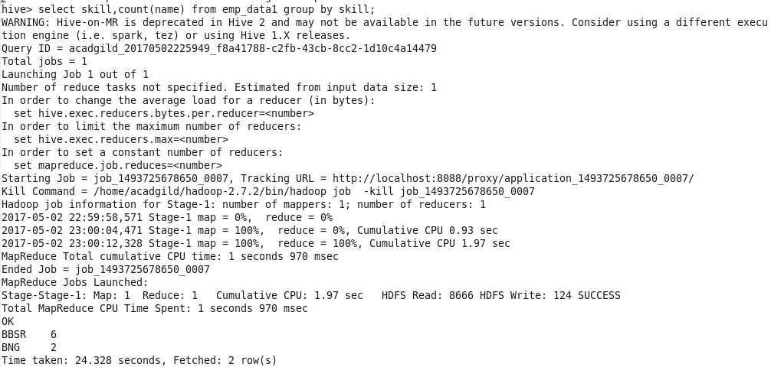

Output: So in BBSR 6, in BNG 2