**ASS-24.4**

**1.Write a hive query find the average age of male and female persons died in the titanic tragedy**

First we load the data set into a table in hive and then we are finding avg of each sex by grouping the data by sex and then selecting sex,average of age .Since they asked only for the people who were dies in the tragedy filter it when life=1(died)****

**2.Write a hive query to find the number of people died and survived in each class**

So to find the count of survivors and dead ,group the data set by life and count the number of person which gives the number of people died and survived.So they also require it based on the class they travelled , so we group the content by class

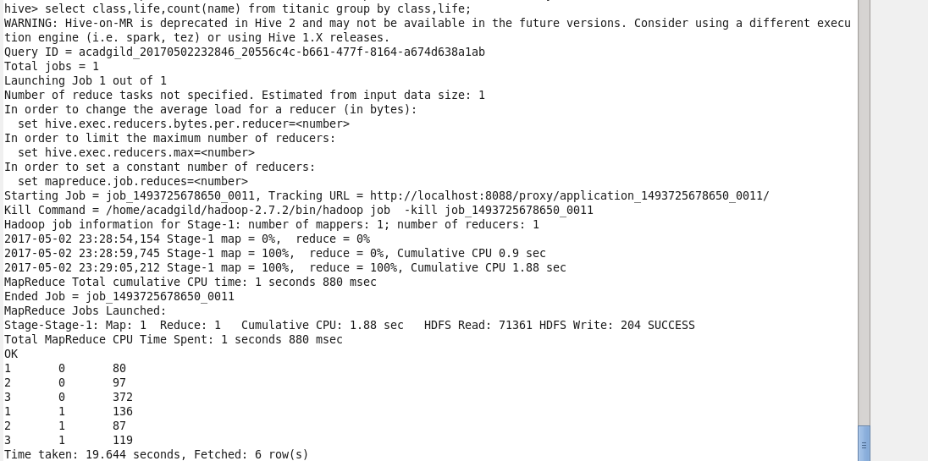

Here each class 1 ,2,3 has survivors and death count

Survivor dead

Class 1 136 80

Class 2 87 97

Class 3 119 372