**Ass24.5**

**Create a hive table and load the dataset into the table and evaluate the below problem statements**

**1. Find out the average HP (Hit points) of all the Pokémons**

Create a table in hive and load the dataset into the table from local file system

To find the average ,we use avg function on the specified column HP

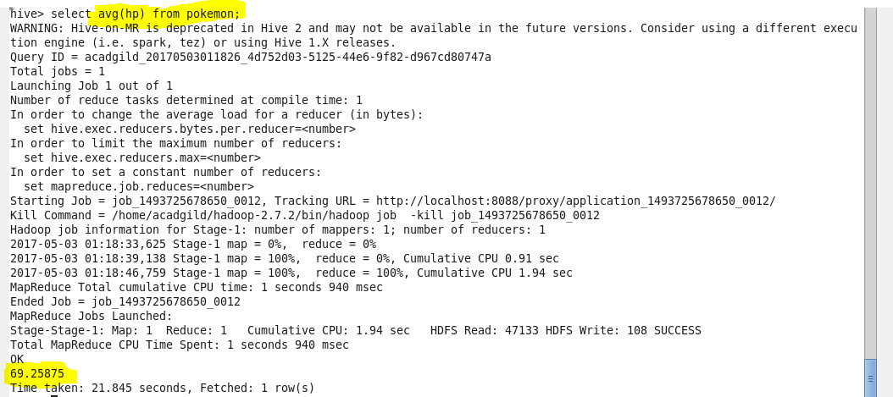

**2. Find out the average Defense of all the pokemon**

Create a table in hive and load the dataset into the table from local file system

To find the average ,we use avg function on the specified column defense

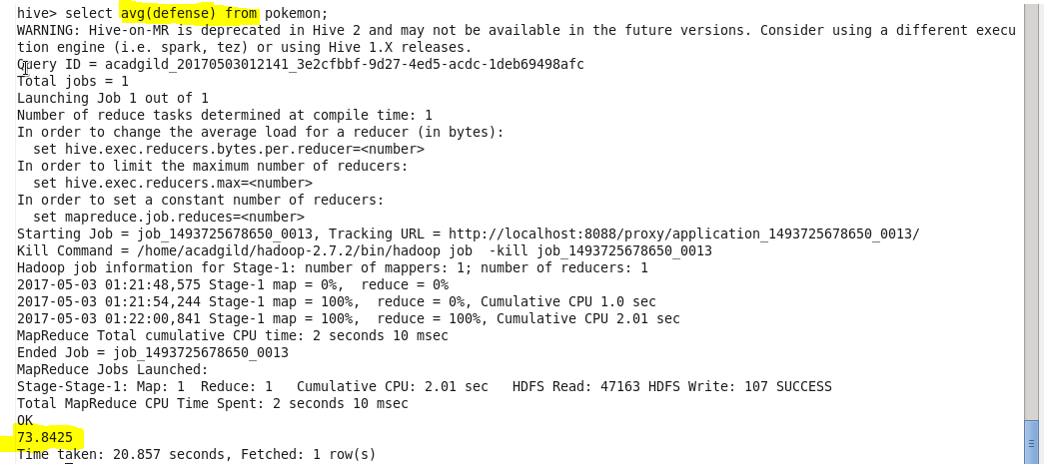

**3. Find out the average Sp.Atk of all the pokemons**

Create a table in hive and load the dataset into the table from local file system

To find the average ,we use avg function on the specified column special attack

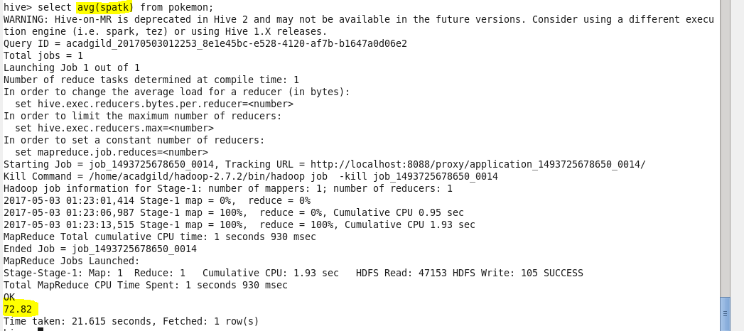

**4. Find out the average sp.Def of all the pokemons**

Create a table in hive and load the dataset into the table from local file system

To find the average ,we use avg function on the specified column special defense

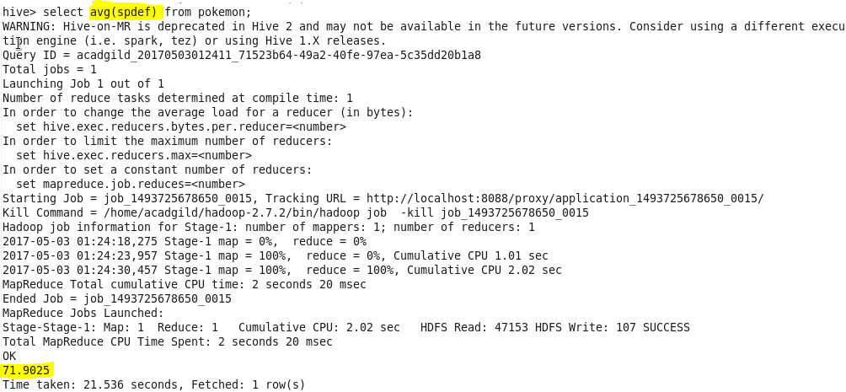

**5. Find out the average Speed of all the pokemons**

Create a table in hive and load the dataset into the table from local file system

To find the average ,we use avg function on the specified column speed. 