**Ass24.6**

**1.Write a hive query to find the minimum temperature observed in a given weather station in a particular year.**

To get minimum temperature on each station,we group the data set by station and then grouping by year from this we will select the minimum temperature for each station for a year

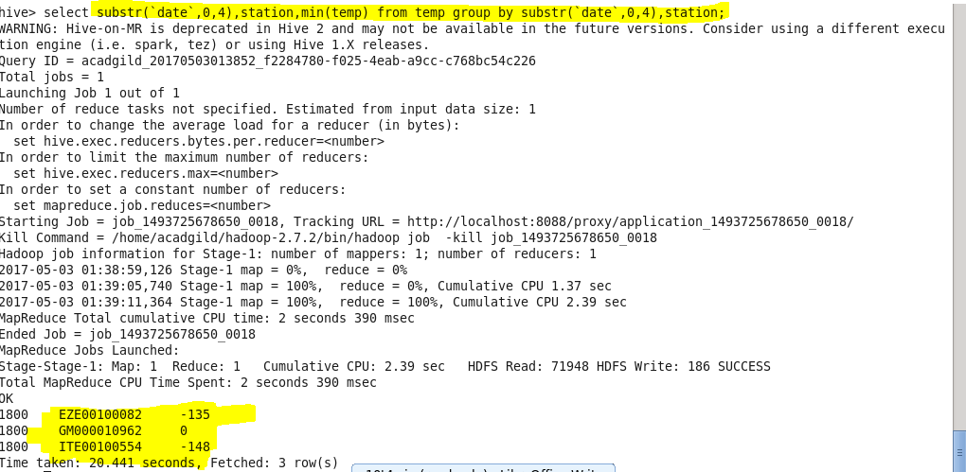

**2. Write a hive query to find the maximum temperature observed in a given weather station in a particular year.**

To get maximum temperature on each station,we group the data set by station and then grouping by year from this we will select the maximum temperature for each station for a year

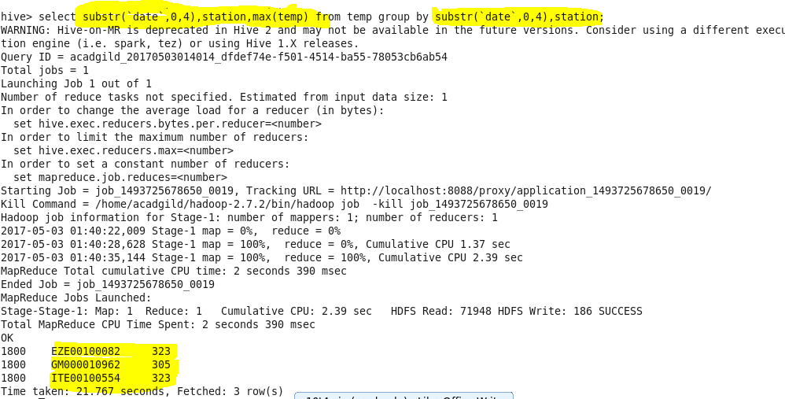

**3. Write a hive query to find the number of readings given by each weather station according to the dataset.**

To get count of recordings on each station,we group the data set by station and then we will find the count of temperature reading for each station for a year

