**Ass25.1**

**Write a Hive program to find the number of medals won by each country in swimming.**

Run command:

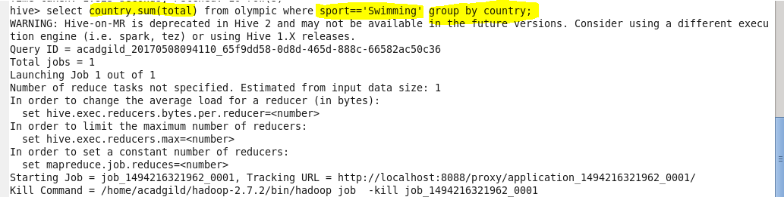

Output terminal:

No of medals won by each country in swimming is given by,

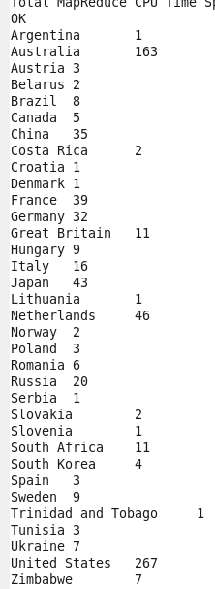

**Write a Hive program to find the number of medals that India won year wise.**

So it is similar to the previous question except that here we are additionally grouping by year to get yearwise medals ad filtering the country which matches with India.

