**Ass25.2**

**Write a Hive Program to find the total number of medals each country won**

First we add the dataset to the newly created table in hive and then we are counting the number of total medals won by each country which can be obtained by grouping the data set by country and adding the total medals column.

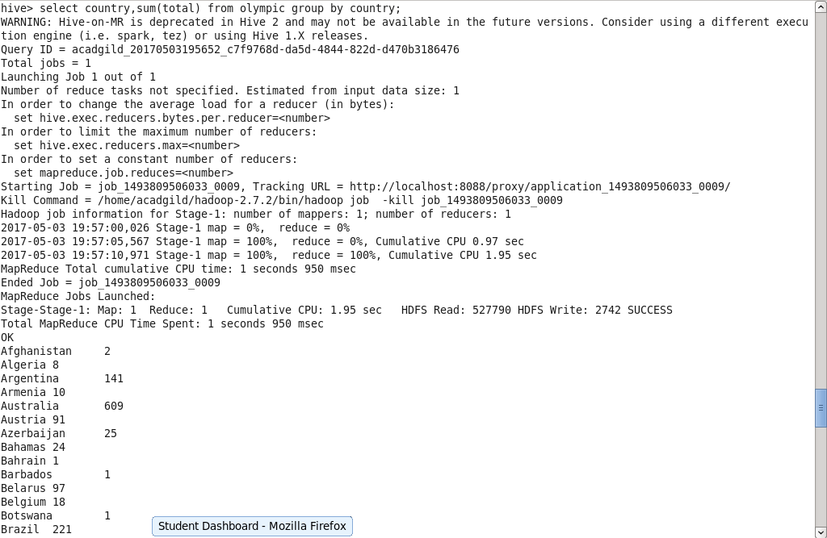

Output terminal:

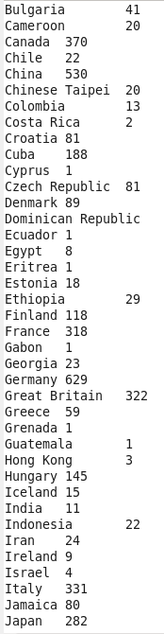 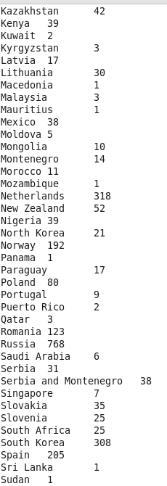 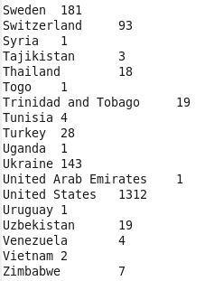

**Write a Hive program to find the number of gold medals each country won**

First we add the dataset to the newly created table in hive and then we are counting the number of gold medals won by each country which can be obtained by grouping the data set by country and adding the gold medals column.

 