**Ass25.4**

**1.Write a hive query to find the top 20 destination people travel the most**

At first we are creating the table in hive with the column description and then we are loading the dataset into the table .Then to get the total no of person travelled to a destination ,we are adding the adult,infant,young,senior and children.Then we are grouping them by destination and sorting in descending order and to get the top 20 alone we are limiting the data by 20

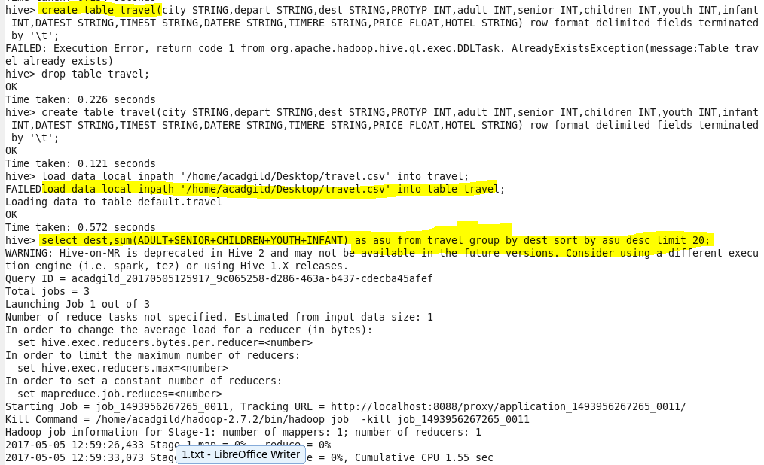

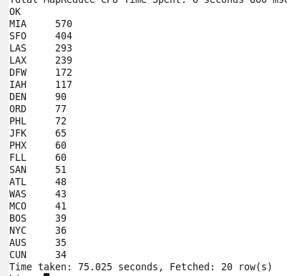

**2. Write a hive query to find the top 20 locations from where people travel the most**

At first we are creating the table in hive with the column description and then we are loading the dataset into the table .Then to get the total no of person travelled to a departure ,we are adding the adult,infant,young,senior and children.Then we are grouping them by destination and sorting in descending order and to get the top 20 alone we are limiting the data by 20

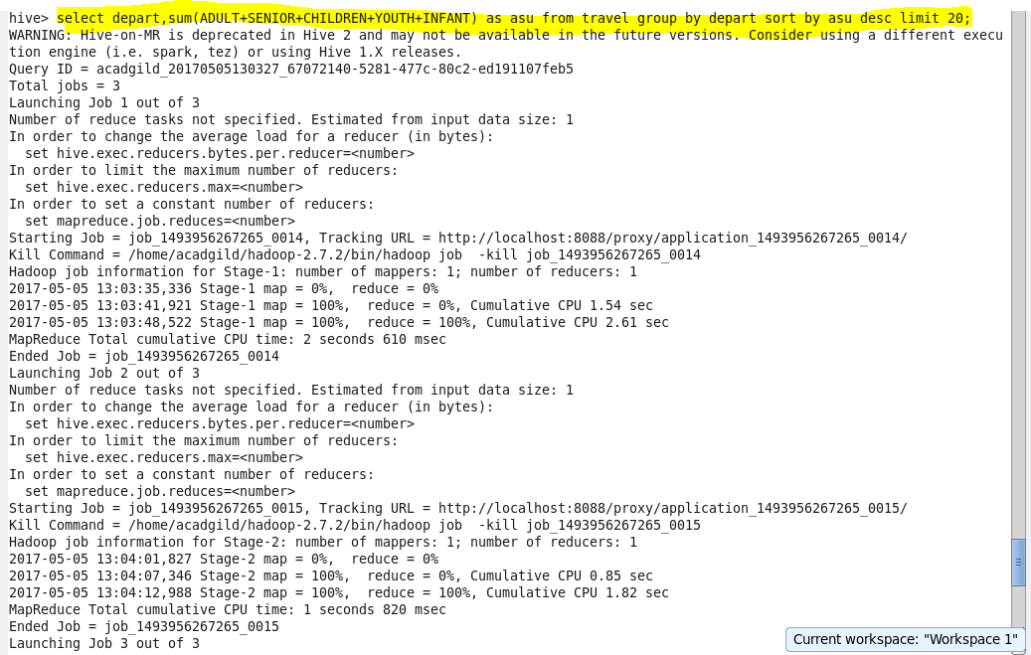

**Output terminal:**

