**Ass25.5**

**1. Write a hive query to list top 5 residency details which lie in the budget of 60000-120000, an area more than 1450, sold after 17th may, min bedroom 3 and, min bathroom 2.**

The given conditions are given in where and the sale after may 17 is obtained by finding the date that comes after the reference date , then if it is the dataset is filtered with a limit of 5

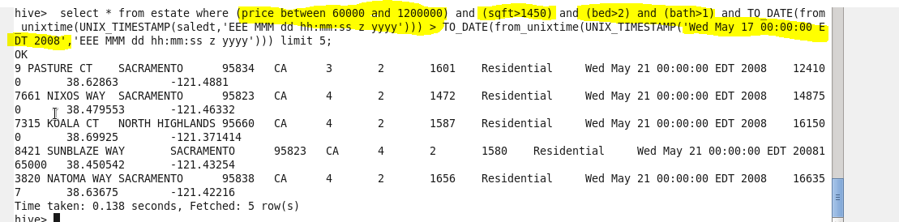

**2. Write a hive query to separate list of residential apartments with more than 2 beds. Also include columns in following order City, Baths, Sq_feet, Price, flat_type, Beds respectively.**

So the condition is that type should be a resident and the no of bedroom to be more than 2 and the selected column are displayed for the filtered dataset.

**C:\Users\Jayachandran\Desktop\bigdata\25.5.2.PNG**

