**ASS-25.6**

**1.Write a hive query to find the city wise list all the Condos which is not less than ten thousand.**

So the condition to be type is condo and the price should be greater than 10000

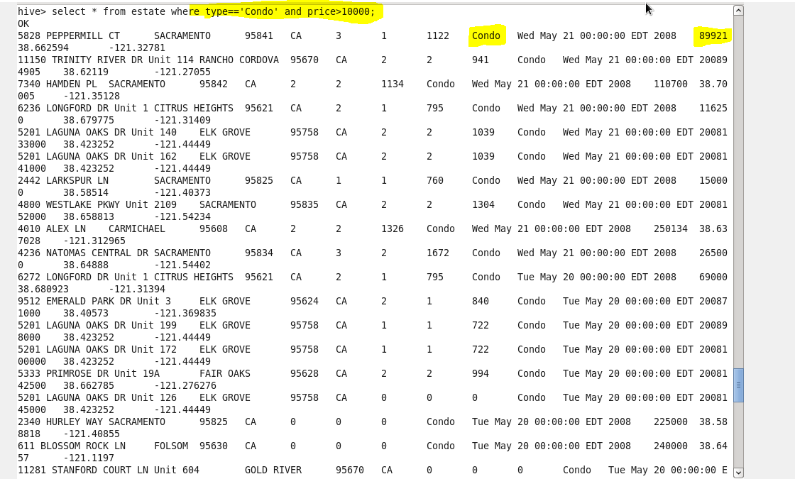

**2. Write a hive query to find which is the cheapest Condo in CA. name the city,street and price for the Condo.**

To select the cheapest we would aggregate the content by minimum priceand then the state should be CA.The filtered content’s city,street and price are obtained

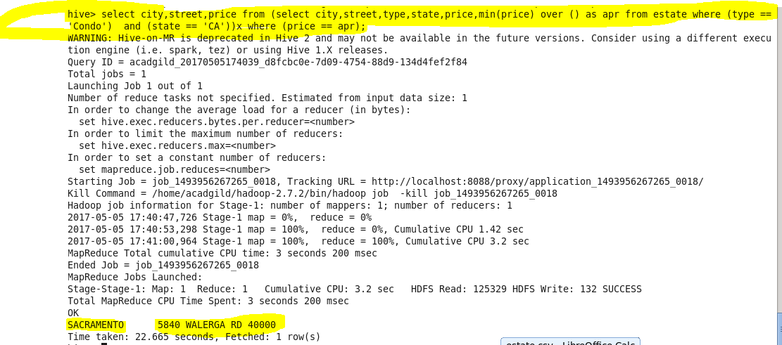

**3. Write a hive query to list top 5 residency details which lie in the budget of 60000-120000, an area more than 1450, sold after 17th may, min bedroom 3 and,min bathroom 2.**

The given conditions are given in where and the sale after may 17 is obtained by finding the date that comes after the reference date , then if it is the dataset is filtered with a limit of 5

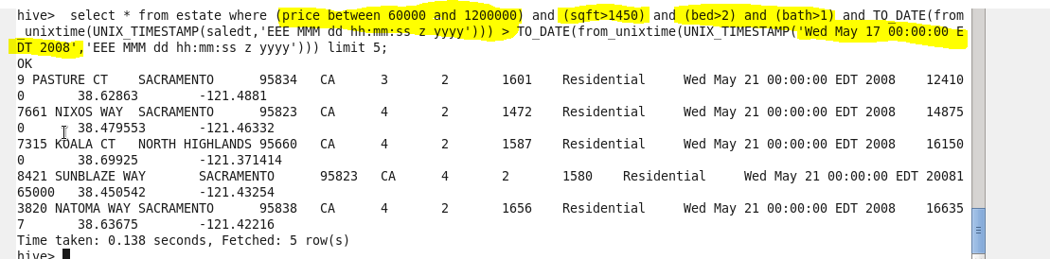

**4. Write a hive query to separate list of residential apartments with more than 2 beds. Also include columns in following order City,Baths,Sq_feet,Price,flat_type,Beds respectively**

So the condition is that type should be a resident and the no of bedroom to be more than 2 and the selected column are displayed for the filtered dataset.

**C:\Users\Jayachandran\Desktop\bigdata\25.5.2.PNG**

