**ASS-26.1**

**Perform word count in Hive for above given dataset**

>First ,we are creating a table in hive and then we are loading the table with the file that you want to count the number of words.

>Now to count the number of words ,we are using the following query.

**>Select worcnt,count(1) as count from(select explode(split(word,‘ ’)) as worcnt)template group by worcnt;**

**>split(word,‘ ’)-**this is used to split the content of the file by space so that we can get each word

>**explode(split(word,‘ ’)-** so to give each word a row ,we are using explode to give each word a row

>So we are storing these rows in **worcnt**

>Now we are grouping the word and then we are counting the number of rows for each word

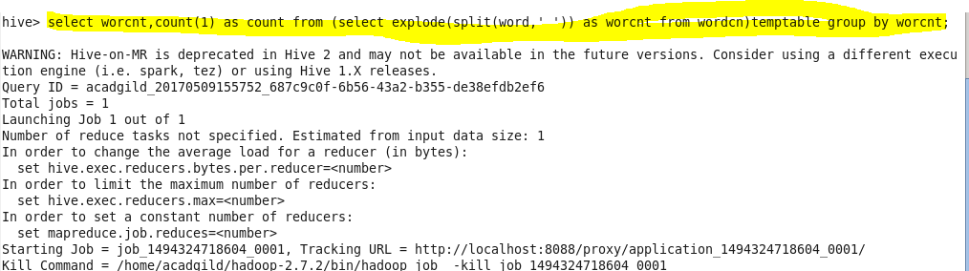

**Output Terminal:**

The count of number of times the word is obtained as output.

