**ASS-26.3**

**Create table RealEstate in Hive database, with all the columns present in dataset.**

**● Load dataset into table realEstate.**

At first we are creating a table in hive to upload the dataset

Then we are loading the file from local system into hive table

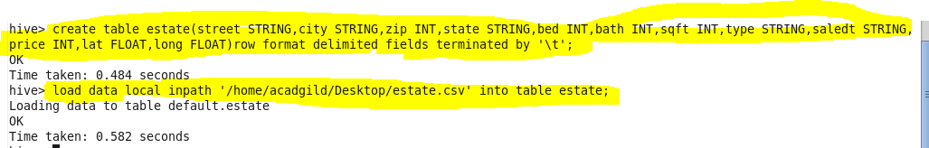

**● Using Dynamic partition get separate lists of residential apartments with more than 2 beds and include columns in following order City,Baths,Sq_feet,Price,flat_type,Beds respectively.**

Now we are creating a table for partitioned content to be stored

Then we are setting the mode into nonstrict ,since dynamic partitioning is possible only in nonstrict mode

Then we are inserting the content from the original table

The partitioned contents are stored in each file

Here partition is done by bed to get the entire content of bed room is greater than 2

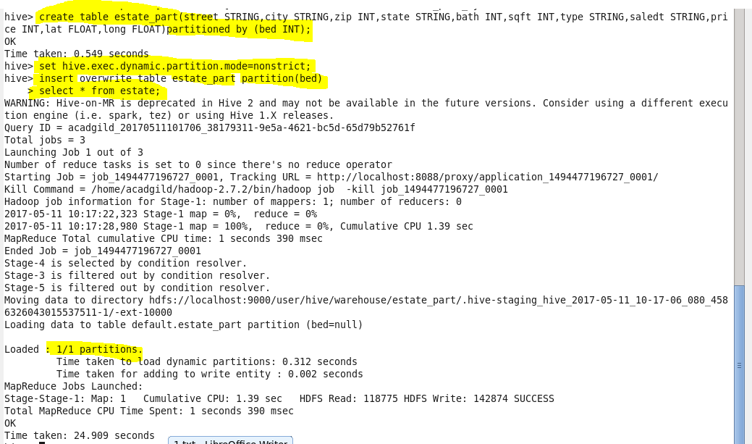

**Output terminal:**

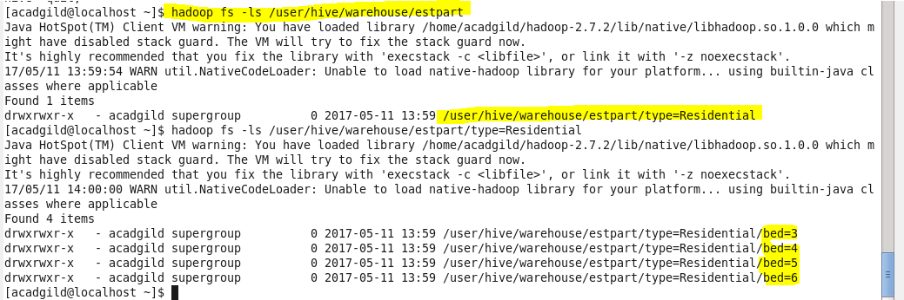

**C:\Users\Jayachandran\Desktop\bigdata\26.3 op 1 cmd.PNG**

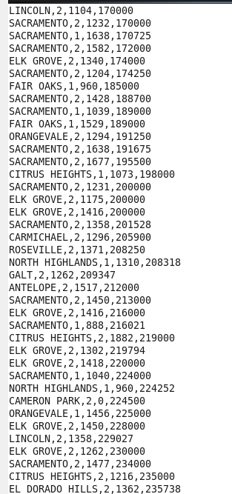

**C:\Users\Jayachandran\Desktop\bigdata\26.3 op2 cmd.PNG**

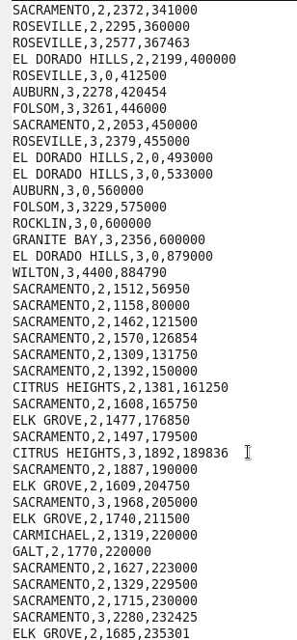

**C:\Users\Jayachandran\Desktop\bigdata\26.3 op3 cmd.PNG**

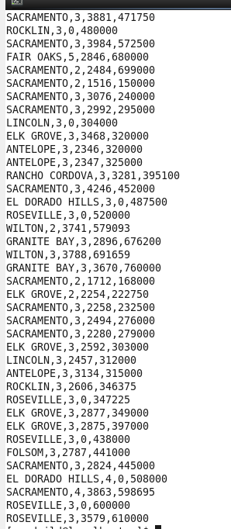

**C:\Users\Jayachandran\Desktop\bigdata\26.3 op4 cmd.PNG**

