**ASS-26.4**

**Implement view in hive**

View is used to reduce the complexity of a query .

It is mostly used while there is a need for joins or nested queries are there

If a job required multiple nested queries then view is useful

View stores the obtained temporary output ,so that can be used through view

Here the following example ,we need to join two tables and we must segregate the dataset.

Two tables people and cart are loaded into the hive

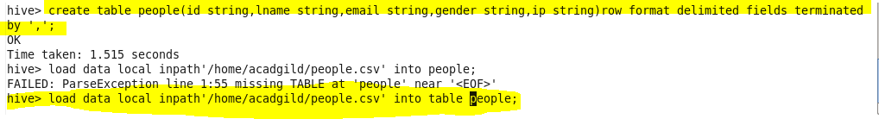

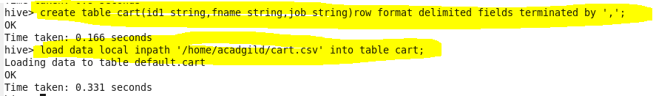

Now by using normal nested queries,the query would be big and complex as follows,

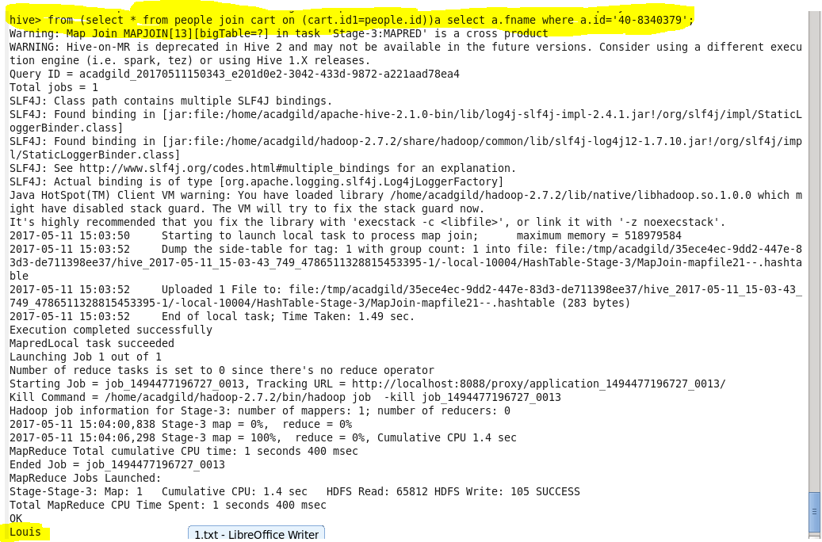

**Let us create a view which has joined content of both the tables**

**C:\Users\Jayachandran\Desktop\bigdata\26 4 join.PNG**

**Now from this view we can the select content easily,so we does not require a complex query to solve this.**

