**ASS-26.5**

**How many kinds of tables are present in hive and explain the difference between them with a demo.**

There are two types of tables namely,

*Internal table or managed table

*External table

**Internal table or managed table-**

Internal table is a default table stored in hive and it can be accessed only by hive .This table is entirely deleted while dropping the table from hive

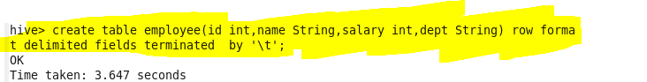

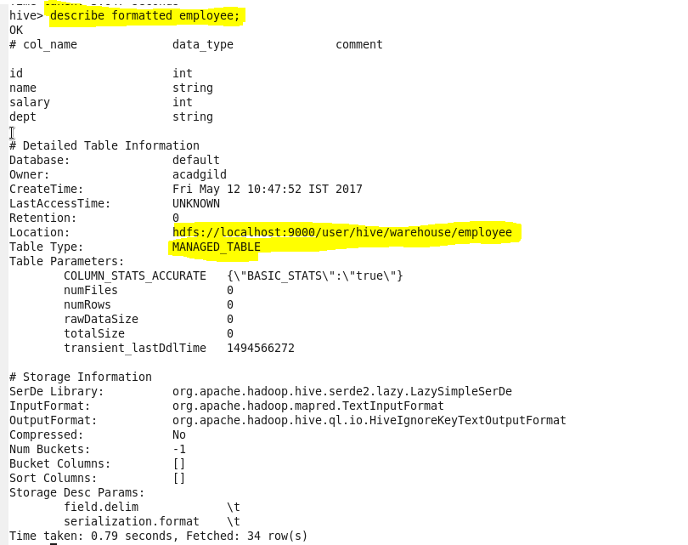

**\*External table**-External table is in local system which can be accessed by other tools also .Even when this table is dropped in hive ,only its metadata would be deleted but not the entire content of the table.

The following example is creating an external table

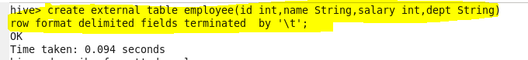

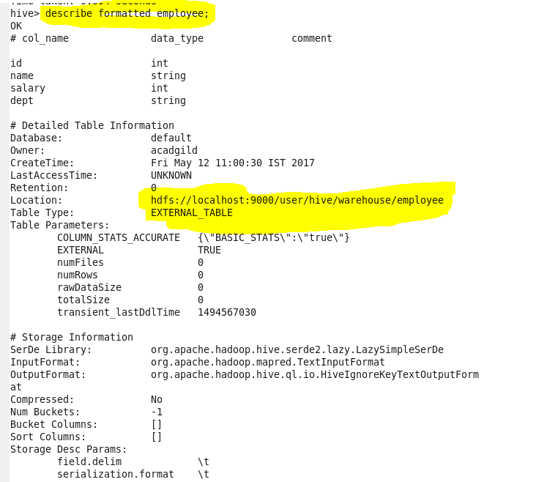

Even after deleting the table still the content is present in local file system