**ASS-26.6**

**1. Explain the differences between static and dynamic partitioning in hive and their working procedures.**

**Static partitioning:**

Static partition is done when the table is big.Here the partition is done statically.

This partition is done in strict mode

This partition can be altered after partition and a specific value of a column can be given to partition

**Dynamic partitioning:**

Dynamic partition is done when there is big data in the table.Here the partition is done explicitly

This partition is done in nonstrict mode

This partition cannot be altered after partition

**2. Use static partitioning in hive and evaluate the below problem statements**

**- Find the number of medals india won year wise**

First we would create a table with partition then we are overwriting it by inserting the data from original dataset which accepts the input with partitioning

Then we will get the output based on the partition on the local system



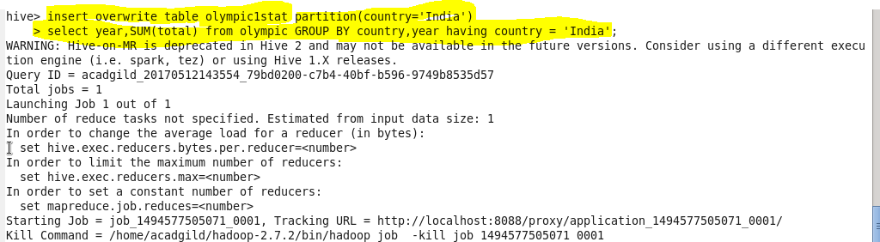

**The output is obtained based on the partition by country**

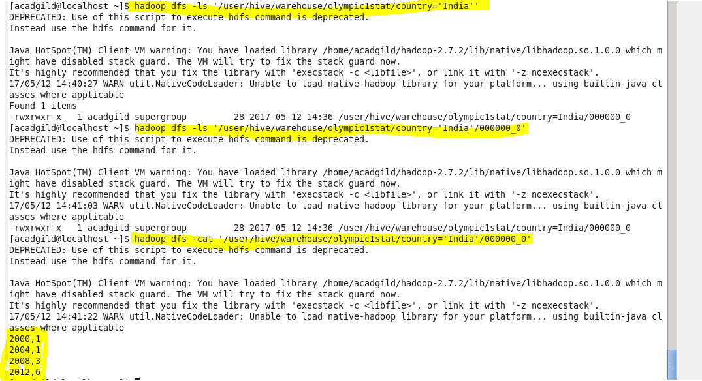

**- Find the number of medals india won in swimming year wise**



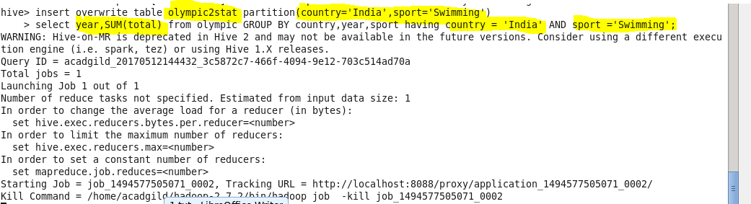

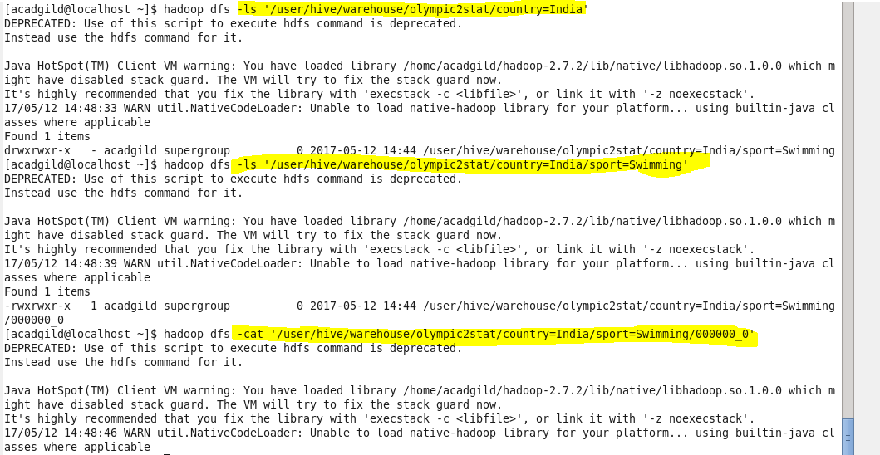

**- Find the number of gold and silver medals india won year wise**



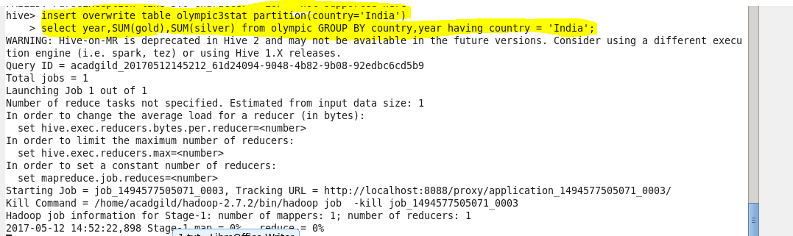

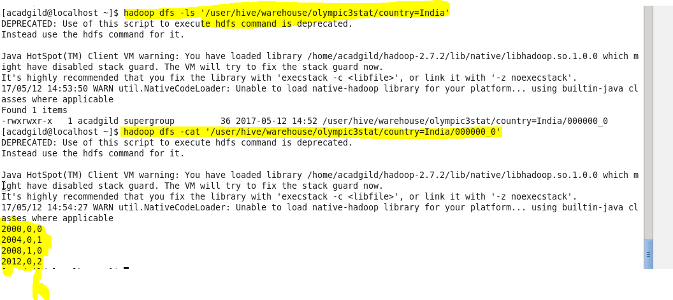

**3. Use dynamic partitioning in hive and evaluate the below problem statements**

**- Find the total number of medals won by each country.**

**C:\Users\Jayachandran\Desktop\bigdata\26 6 p1 create.PNG**

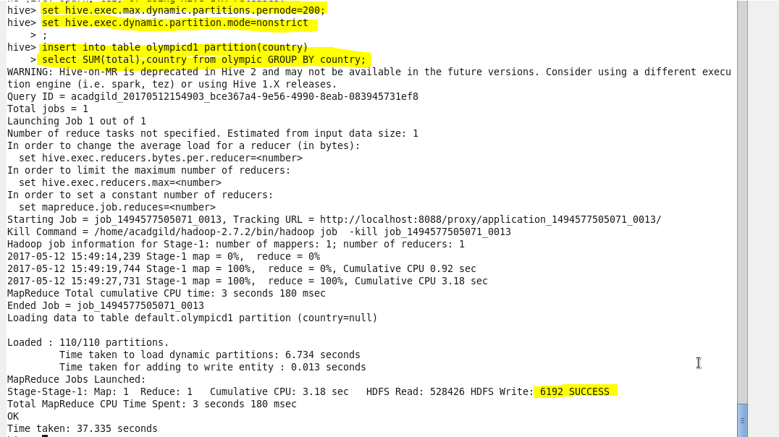

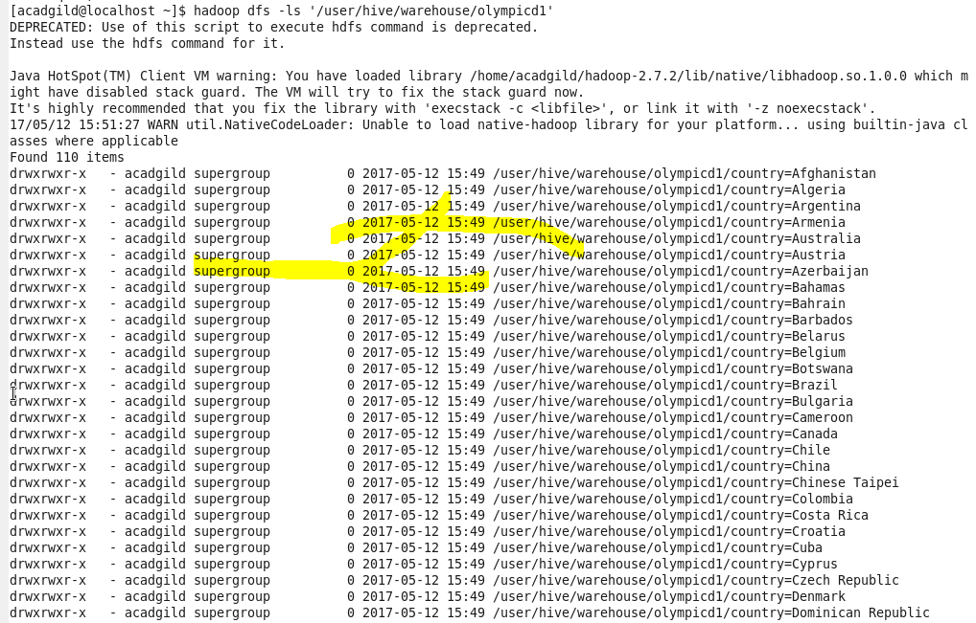

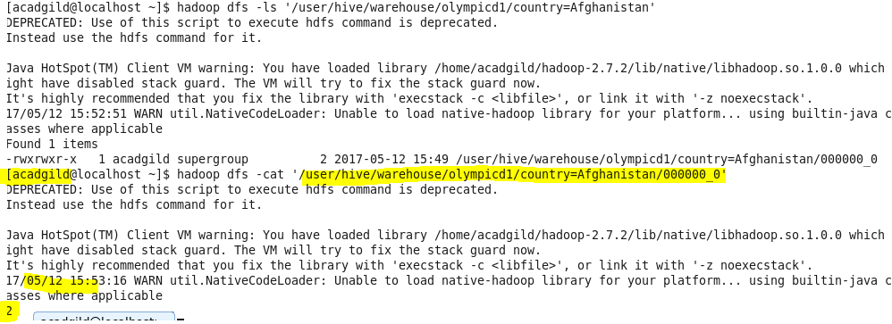

**- Find the number of medals each country won in Athletics year wise**

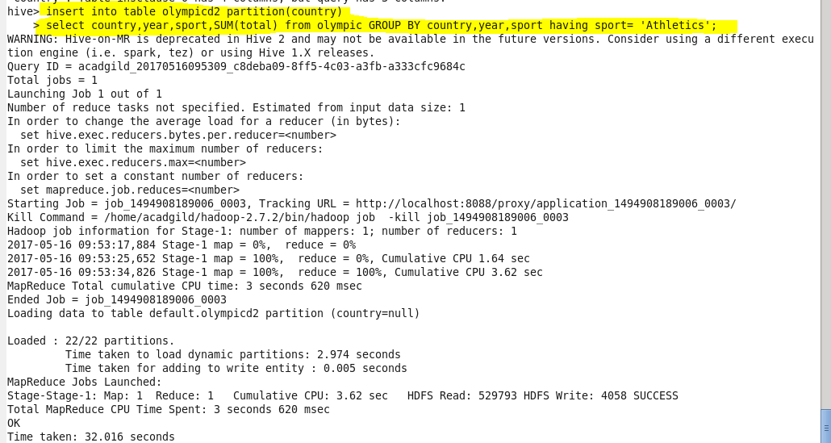

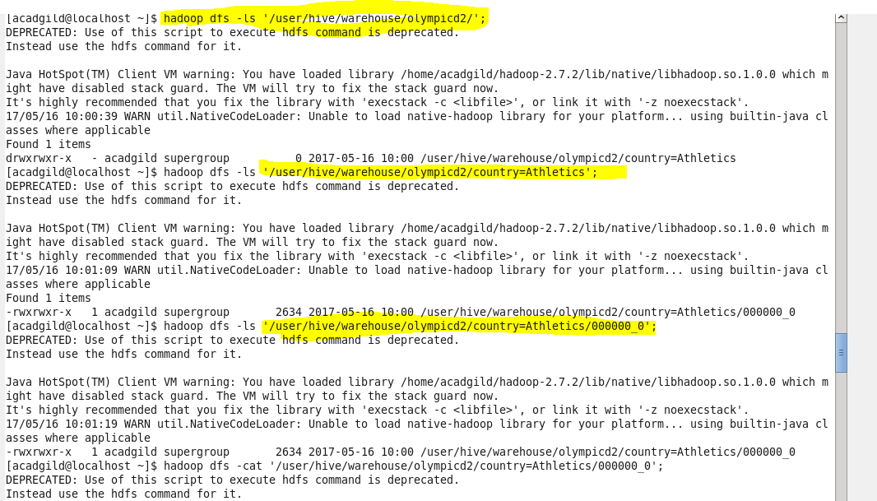

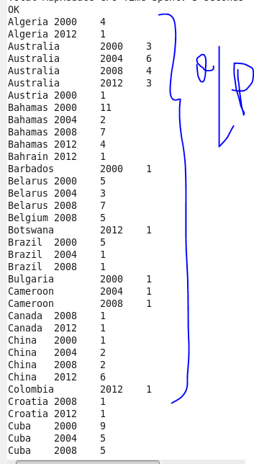

**- Find the average age of atheltes participated from each country in Olympics year wise**

