**ASS-27.4**

**Run parallel jobs in hive**

**Creating New files:**

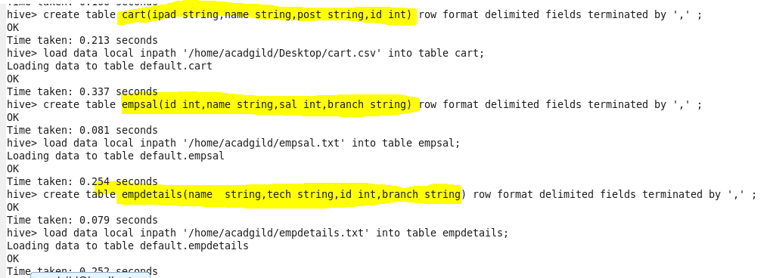

we are creating three tables cart,empsal,empdetails

**Joining three files parallel**



**So we are setting execution in parallel mode by**

**Set hive.exec.parallel=true**

**Set hive.exec.parallel.thread.number=8**

**so they would execute in a short time**

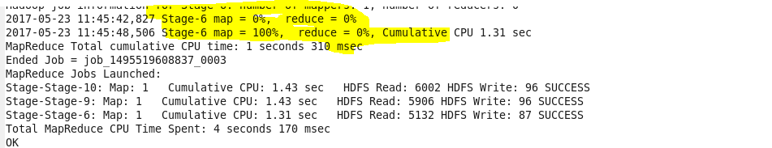

**Output terminal:**

