**1. PUT command: to feed the data into HDFS.** 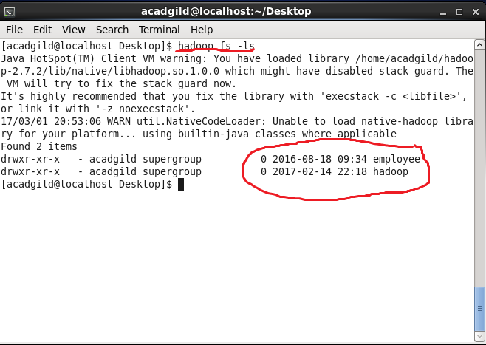

**2. LS command: list all the files**

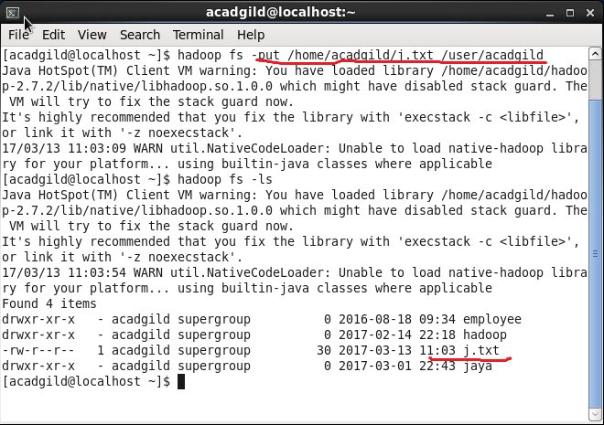

### 3.Get Command

### C:\Users\612912\Pictures\getco1.PNG

### 4. ****Make Directory Command****

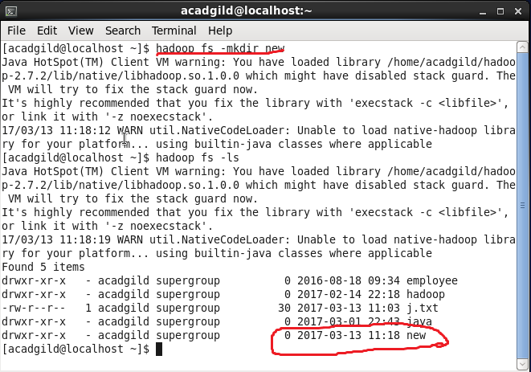

**5. CAT –used to display the content of a file.**

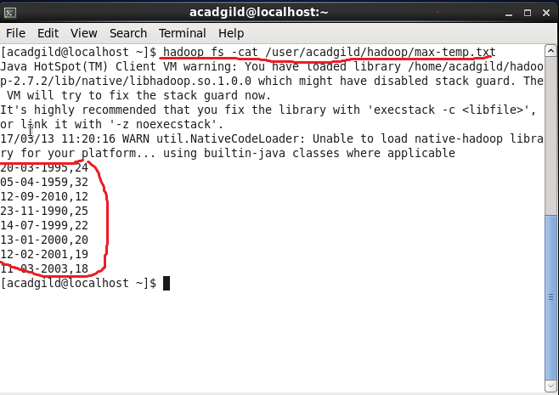

**6. copyfromlocal –it will copy file from the local file system to the HDFS.**

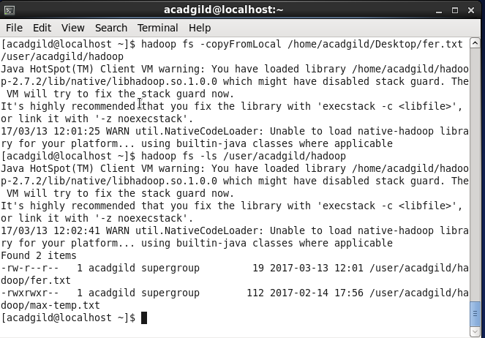

**7. rm- will delete the file stored inside the HDFS.**

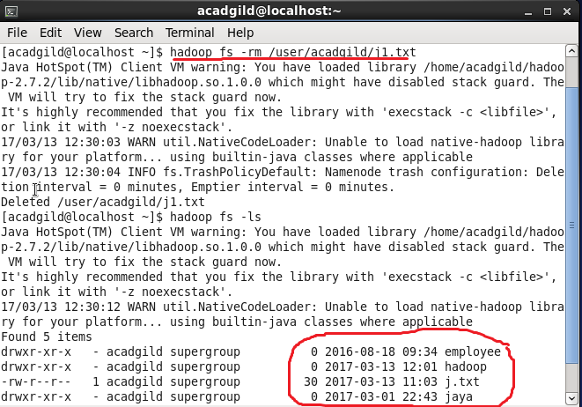

**8. fsck-is used for checking the consistency of a file system**

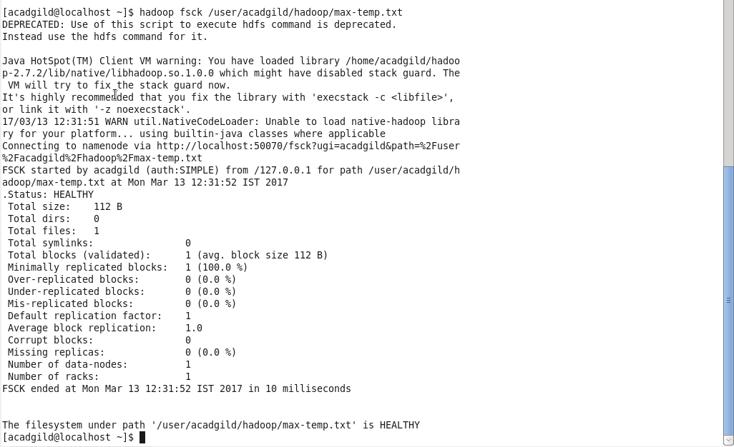

**9. balancer-will check for work load on nodes in cluster and balance it.**

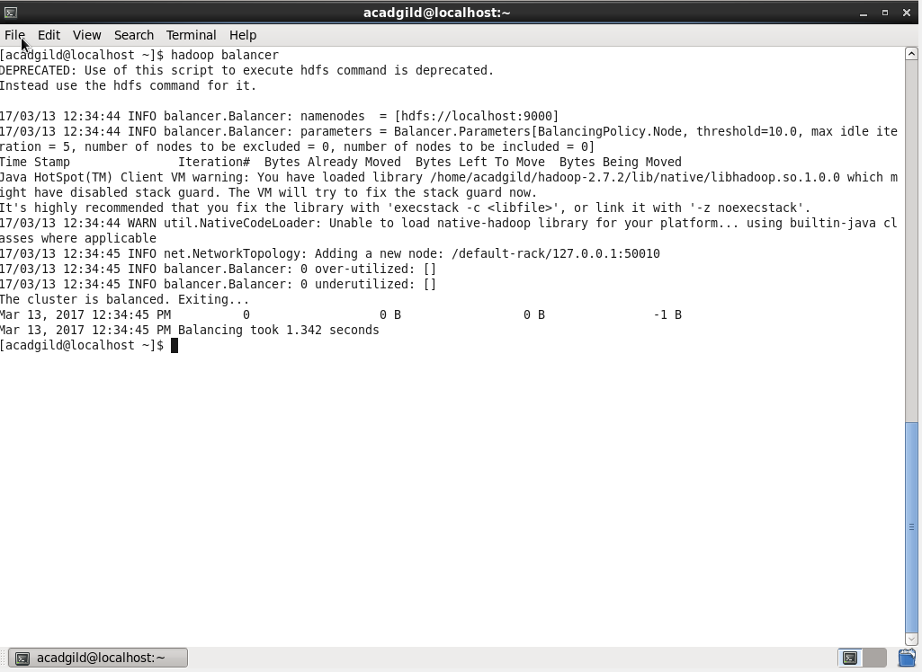

**10.to check space in a file** 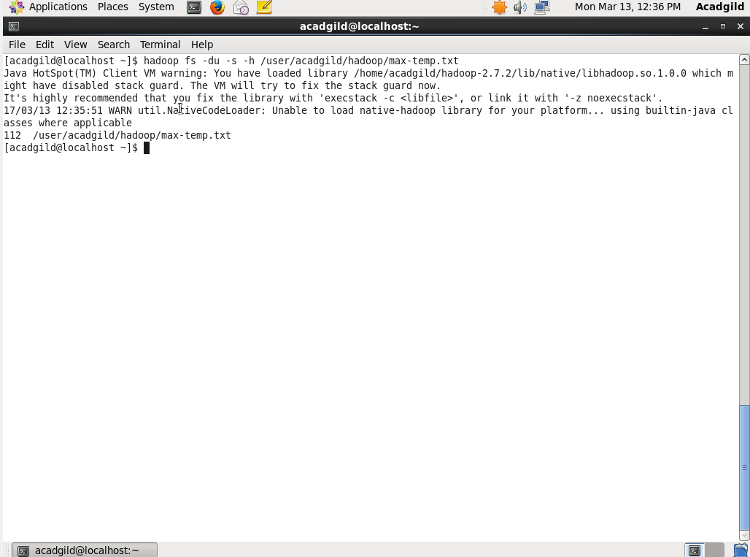

### 11. fs- command lists down all the shell commands of the Hadoop File System

### C:\Users\612912\Pictures\fs.PNG