**ASS-35.1**

**Problem Statement:**

**● Create a employee table in Mysql and columns as Emp_id, Emp_name,**

**Dept_name(Hadoop Developer), Emp_sal.**

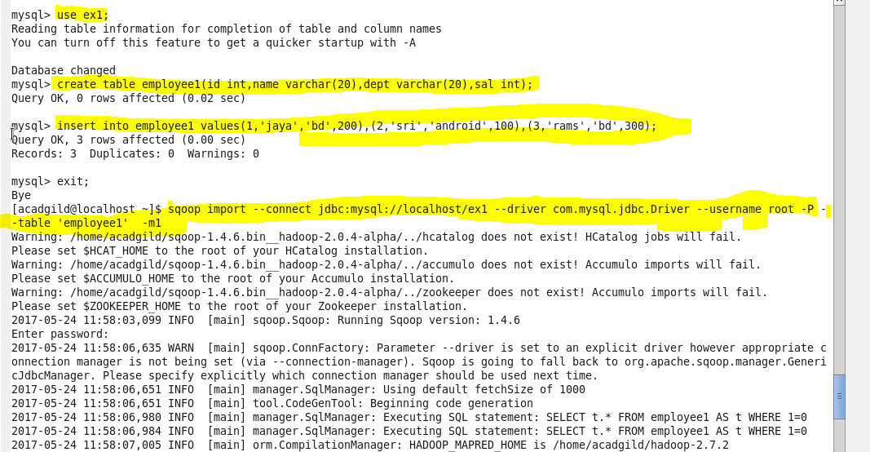

At first we are creating a database ex1,in this database we are creating a table employee1

Then we are inserting the content into the table

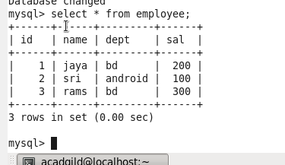

**● Import the employee table contents into the HDFS directory using Sqoop.**

Now we need to import this table from mysql to hdfs



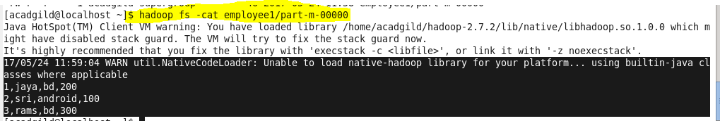

**● Create a employee2 table in Mysql and Export Top 5 employee details Emp_name and Emp_sal from HDFS directory to Mysql table employee2 using Sqoop.**

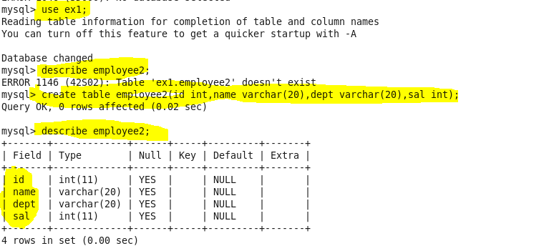

Now we are creating an empty file in mysql

WE need to export the content from hdfs to mysql using sqoop



Now the exported content can be seen in mysql employee 2 table

