**ASS-35.2**

**Problem Statement:**

**● Explain and perform Sqoop Incremental Import operation to load data from Mysql To HDFS using Sqoop**

Incremental import is used to show the additional modification done from the original file.This is of two types append and last modified.Append used to display the content that are continuously modifying whereas last modified shows the already return content

Now we are inserting the column with two new rows

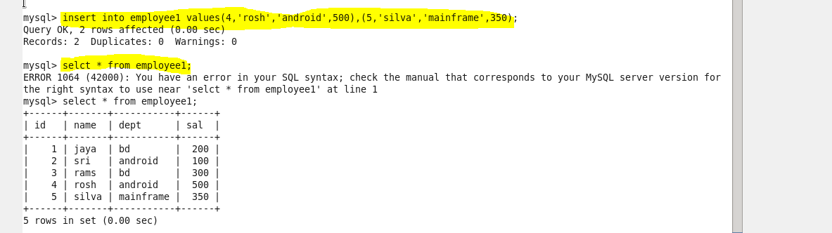

Then we are importing this content which are incremented from the already stored file ,here we give the column name id which has been appended from the last value 3

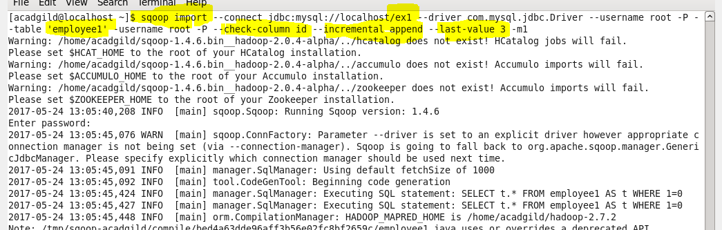

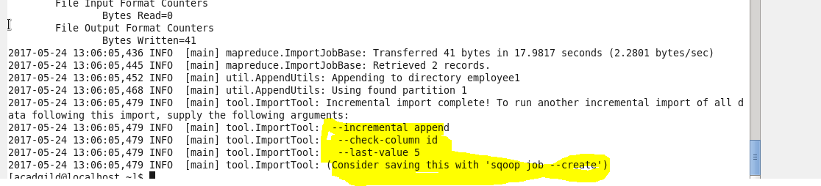

**Output Terminal:**

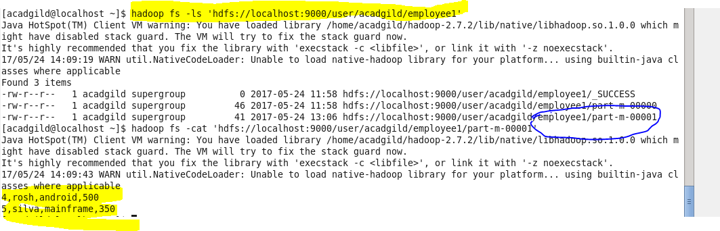

So in hdfs we can see that a new file that has the appended value is stored