**ASS-35.3**

**Explain and perform Importing table contents from Mysql to Hive using Sqoop.**

First we are creating a table in mysql,then we are inserting the content into the table

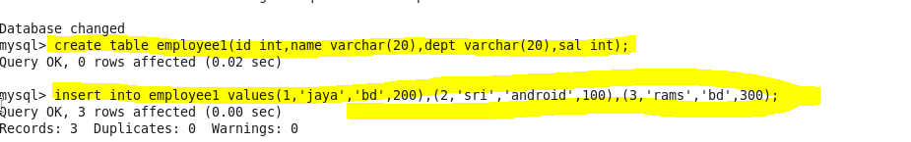

**Now we are importing the content from mysql to hive ,that we split by a column and then describing the column names ,then we are creating a hive file to be imported.**

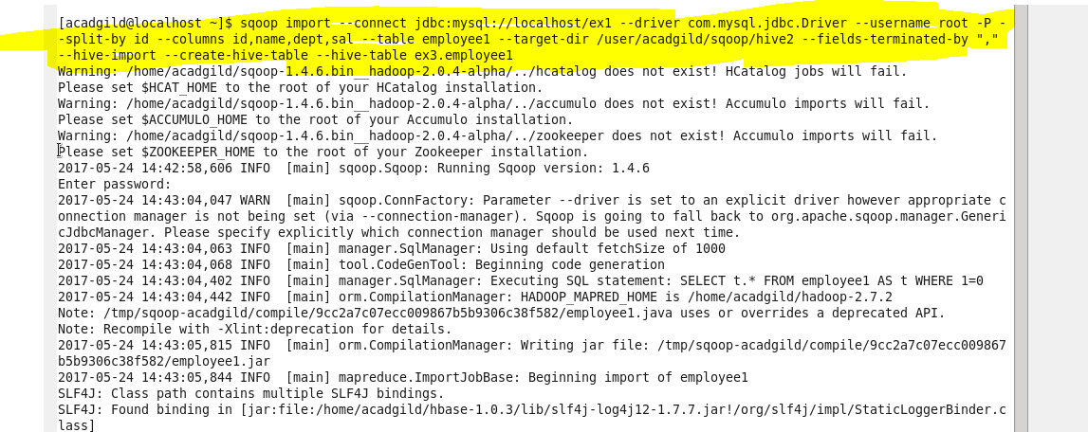

This shows that the hive importing is completed

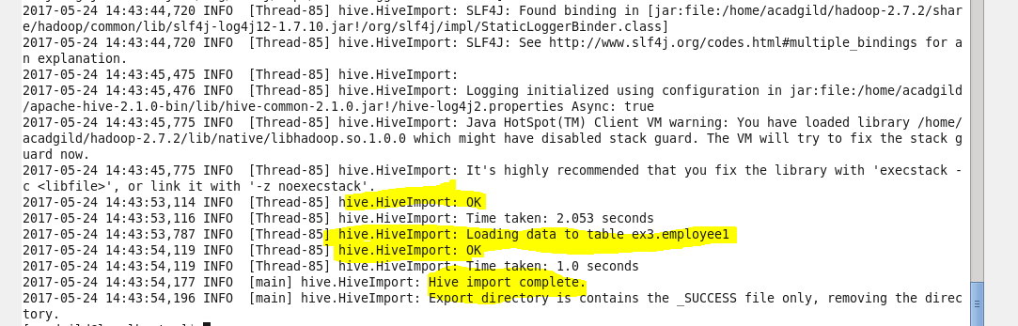

Imported value in hive

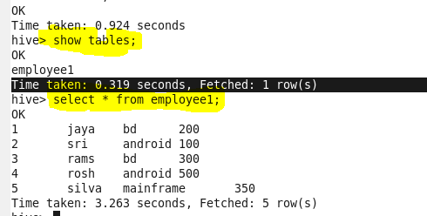

**Explain and perform Importing table contents from Mysql to HBase using Sqoop**

At first we are creating a hbase table employee table with columns description

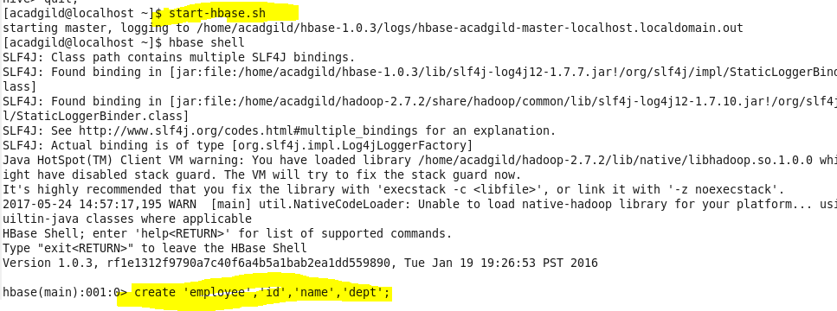

**Then we are importing the content from mysql to hbase with column family name**

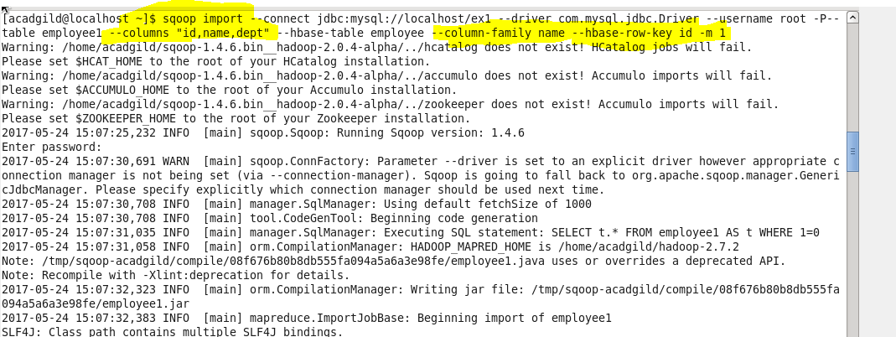

**Output:**The values are imported in hbase from mysql

