ASSIGNMENT -4.3

1.Java program to display the content of a file in HDFS on screen.

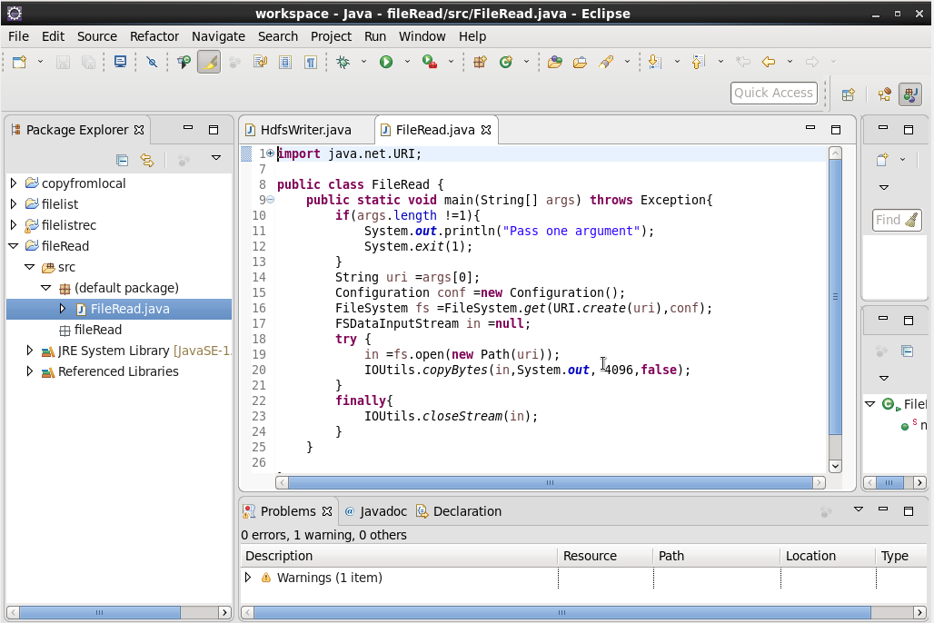

Terminal output:

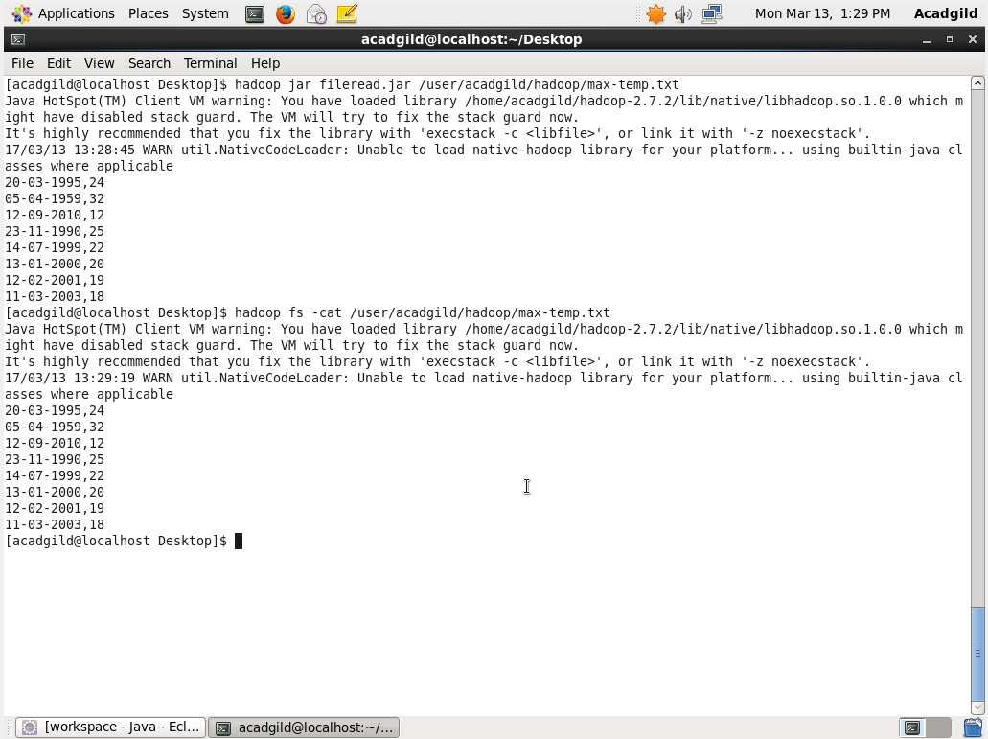

2. Java program to copy a file from local filesystem to HDFS.

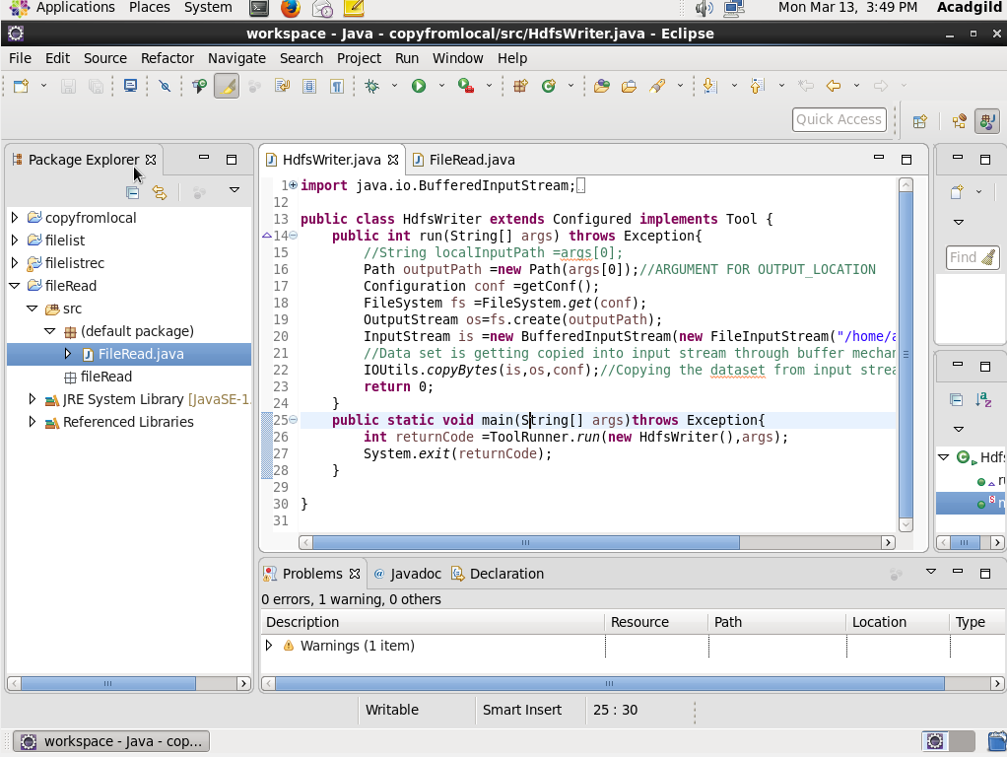

Output terminal:

