**ASS-5.1**

1.MapReduce program to filter out the invalid records

DRIVER CLASS

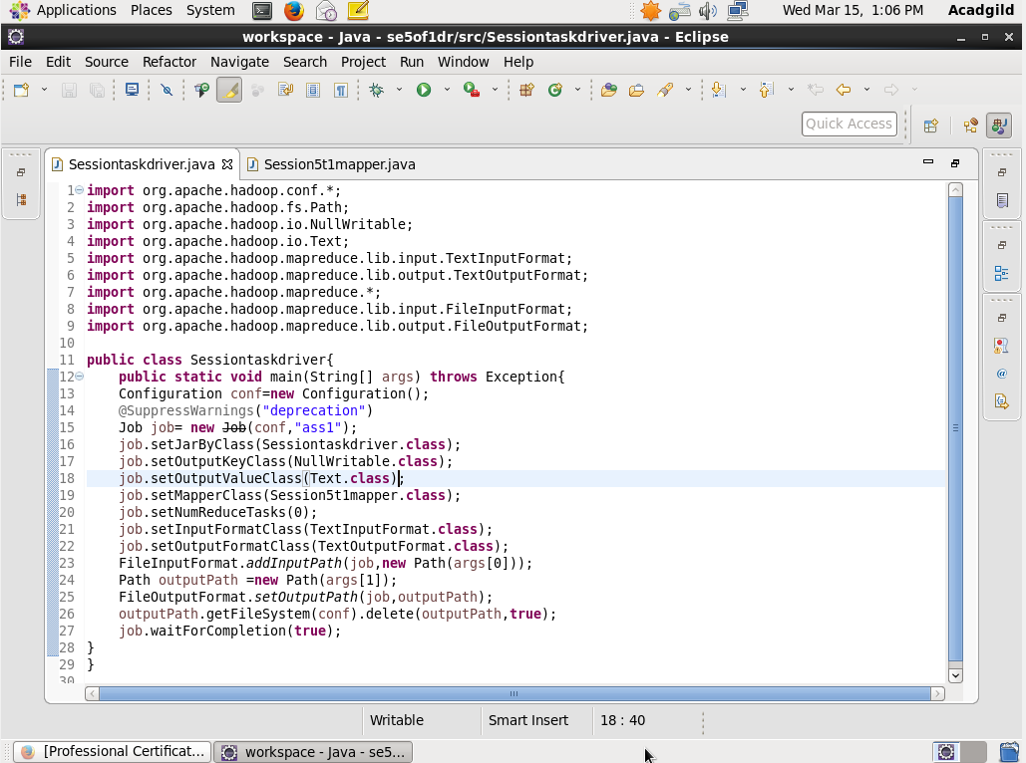

The driver class just defines the path of input file and where output to be stored

MAPPER CLASS:

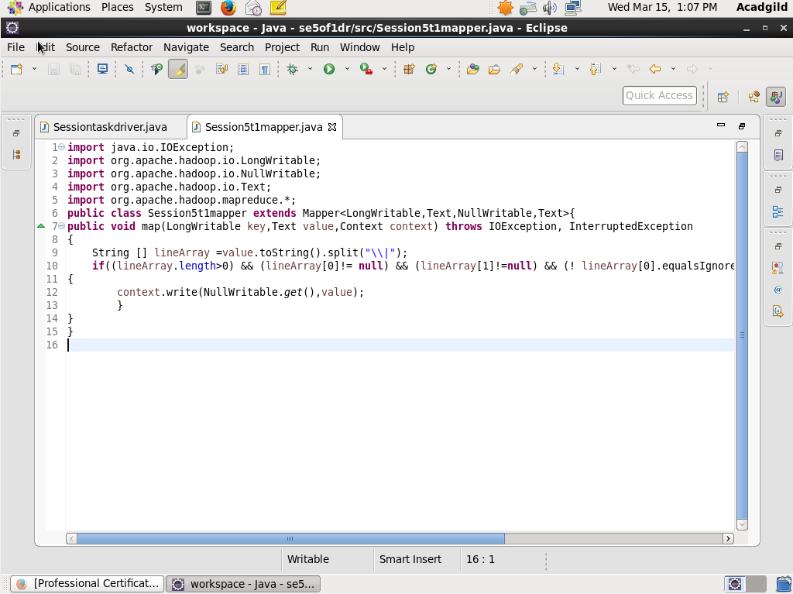

In this mapper class it first splits data by ‘|’ and then the first and second element is checked whether it is “na” .if it is not then it writes on the output file.

RUN:

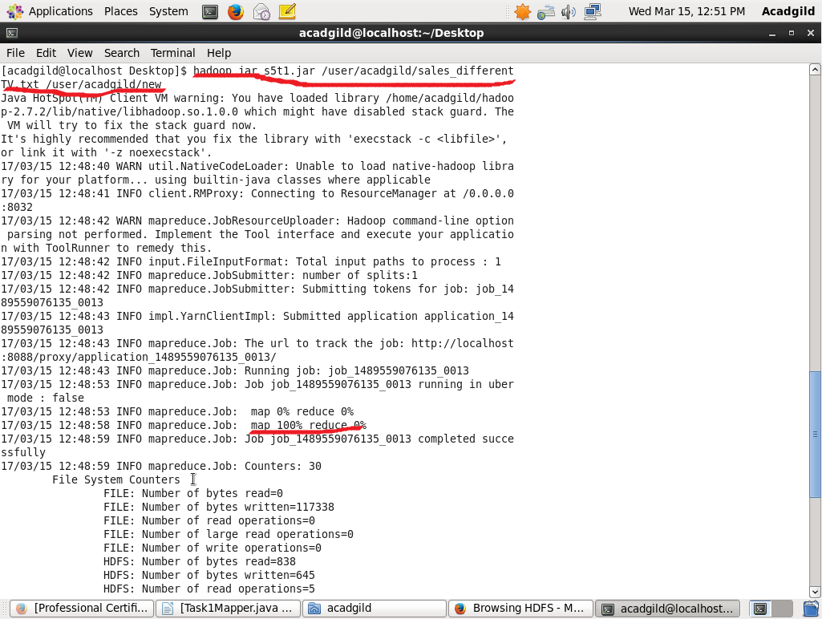

Here the java program is in s5t1.jar and the input data is in sales_differentTV.txt file and the new denotes the output file.

OUTPUT TERMINAL:

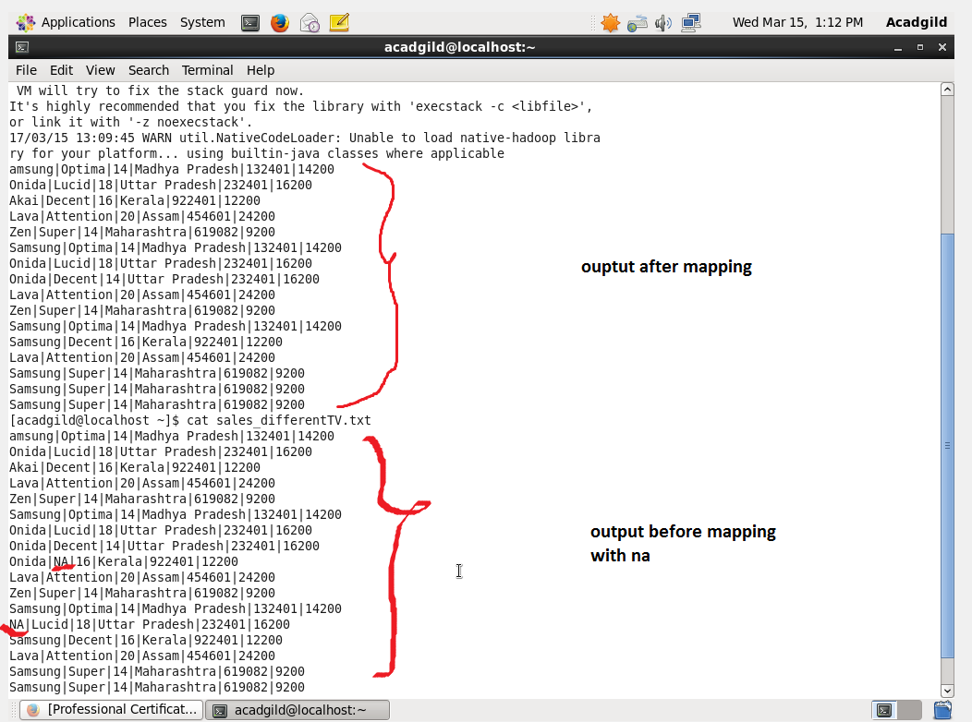

The output is in /new/part-r-00000 file and here we can see that after mapping input data we get an output without “na”.